Name of Company  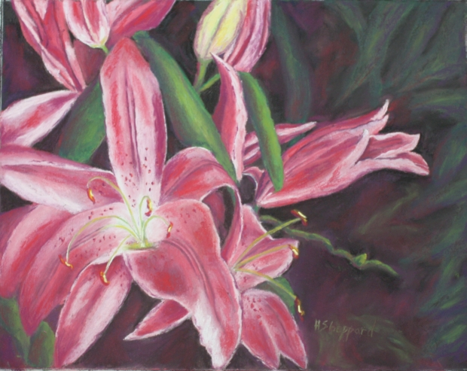 Heather Sheppard Fine Art  Pastels and Pencils  Small friendly classes  Adult & Children  Day & Evening  Ph: 0413 829 390  www.heathersart.com.au | Heather Sheppard Fine Art  Pastels and Pencils  Small friendly classes  Adult & Children  Day & Evening  Ph: 0413 829 390  www.heathersart.com.au
Heather Sheppard Fine Art  Pastels and Pencils  Small friendly classes  Adult & Children  Day & Evening  Ph: 0413 829 390  www.heathersart.com.au | Heather Sheppard Fine Art  Pastels and Pencils  Small friendly classes  Adult & Children  Day & Evening  Ph: 0413 829 390 www.heathersart.com.au
Heather Sheppard Fine Art  Pastels and Pencils  Small friendly classes  Adult & Children  Day & Evening  Ph: 0413 829 390  www.heathersart.com.au | Heather Sheppard Fine Art  Pastels and Pencils  Small friendly classes  Adult & Children  Day & Evening  Ph: 0413 829 390  www.heathersart.com.au
Heather Sheppard Fine Art  Pastels and Pencils  Small friendly classes  Adult & Children  Day & Evening  Ph: 0413 829 390  www.heathersart.com.au Name of Company | Heather Sheppard Fine Art  Pastels and Pencils  Small friendly classes  Adult & Children  Day & Evening  Ph: 0413 829 390  www.heathersart.com.au
Heather Sheppard Fine Art  Pastels and Pencils  Small friendly classes  Adult & Children  Day & Evening  Ph: 0413 829 390  www.heathersart.com.au Name of Company | Heather Sheppard Fine Art  Pastels and Pencils  Small friendly classes  Adult & Children  Day & Evening  Ph: 0413 829 390  www.heathersart.com.au

