Edith Cowan University

Trans-Mit Pty Ltd

Quotation to Upgrade the Bilmax21 to include:
Historical report generation.
Mobile average cost comparison.
Management summary reports.
YTD reports.
Exporting of summary and detail reports into Excel

Contact : Rodney Sheppard

Telephone : 03 9574 8956

email : rod@transmit.com.au

website : www.transmit.com.au

Project Background

Edith Cowan University (ECU) is seeking additional features in the Bilmax21 to provide:-
- Historic Report Generation for Distribution Lists.

There is a growing requirement to be able to re run Bilmax21 reports for new users who typically want access to the last 6 or so months not just from when they start.
The business rule originally for this scenario was that new recipients could only have reports from the date they were configured as a user.
Up until now, when this was required a request was placed on Trans-Mit and a manual adjustment was made by Trans-Mit to give the user access to the historical reports and information.

- Mobile Average Cost Comparison report.

ECU require a new report to allow comparison of the average Mobile Cost for a distribution List against the overall average mobile cost.

- Management Summary reports.

A new reporting feature in the Bilmax21 to provide management summary information reports to senior management and other recipients of the Bilmax21 online reports.

- YTD reports.

A new reporting feature in the Bilmax21 to provide YTD information graphs to senior management and other recipients of the Bilmax21 online reports

- Exporting of summary and detail reports into Excel.
A new feature to give users of the Bilmax21, the ability to export the data in the Cost Centre Summary, Extension Call Detail (Fixed Line) and ServiceID Detail (Mobiles) reports directly into Excel. This is to allow users on an ad-hoc basis to manipulate the report data as they wish.

Solution

- Historical Bilmax21 Reports

Modification of the Bilmax21 Distribution List Administration screen to provide the ability to generate/re-generate historical reports for new and existing Distribution lists (fig. 1)

The addition of a new Administration screen to manage reports release, and notification (fig. 2a/2b).

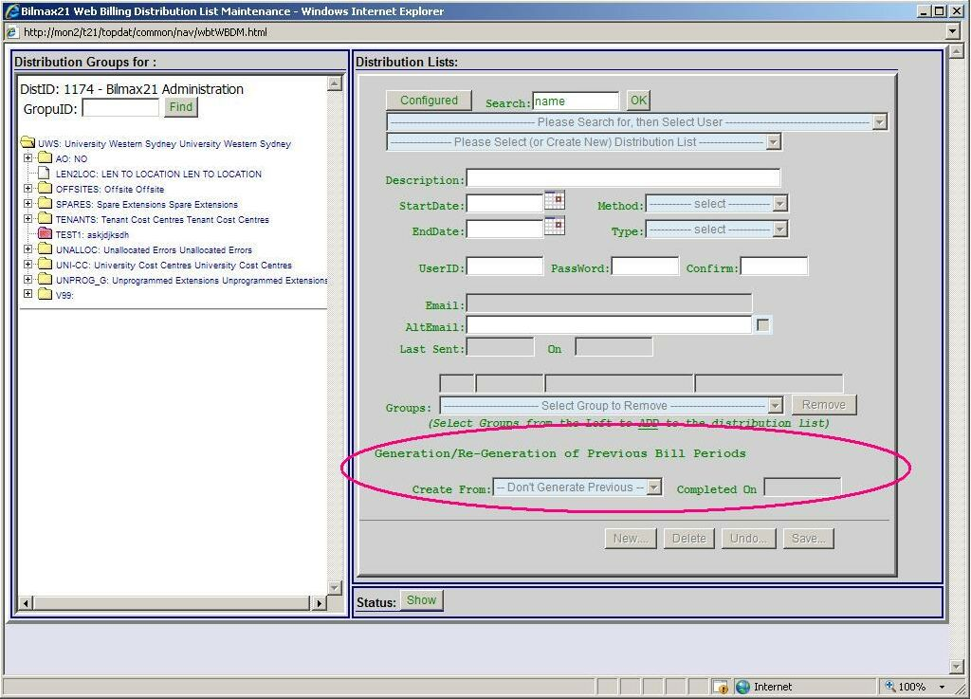
Fig. 1 – Modifications to Distribution List Admin Screen.

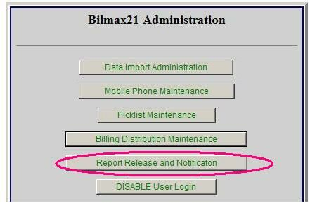
Fig. 2a – Addition to Admin Menu

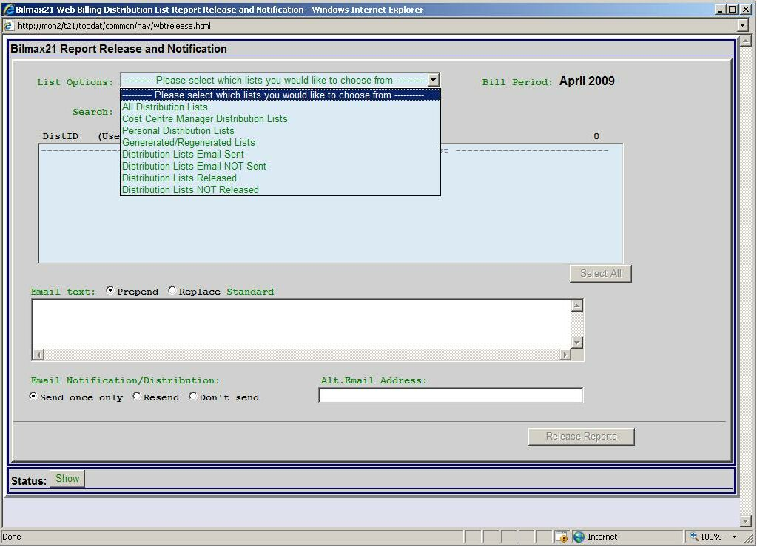
Fig. 2b – New report Release and Notification Screen.

- Mobile Average Cost Comparison report.

This is best implemented as an addition to the Totals Section of the existing Mobile Service Report. An example is shown below.

Mobile | Campus | Location | Name | Project | Description | Total Cost
0407-294399 | BNK | 1.G.53 | Jane Doe | 00000 | ART:DEANS UNIT | $12.56
0450-907834 | BNK | 24.3.25 | Jack Smith | 00000 | ART:DEANS UNIT | $10.50
 |  |  |  |  | Average for List | $11.53
 |  |  |  |  | Overall Average | $18.50
 |  |  |  |  | Total | $236.76

- Bilmax21 Management Reports
The reports are as follows;

Report 1 - Top 20 Users by Cost
One line per user giving a total of 20 lines in the report
There would a report for fixed line and another for mobiles.

Report 2 - Top 20 Most Expensive Calls
One line per user giving a total of 20 lines in the report
There would a report for fixed line and another for mobiles.

Report 3 - Top 20 Longest Duration Calls
One line per user giving a maximum of 20 lines in the report
There would a report for fixed line and another for mobiles.

Report 4 – Top 20 Most Frequently Dialled
One line per user giving a maximum of 20 lines in the report
There would a report for fixed line and another for mobiles.

Report 5 - Top 20 SMS Users by Number Sent
One line per user giving a maximum of 20 lines in the report

Report 6 - Top 20 SMS by Cost
One line per user giving a maximum of 20 lines in the report

Report 7 – All Global Roaming Users
One line per user no maximum of lines in the report

Report 8 – Fixed Line Call Distribution by Date
This report includes views by Call Count, Call Costs and Call Duration for fixed line services.

Report 9 – Fixed Line Call Distribution by Hour
This report would show the average for a particular hour over the month eg all calls between say 2.00 and 3.00pm totalled and divided by the number of days in the month. It would exclude weekends as this would typically lower the average figure.
This report includes views by Call Count, Call Costs and Call Duration for fixed line services.

Report 10 - Intra-Organisational Call Distribution
The chart would show a breakdown on extension to extension, extension to ECU mobiles and ECU mobile to ECU mobile and include views by Call Count, Call Costs and Call Duration

Report 11 - Call Distribution by Call Type
There would be a report for fixed line and another for mobiles and include views by Call Count, Call Costs and Call Duration
The fixed line report would have the following call types;
Local, National, International, Mobile and Miscellaneous.
The mobile report would have the following call types;
National, International, Messaging, Commerce, Onnet and Miscellaneous

Report 12 – Premium 1900 Services Users
The report will have one line per user who has used the premium service at least one in the billing period. The cost will be the total of all the times they have used the premium service in the billing period. The report will show all users even if there are more than 20.

Report 12a – All Internet Users (only if data is in BRSS)
The report will have one line per user who has mobile Internet use. The report will show all users even if there are more than 20.

Bilmax21 Management Reports 1 to 12a will be accessed by selecting on the Bilmax21 front screen the Management Report option (fig 3a). The management Report selection screen will be displayed first (fig 3b). Example Management Report Layouts can be found in the accompanied file “Management Reports Layouts 3c.doc”.

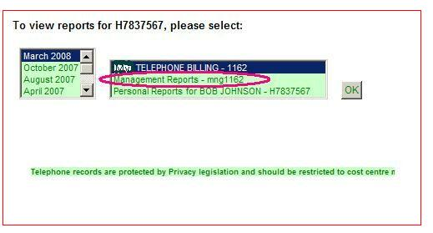
Fig. 3a – Management Reports on Bilmax21 main (Home) screen

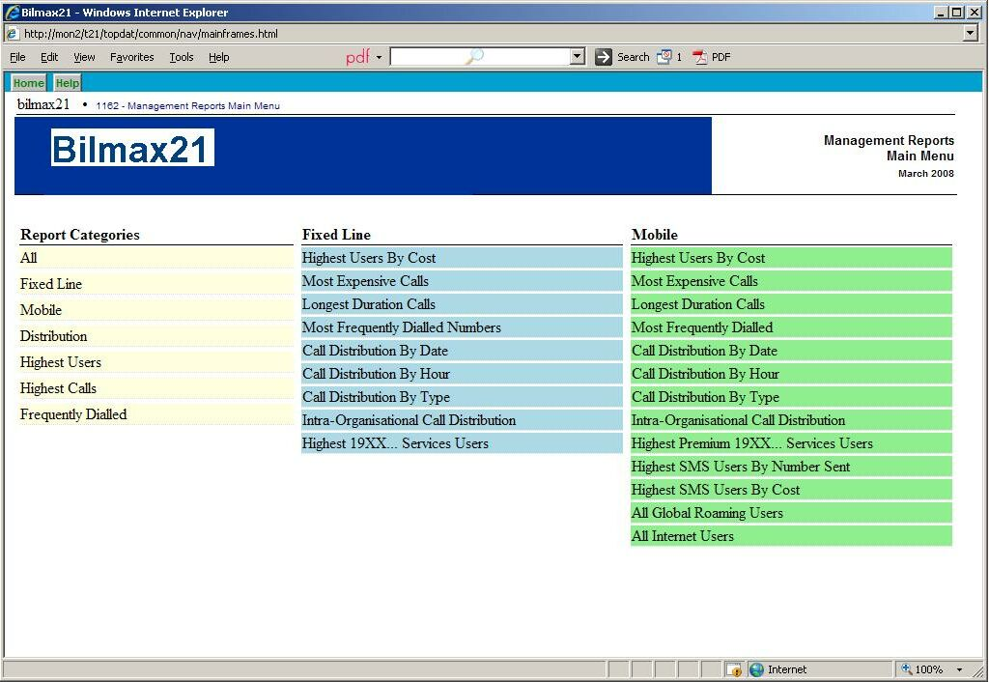
Fig. 3b – New management Report selection screen.

- Year to Date Comparison by Cost
The YTD information report is integrated into to the existing Bilmax21 reports.
The existing monthly trend report will be modified to include an additional graph showing YTD information and a comparison with the same period in previous years at the Cost Centre Summary Report level (fig 4).
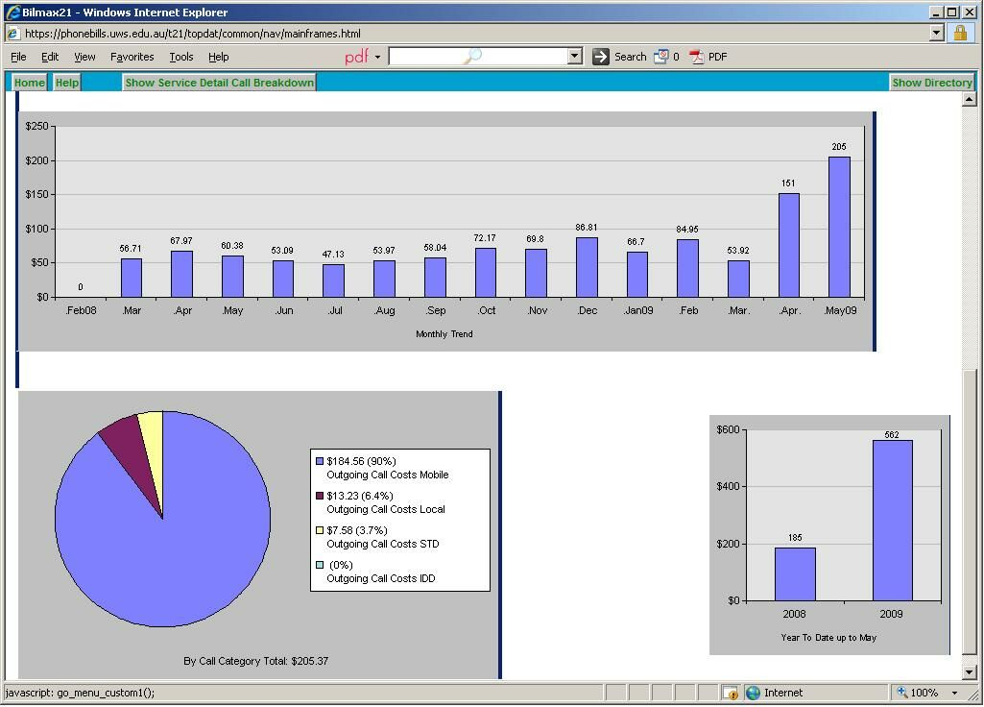
Fig. 4. Year to Date Graph

- Export to Excel.

On the Cost Centre Summary, Extension Call Detail (Fixed Line) and ServiceID Detail (Mobiles) reports a button will be provided in the header that when clicked will cause the data to be opened in Excel and be saved by the user.
If the user has set filters on the report then the Excel report will only contain the data matching the filter parameters that have been set.

Implementation

The described new features will be best implemented by
Coding any ECU customizations into the Latest Bilmax21 System.
This would include the Logout button on report screens, the Account Code maintenance and report screens, and the login AD
Authentication code.
The Code will first be installed into a test area on the ECU Telmax21 for review.

Pricing

- To implement the described new features the cost would be $8750 + GST

Notes
- All prices are exclusive of GST
- Delivery 4 to 6 weeks after receipt of order
- Quotation is valid for 30 days

