Victrack Access

Trans-Mit Pty Ltd

Quotation to upgrade the Bilmax21

Contact : Rod Sheppard

Telephone : 03 9574 8956

email : rod@transmit.com.au

website : www.transmit.com.au

Project Background

Victrack are seeking additional features in the Bilmax21 including access via the web protocol. It is to provide Management of distribution lists, Cost centre management reports, Report Release and Notification and Web Reporting access via customer login. It also includes personal reporting and call cost recovery. Those users who are issued with a mobile phone are requested to pay for calls that are deemed to be of a personal or private nature rather than work related.
Scope of Work

The following key tasks will be undertaken.

- Integrate the existing Victrack Bilmax21 Reports into the current Bilmax21 Software, thus providing the new features as described above. .

- Load and configure the new Bilmax21 including the Mobile module, Management Reports and YTD onto the Telmax21 server.

- Set-up of the integration with Active Directory to provide personal Mobile Users access to Bilmax21 Login. Integration with the Directory Maintenance screen will be required here. (i.e. A field to link to the AD)

- Users are to authenticate against the Active Directory when logging on to view their reports. Alternatively, they can be configured into the Bilmax21 with a userid and password.

- Web access is via the https (secure web protocol). This will require the installation of a valid signed certificate either self signed or by a CA (i.e. VeriSign)

- External access can be achieved by allowing access thru to the Telmax21 on port 443 (https); a domain name would need to be registered against the external IP address.

- The reports will also remain available for burning and access via CD.

Features

- Historic Report Generation for Distribution Lists.

There is a growing requirement to be able to re run Bilmax21 reports for new users who typically want access to the last 6 or so months not just from when they start.
The business rule originally for this scenario was that new recipients could only have reports from the date they were configured as a user.
Up until now, when this was required a request was placed on Trans-Mit and a manual adjustment was made by Trans-Mit to give the user access to the historical reports and information.

- Management Summary reports.

A new reporting feature in the Bilmax21 to provide management summary information reports to senior management and other recipients of the Bilmax21 online reports.

- YTD reports.

A new reporting feature in the Bilmax21 to provide YTD information graphs to senior management and other recipients of the Bilmax21 online reports

- Exporting of summary and detail reports into Excel.
A new feature to give users of the Bilmax21, the ability to export the data in the Cost Centre Summary, Extension Call Detail (Fixed Line) and ServiceID Detail (Mobiles) reports directly into Excel. This is to allow users on an ad-hoc basis to manipulate the report data as they wish.

New Mobile Features

- The individual mobile owners to only have access to reports on their own mobile
- A method that easily allows users to check for and identify private use calls
- Managers to have access to all the phones allocated to their departments.
- Average cost comparison in summary and detail reports

The Bilmax21 detailed mobile phone report has a feature that allows individual calls to be tagged as being private use. By applying a filter it will hide the non-private calls and only display the private use ones with a total. This can then be printed and used as record when paying the amount owing to the cashier.
The mobile reports will be made available on a monthly basis the same as the other Bilmax21 reports.

A Report on Mobile Personal vs. Business usage for previous months having columns for Date of review, Personal Cost, Business Cost. The report includes mobiles that have not been reviewed.

A feature in the Mobile detail report to store a list of personal numbers that are used to pre-populate the personal call tick box. The list will have new personal numbers automatically added. The addition of a drop list for these numbers so the user can select and delete numbers. Modification of the Dialled Number Column header to include note about personal usage tick box.

The ability for Cost centre Managers to see individual personal calls that have been selected by uses of mobiles.

Solution

In response to the above Scope of Works Trans-Mit are pleased to propose the following solution for consideration by Victrack.

Whilst retaining the core Telmax21 and Bilmax21 functionality already in place it is proposed to integrate and configure the latest Web based screens

Administration and User Login screen, (Fig 1).
Users can be authenticated against a local Bilmax21
User id and password or via the Active Directory

Main Home Report selection screen, (Fig 2).
The Administration Login will have an additional User
selection drop list along with the standard month and distribution
list selection.

Administration Screen, (Fig 3).
This button is only available on the Administration
Login, which allows access to the Administration features.
(in this case only Billing Distribution Maintenance and Report release and Notification will be visible)

Distribution list maintenance screen, (Fig 4).
This screen is used to configure the Report distribution
Lists. Each list is assigned one more Groupid’s, which determines
what is contained in their reports.

Report release and notification screen, (Fig 5).
This report is used to enable user access to the newly created
month’s data. It also sends an email notification that the reports are available.

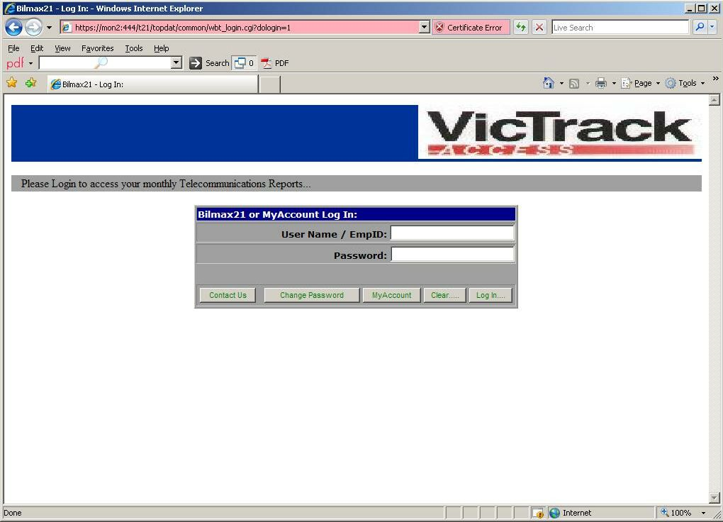
Web Login for Administration and User Reports
Fig. 1

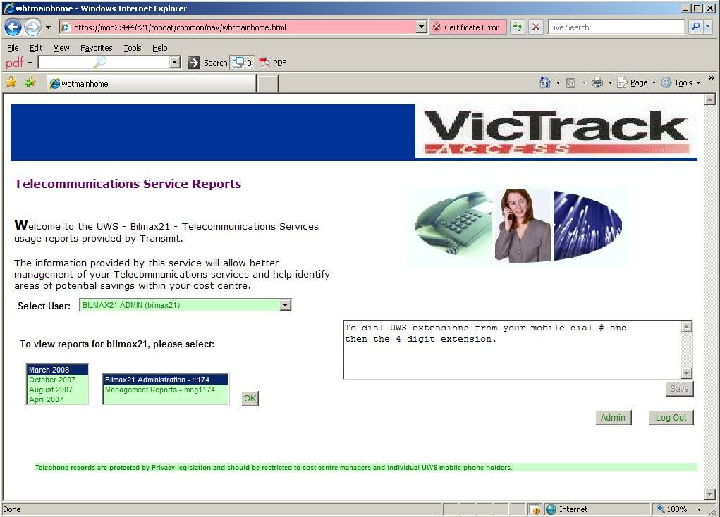
Main Home Report selection screen
Fig. 2

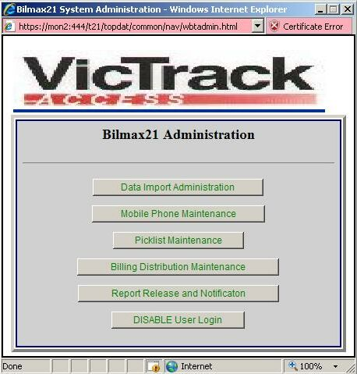
Administration Screen
Fig. 3

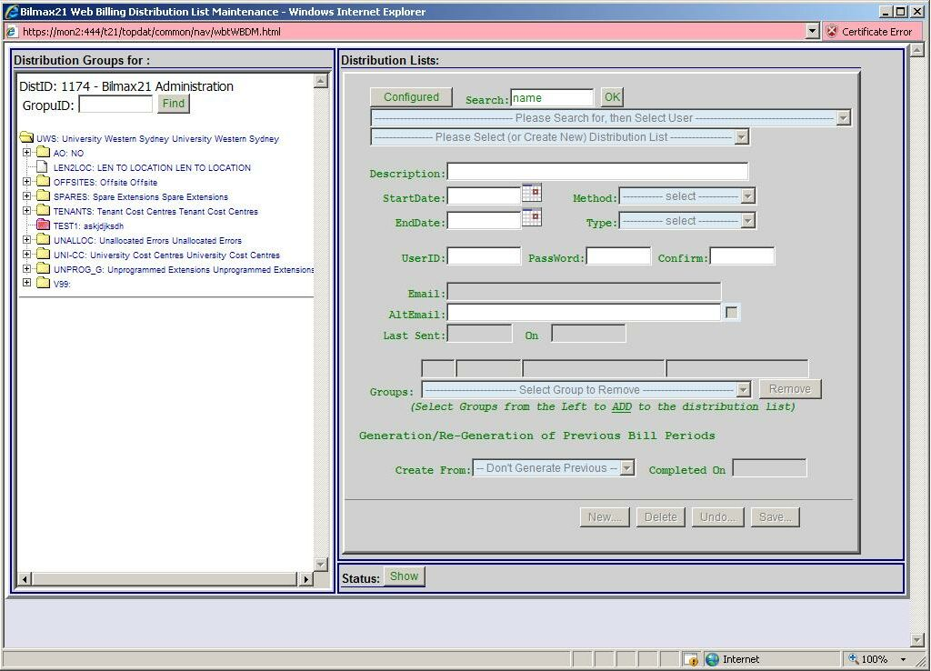
Distribution list maintenance screen
Fig. 4

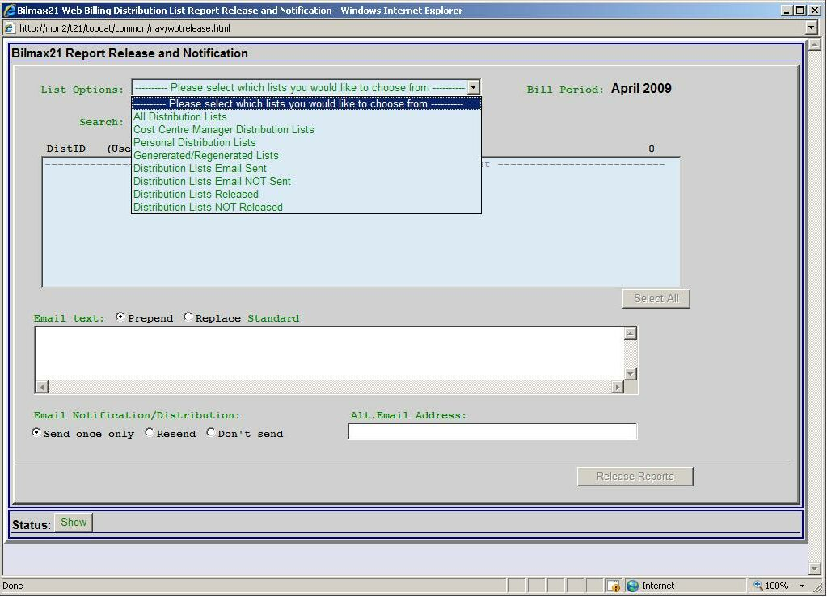

Administrator Report Release and Notification screen
Fig. 5

Bilmax21 Management Reports
The reports are as follows;

Report 1 - Top 20 Users by Cost
One line per user giving a total of 20 lines in the report
There would a report for fixed line and another for mobiles.

Report 2 - Top 20 Most Expensive Calls
One line per user giving a total of 20 lines in the report
There would a report for fixed line and another for mobiles.

Report 3 - Top 20 Longest Duration Calls
One line per user giving a maximum of 20 lines in the report
There would a report for fixed line and another for mobiles.

Report 4 – Top 20 Most Frequently Dialled
One line per user giving a maximum of 20 lines in the report
There would a report for fixed line and another for mobiles.

Report 5 - Top 20 SMS Users by Number Sent
One line per user giving a maximum of 20 lines in the report

Report 6 - Top 20 SMS by Cost
One line per user giving a maximum of 20 lines in the report

Report 7 – All Global Roaming Users
One line per user no maximum of lines in the report

Report 8 – Fixed Line Call Distribution by Date
This report includes views by Call Count, Call Costs and Call Duration for fixed line services.

Report 9 – Fixed Line Call Distribution by Hour
This report would show the average for a particular hour over the month eg all calls between say 2.00 and 3.00pm totalled and divided by the number of days in the month. It would exclude weekends as this would typically lower the average figure.
This report includes views by Call Count, Call Costs and Call Duration for fixed line services.

Report 10 - Intra-Organisational Call Distribution
The chart would show a breakdown on extension-to-extension, extension to mobiles and mobile to mobile and include views by Call Count, Call Costs and Call Duration

Report 11 - Call Distribution by Call Type
There would be a report for fixed line and another for mobiles and include views by Call Count, Call Costs and Call Duration
The fixed line report would have the following call types;
Local, National, International, Mobile and Miscellaneous.
The mobile report would have the following call types;
National, International, Messaging, Commerce, Onnet and Miscellaneous

Report 12 – Premium 1900 Services Users
The report will have one line per user who has used the premium service at least one in the billing period. The cost will be the total of all the times they have used the premium service in the billing period. The report will show all users even if there are more than 20.

Report 12a – All Internet Users (only if mobile internet data is available)
The report will have one line per user who has mobile Internet use. The report will show all users even if there are more than 20.

Bilmax21 Management Reports 1 to 12a will be accessed by selecting on the Bilmax21 front screen the Management Report option (fig 6a). The management Report selection screen will be displayed first (fig 6b). Example Management Report Layouts can be found in the accompanied file “Management Reports Layouts 6c.doc”

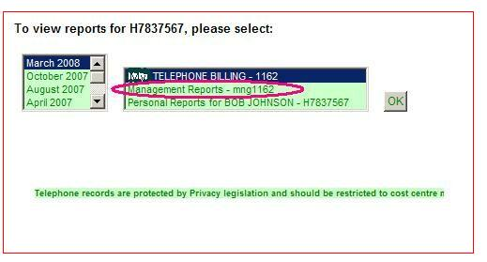
Fig. 6a – Management Reports on Bilmax21 main (Home) screen

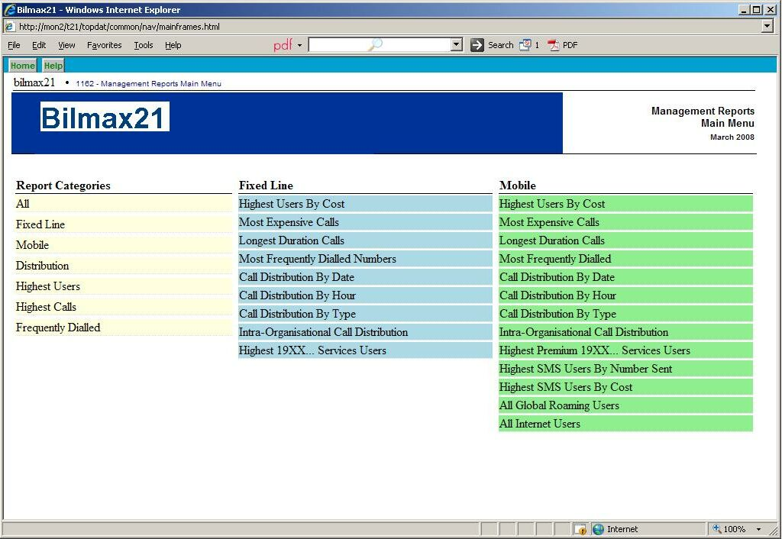 Fig. 6b – New management Report selection screen.

- Year to Date Comparison by Cost
The YTD information report is integrated into to the existing Bilmax21 reports.
The existing monthly trend report will be modified to include an additional graph showing YTD information and a comparison with the same period in previous years at the Cost Centre Summary Report level (fig 7).
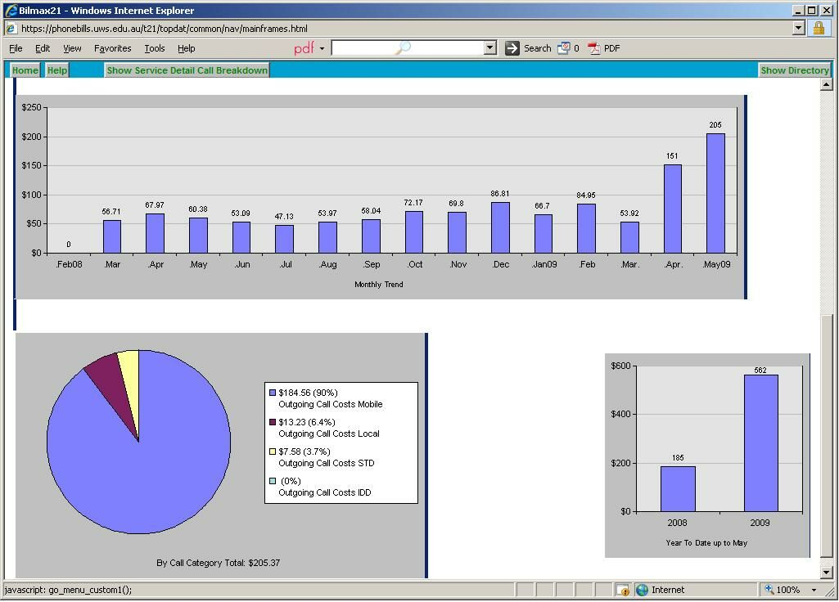
Fig. 7. Year to Date Graph

- Export to Excel.

On the Cost Centre Summary, Extension Call Detail (Fixed Line) and ServiceID Detail (Mobiles) reports a button will be provided in the header that when clicked will cause the data to be opened in Excel and be saved by the user.
If the user has set filters on the report then the Excel report will only contain the data matching the filter parameters that have been set.

Implementation

The described new features will be best implemented by
coding any customisations into the Latest Bilmax21 System.
This would include the Logout button on report screens, and the login AD Authentication code.
The Code will first be installed into a test area on the Telmax21 for review.

Pricing

To implement the described new Bilmax21features including:

- Bilmax21 Web Reporting, Including the Management Summary reports and YTD, Plus personal mobile features.
- Customize, install, configure and test software, including integration with active Directory
- Half day onsite training.

Total Cost $13,950

Notes
- All prices are exclusive of GST
- Delivery 6 to 8 weeks after receipt of order
- Quotation is valid for 30 days

