Victrack

Trans-Mit Pty Ltd
Quotation Telmax21 - Replace RRCN Mitel serial interface with IP connection for call data and optional Virtual Call Loggers

CONTACT: Rod Sheppard
TELEPHONE: 03 8787 8744
EMAIL: rod@transmit.com.au
WEBSITE: www.transmit.com.au ABN:: 12 100 711 957

Project Background

Replace Ethernet to serial converters with direct IP interfaces at RRCN

Current Setup

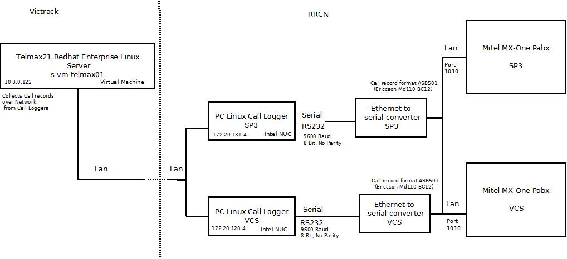

There is a requirement to capture the call record information from the RRCN Mitel PABX’s via the IP Interface on each PABX.

Option 1 – Using Existing Intel NUC Call logging Units

Proposed Setup – Option 1

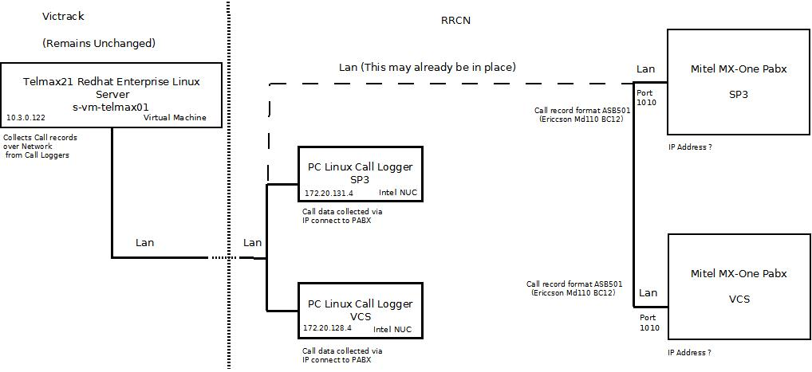

Scope of Work

- Configure and test both Virtual Call Loggers
- Validate cdr processing

Installation

The two existing Intel NUC Call logger units will need to be reconfigured to capture data via an IP connection to the Mitel PABX’s on port 10101.
The raw data will be collected on each call logger and polled from the Telmax21 server which will remain unchanged.

Option 2 – Collect data directly on the Telmax21 server
via Virtual Call Loggers.

Proposed Setup – Option 2

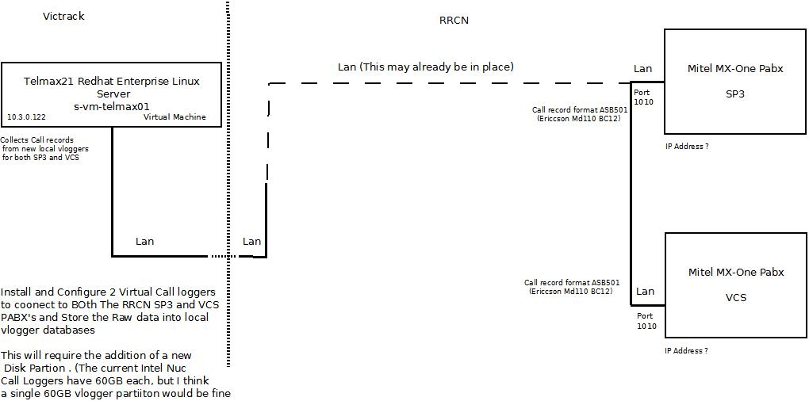

Scope of Work

- Create, Install, Configure and test Virtual Call Loggers
- Validate cdr processing

Installation

Two Virtual Call logger software and licenses, will need to be installed and configured on the Telmax21 Server.

A new 60GB Disk partition will need to be added to the Telmax21 (s-vm-telmax01), to store the Virtual logger data.

The raw data will be collected directly from the Telmax21 server via an IP connection to each Mitel PABX on port 1010. The existing SP3 and VCS Call Logger node entries on the Telmax21 will be re-configured to collect data from the new local virtual call loggers.

Option 3 – Collect data via Virtual Call Loggers on RRCM VM Server

Proposed Setup – Option 3

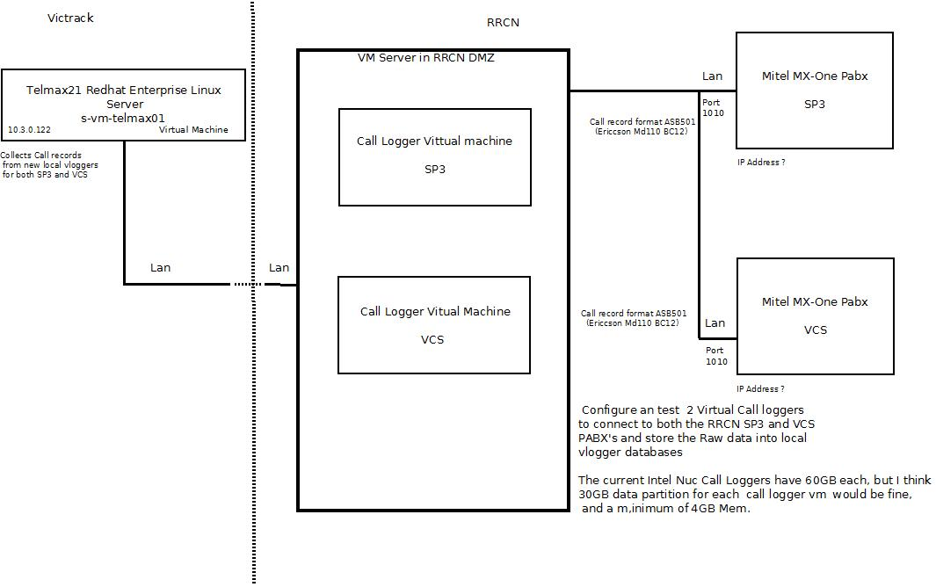

Scope of Work

- Create 2 Call Logger Virtual Appliance for installation on RRCM VM Server in DMZ, Configure and test Virtual Call Loggers
- Validate cdr processing

Installation

Two Virtual Call logger software and licenses, will need to be installed and configured on the RRCM VM Server in DMZ.

A 30 Gig Data part ion will be needed for each VM.

A Minimum of 4 GIG Mem is needed for each VM

The raw data will be collected on the virtual call loggers via an IP connection to each Mitel PABX on port 1010. The existing SP3 and VCS Call Logger node entries on the Telmax21 will be re-configured to collect data from the new local virtual call loggers.

Option 4 – Collect data via RHEL Virtual Call Loggers on RRCM VM Server, then CIS Hardened.

Proposed Setup – Option 4

Scope of Work

- Victrack will create 2 RHEL virtual machine on RRCM VM Server in DMZ
- Transmit will Install, Configure and test Virtual Call Logger software
- Victrack will CIS harden the VMs, Maybe create one Hardened VM and duplicate and rebadge to make the 2nd.
- Validate cdr processing

Installation

Two Virtual Call logger software and licenses, will need to be installed and configured on the RRCM VM Server in DMZ.

A 30 Gig Data part ion will be needed for each VM.

A Minimum of 4 GIG Mem is needed for each VM

The raw data will be collected on the virtual call loggers via an IP connection to each Mitel PABX on port 1010. The existing SP3 and VCS Call Logger node entries on the Telmax21 will be re-configured to collect data from the new local virtual call loggers.

Pricing and Delivery

Option 1

The cost to reconfigure and test the call loggers to capture data via an ip connection to the Mitel PABX’s - assuming the call data records are in ASB501(md110 BC12 format)
2 x 4 hours @ $150 / hr Total: $1200 + GST.

Option 2

The cost to develop new virtual call loggers, assuming Interface is ASB501(md110 BC12 format)
14 hours @ $150 / hr $2100 + GST.

The cost to license, install, configure and test the two virtual call loggers
2 x 3 hours @ $150 / hr

SP3 Virtual Logger $900 + GST.
VCS Virtual Logger $900 + GST.

Total $3900 + GST

Option 3

The cost to develop virtual call loggers appliance, assuming Interface is ASB501(md110 BC12 format)
14 hours @ $150 / hr $2100 + GST.

The cost to license, install, configure and test the two virtual call loggers
2 x 3 hours @ $150 / hr

SP3 Virtual Logger $900 + GST.
VCS Virtual Logger $900 + GST.

Total $3900 + GST

Option

The cost to create the virtual loggers software fro RHEL, assuming Interface is ASB501(md110 BC12 format)
14 hours @ $150 / hr $2100 + GST.

The cost to license, install, configure and test the two virtual call loggers
2 x 3 hours @ $150 / hr

SP3 Virtual Logger $900 + GST.
VCS Virtual Logger $900 + GST.

Total $3900 + GST

Variation

If the call data format or IP communications protocol is different to the existing ASB501 (Md110 BC12) format, and not compatible with any other existing Transmit PABX interface code (i.e. Mitel SS24 or Mitel SX2K - MVoice).

Additional cost to develop a new Interface
10 hours @ $150 / hr $1500 + GST.

Delivery 4-6 weeks after receipt of order - Quotation is valid for 30 days

