Victrack Access

Trans-Mit Pty Ltd
Quotation to collect call records from the Cisco Call Manager system and merge them into the Telmax21
Enhancements

CONTACT: Rod Sheppard
TELEPHONE: 03 8787 8744
EMAIL: rod@transmit.com.au
WEBSITE: www.transmit.com.au ABN:: 12 100 711 957

Project Background

Victrack have implemented the Cisco Call Manager (C.M.) VoIP System. There is a requirement to be able to capture the call record information and produce reports on the VOIP phones the same as the existing telephones.

To achieve this, the Telmax21 has been upgraded to include the software interface module that communicates with the Call Manager server to receive and process the call records.

An additional requirement is now needed to retrieve the Cisco CDR from an intermediate system, rather than the Cisco C.M. sending the calls directly to the Telmax21 (via ftp/sftp)

Modification to this software, (and other modules), is also required to include enhancements to the processing of the Cisco C.M. data.

Scope of Work

Part A

- Due to Fire walling issues, modifications to the Telmax21 Cisco module is required to pickup the cdr from another system, this must be implemented for any of the enhancement in PART B to be possible.
Develop, install and test a new software enhancement to the Telmax21 Cisco Module to collect the CDR files from an intermediate system.
Liaison with the Call Manager Administrator to setup and test the transfer of the call records from the Call Manager to the Telmax21 server
It is a requirement that the files can be retrieved via ftp or scp or smb client transfer, and the Telmax21 has access to either move or delete these files once retrieved

Scope of Work (cont.)

Part B
- Additional requirements have been established to import into the Telmax21 Directory, including the Web based Operator Directory21 following fields.

MAC Address
IP Address
Subscription
Telephone Equipment Code
Phone Contract – (leased/bought outright)
Phone Type
Instrumnet

(Subscription Fields will be added during this work, as long as the size requirements can be established)..
- It is a requirement that the MAC address be stored in the Telmax21. Mac will be recorded against date/time/phone number in a new table. This information would then be accessed from the Telmax21 Forms.

- Modifications to the Bilmax21 to create separate call (c9_.. and rent (r9_..), and Switchboard (r9) for the Cisco Call Manager data, and also exclude the CISCO from the existing Voicemail (v9_..) data.

- Modifications to the Preprocessor to import separate call (c9_.. and rent (r9_..), and Switchboard (r9) for the Cisco Call Manager data, and also allow for the non-existant Cisco Voicemail (v9_..) data, This inckudes allowing for new batch types/ Report Typs for the Cisco CUCM data.

- Create a catwarn “polling alert” for “No Data” and “Polling Failed” and also modify the polling module to create a catwarn for no (zero) calls polled.

- Generate an email if there is a polling alert and automatically log it into VQSM

- A requirement to create a file (llssc) for Import into ISDN
- A requirement to have A Call Type for Cisco CDR Video Conference Records.

- Develop, install and test the new software enhancements.

Scope of Work (cont.)

Part C
- Modifications to the Preprocessor to import separate call (c9_.. and rent (r9_..), and Switchboard (r9) for the Cisco Call Manager data, and also allow for the non-existant Cisco Voicemail (v9_..) data, This includes allowing for new batch types, Report Types and Import Menu Options for the Cisco CUCM data.

- Pricing code for the CUCM rent (R9) data will also be required

- Develop, and test the new preprocessor software enhancements.

Part D
- A separate quote to import the subscription and TEC/RSC/RSC, email, and name information etc. will be provided when information becomes available.
- A separate quote for the Separate Video Conferencing System will be provided when information becomes available. As data will not be supplied from the separate Video Conferencing Systems, it will involve customised handling of records from the Cisco CDR on a particular gateway(s) to the Video Conferencing System.
- A separate quote for a new Report required in the Bilmax21 to match the invoice generated by TBIMS. When details have been finalised. It should be noted here that if Options 2 or 3 for the new report format is chosen then changes to the content of the C9, S9 Cisco format will also be requierd.

For further details, please refer to Appendix A,
(Automatic Unified Comms V8 doc)

Installation

The raw data is sent by the Cisco C.M. to an intermediate system,
An additional module will be installed on the Telmax21 to collect the
CDR files from this system, in place of them being directly sent to the Telmax21 by the Cisco C.M.

The Telmax21 Directory Maintenance and Directory 21 Software will be replaced with new versions. The existing Telmax21 Cisco module will be modified to extract and store MAC address against Telephone number, which will then be updated daily into the Telmax21 Directory. The Bilmax21 modules will be modified
The Polling module will be modified. The catwarn module will be modified.

Pricing and Delivery

Part A
The cost to develop, install and test the enhancement to the Telmax21 Cisco C.M. Module would be

$475 + GST.

PART B

The cost develop, install and test the Telmax21 and Bilmax21 Enhancements for Cico Vpip procesasing would be
$5400+ GST.

PART C

The cost develop, install and test the Preprocessor Enhancements for Cico Vpip procesasing would be
$1350 + GST.

Delivery 6-8 weeks after receipt of order - Quotation is valid for 30 days

Appendix A – From Automatic Unified Comms V8 doc

UNIFIED COMMUNICATION

Unified Communications has three components to the billing. There is Calls, Rental for Capability Bundles and possibly handset once-off, rental or no handset to consider in the modeling of the invoice process. The existing batchtype “Rental and Calls” only has Rental and Calls.

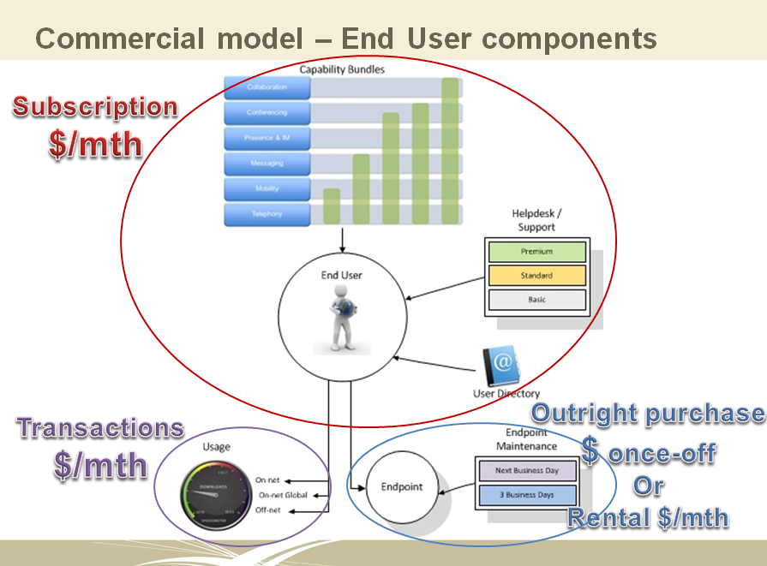

The import process and its interface to the billing functions are listed below. It has allowed for the second import for UC phones. Two batch imports means two different reports can be applied.
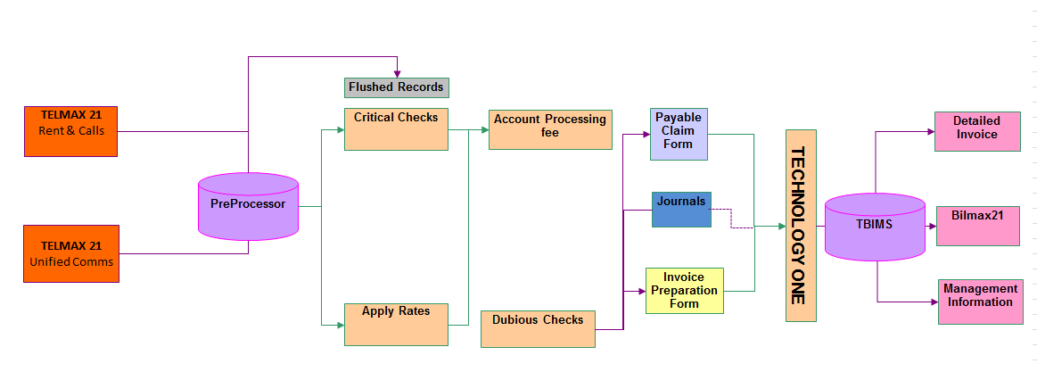

Billing Modification
This is specifically written for the billing team and the developers so the terminology used is geared to their understanding. The solution is my initial thoughts and I am expecting this to change once I have consulted with the David Wells, Billing Team Members and the developer.

The Telmax21 System has a module for the Cisco Unified Call Manager. (v 3 thru V8.x). This work has already been configured and only the collection of live data and testing is outstanding.

List of Activities and involved in import and reporting for the implementation of Unified Comms, of which the BSS supporting suppliers will need to provide that functionality.

2.1 Craig Halliday, MDB Consulting
- Add new invoicing report Need to decide what this new report would look like.

If we use an existing format then this will not cost anything. I have included a sample bill below for the recurring amounts.

The Front page shows the Batchtype name e.g. VicTrack Rent and Calls.

The second image is the Summary records, which shows the fields – Serviceid, Location, User, Cost Centre Ref., Rental, Calls, Other, Admin, Total

EXISTING INVOICE AND BILMAX FORMAT
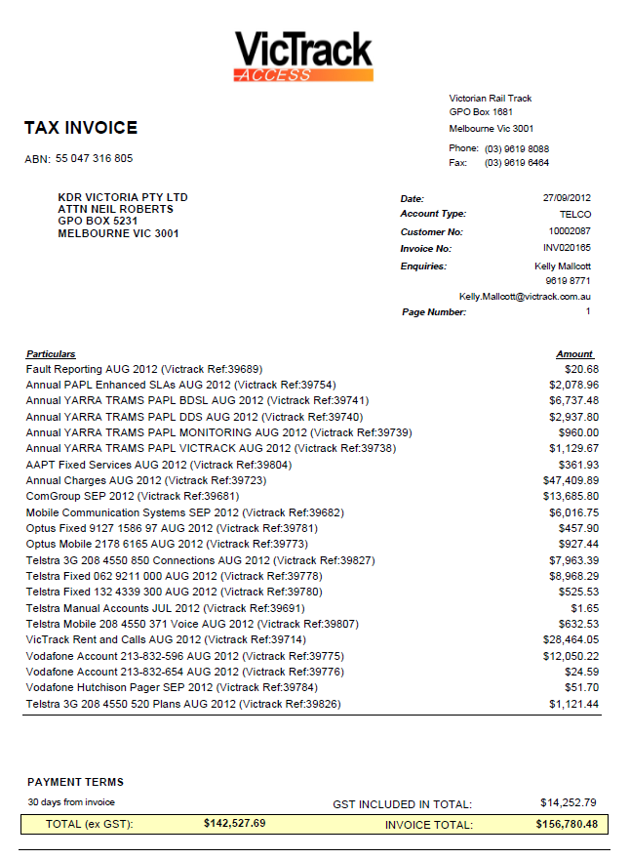
Existing Front Page of invoice

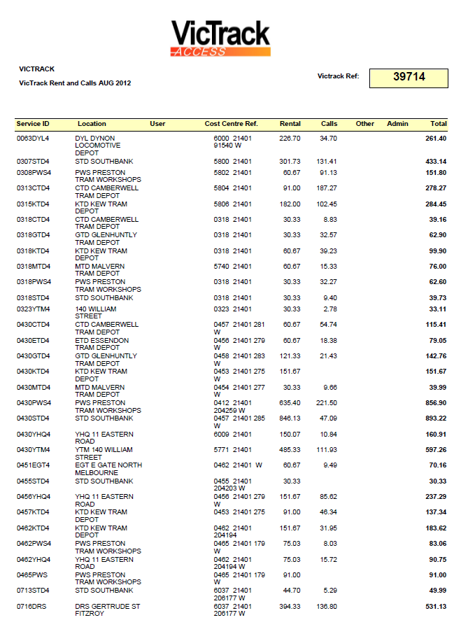
Existing Invoice Detail format

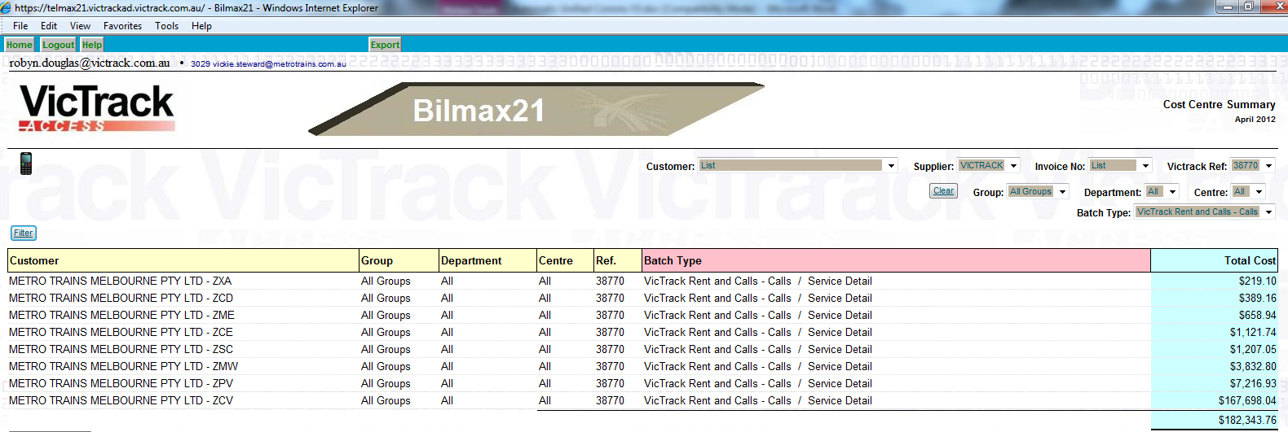
Existing Bilmax Cost Centre Summary (allows customer to see multiple shiptos across multiple invoices to see total costs for a single item type.

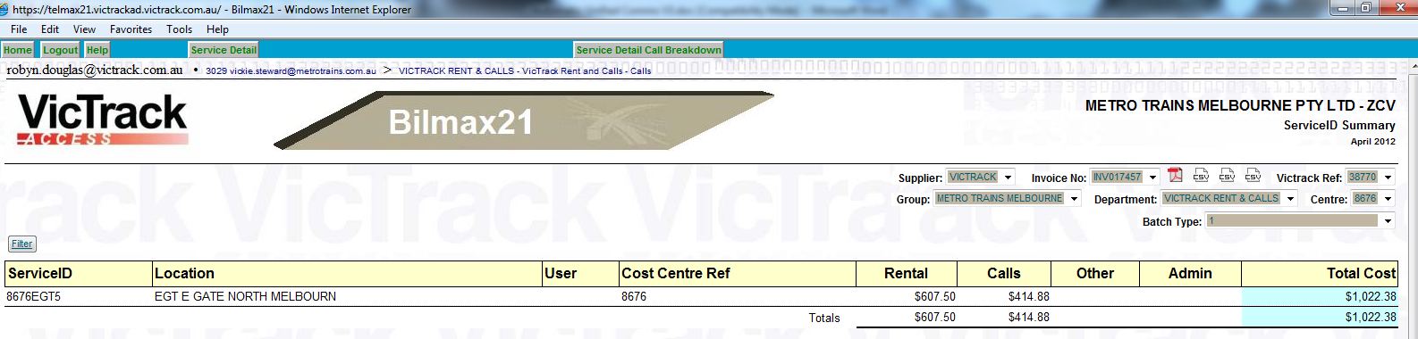
Existing Bilmax ServiceID Summary Report

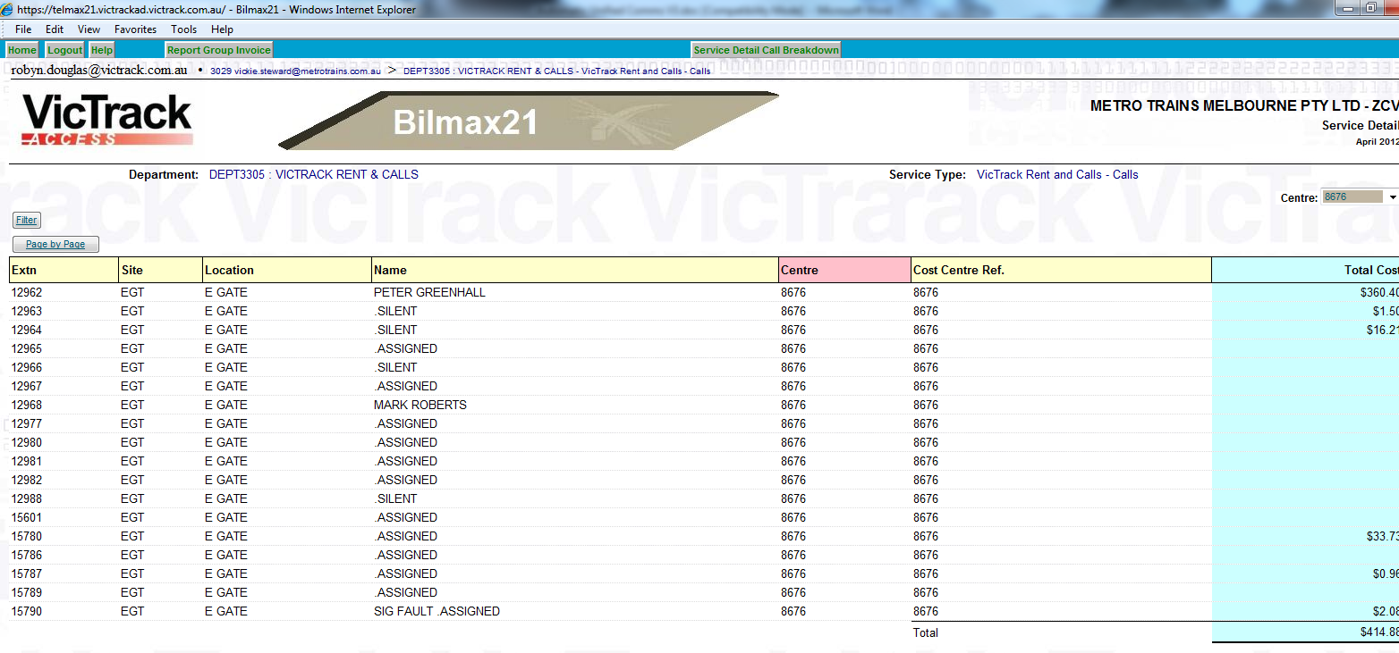
Existing Bilmax ServiceID Detail Call Breakdown

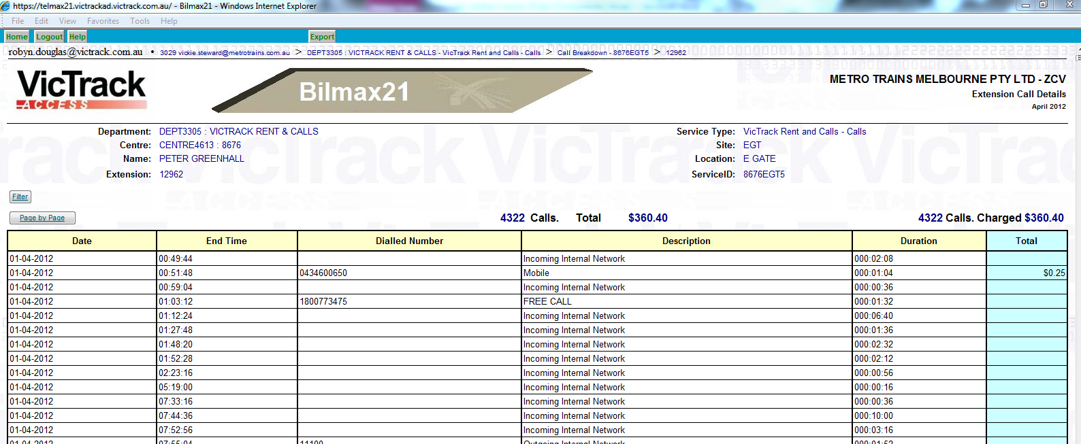
Existing Bilmax Extension Call Detail report

SUGGESTED INVOICE AND BILMAX FORMAT

No change to the front page but the VicTrack Rental and Calls should be modified to remove surplus fields.
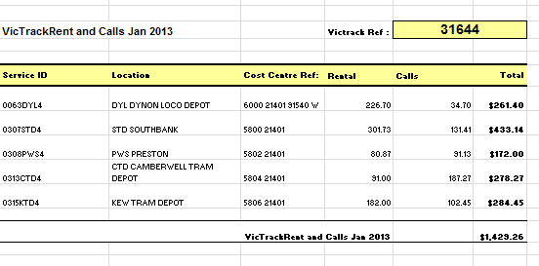
Suggested new Front Page
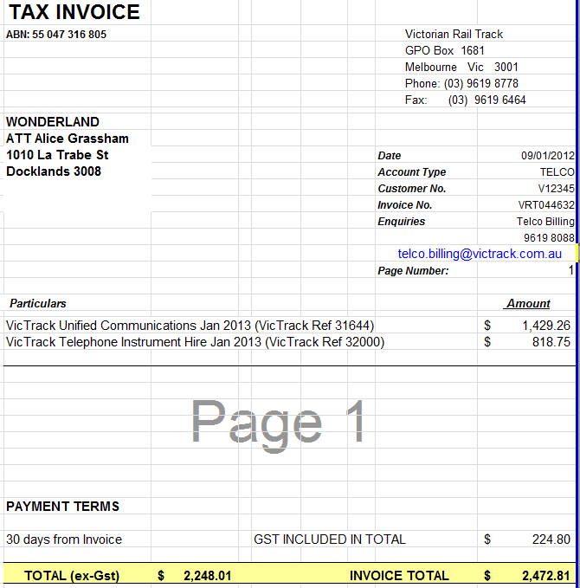
Suggested Detail format – Option 1

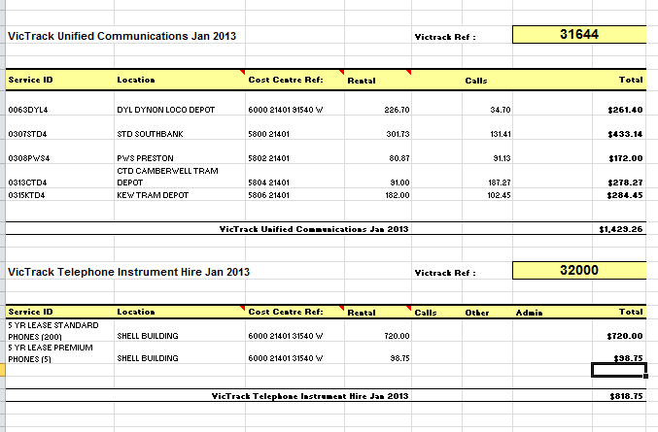

Suggested Detail Format – Option 2
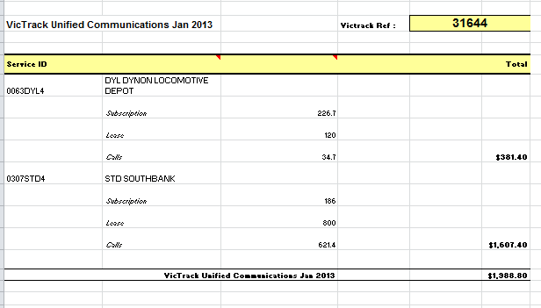
Suggested Detail Format – Option 3

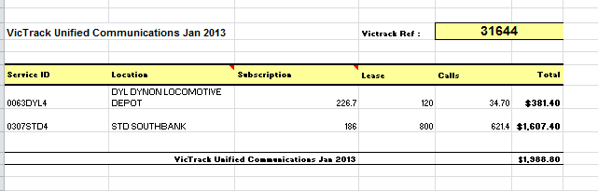

2.2 Ron Cranston, Trans-Mit
- Import Function –. The import process will need to be modified to allow a second import from the same source.
- If Option 2 reporting is accepted by Sales then the TEC and SFC will need to be imported into the var fields so that the type of Subscription and Phone Type can be displayed as a summary record against each ServiceID (extn group).
- Ignore the missing V9. There is a new file name format for the Cisco R9 and C9. c9ccm_MMYYYY.txt (Call Record froM The Cisco Unified Call Manager)
r9ccm_MMYYYY.txt (TEC values for extension with the CIsco site)
s9ccm_MMYYYY.txt

11911 = Incorrect Number
11966 = Threatening Calls

O/S what about switchboard?
(ie. OPASSISTDIALNUMS="'11900', '11911', '11912', '11914', '11918', '11921', '11922', '11924', '11966', '19024', '19000', '11111', '999'"
- except for PAR Div UNA, TLM, and siteid 201)

Num | Name
11100 | VT Fault Centre
11102 | Spare Queue 1
11105 | Kamco
11106 | Smartbus
11109 | VT Security Service
11111 | VT Call Centre Ex
11900 | VT Call Centre In
11912 | Lvl 8 Foyer Phone
11914 | Country Level Cross
11915 | Light & Power Faults
11918 | RM
11920 | VT Cable Location
11921 | Motorola
11924 | Gemco Rail
11929 | VLine WAN Faults
11933 | Connex WAN Faults
11936 | Enviro & Sustain
11941 | DTRS Help Desk
11949 | Mainco WAN Faults
11960 | LASP LIFT
11977 | Mainco
11989 | GlenWaverley project

2.3 Rod Sheppard, Trans-Mit
- Project has paid for the implementation of the Call logging interfacing and capturing of data from the Call Manager.

2.4 The additional work required by Trans-Mit falls into updating of Directory21, ISDN List Len, File Transfer, Calculation of combined phone and subscription, Batch/Monthly Import File Generation, TP Video Conferencing and Bilmax Report.

Additional work that will need to be done on the Telmax21 is:-

CALCULATION OF COMBINED PHONE LIST AND SUBSCRIPTION
- T value for the combined phone type and subscription David Wells still to advise how we are going to update RSC and SFC
- Rod to calculate the RSC and SFC (Subscription) with David Well’s assistance.
- David Wells to indicate fields for subscription calculation by TransMit
- Phone type to be supplied by David Wells with MAC address which TransMit will import to the Directory21 and use as lookup for TEC value
- David Wells needs to provide Rod Sheppard two lists. One is a list of handsets, mac address and some fixed numbers. Second list is the subscription list. As the TEC is a combination of phone type and subscription Rod will need both bits of information.
- Adam Fry to define the phone models which qualify for Gold, Premium and Platinum
- A new table needs to be added as a phone lookup with model, type and active fields
- Confirm with Adam Fry that the final subscription at the end of the month will be invoiced for the entire month.

ISDN IMPORT FILE
- Rod needs to provide a file which has the extension, TEC, RSC, SFC populated and a pseudo len number generated. I will supply a format which you need to include all column headings but only populate the fields indicated above.
- This file needs to be emailed to me
- There needs to be a procedure put into place to save the file as xls extension as the Telmax can only generate the file as a csv format.

UPDATING DIRECTORY21
As these new fields will be updated automatically they will not be visible in the directory maintenance screens. The will only appear in the Directory21. The only new field in Directory maintenance will be the instrument field.
- Add modification to correct Subscription information
- Allocate new fields in Telmax Directory21 for UC instrument, MAC address and subscription description against extension number and automatic updating.
- Add a new field for instrument updatable by users to indicate if phone is leased or brought outright.
- Update TEC field with TEC, RSC and SFC.
- As data collection is common there should be only one Site in Telmax for UCP
- David Wells to provide CMR specification
- Automatic directory updates from the AD information if we get email, subscriber name. This is still to be defined. More discussion required. Telmax requires unique join field which needs to be identified. Email address is the suggestion.
- Phones which are pool phones for Premise Mobility are assigned virtual phone numbers when no-one has logged onto them. These need to be included in the directory. Spare pool numbers will be programmed internal and dial 000 only and should belong to the same extension group and only be an expense to the system expenses.

BATCH/MONTHLY IMPORT FILE GENERATION
- Separate R9, S9 and C9 to exclude Cisco from NEAX data. No files for V9 Voicemail.
- Create a polling alert for “No Data” and “Polling Failed” for zero calls
- Generate an email if there is a polling alert and automatically log it into VQSM
- Modify the batch program to request the month’s data and produce two folders with the original PABX R9, C9 S9 and V9 files, then in the other folder include the CCM_C9, CCM_C9 AND CCM_S9 – no CCM_V9 required.
- Polling to be configured for 30 minutes polls in the Cisco call manager
- Include all the new UC call traffic feature e.g. Video conferencing David Wells needs to advise us if the UC video conferencing has a characteristic or a flag indicating that it is a video call.
- Extract Subscription from CMR/CDR and combine with phone Type to provide TEC value. This needs to be automated by Trans-Mit (duplicate)
- Storage of the mac address will need to be included in the call data records. Rod will put this data into the account number field. Rod will record the date, time, extenstion and mac address in a table which will record the multiple changing if the extension changes against the mac address in the one day.

TP VIDEO CONFERENCING
- TP Video Conferencing not including presently as it indicates CDR which is not defined.
As TP will no supply CDR the configuration would normally for the Routes/Trunks would be a Tributary Route. Tributaries have their own reporting which is not one Extension Group summary format used for billing. Rod is able to modify the call traffic to reflect real calls.
- David Wells needs to tell us if there is a relationship between ports and extensions.

BILMAX REPORT
- Bilmax report to match the invoice generated by TBIMS

FILE TRANSFER
- Due to VicTrack’s security requirement, Rod will need to quote for the moving of files from a nominated drive to the Telmax. An additional quotation is required for this part.

2.4 VicTrack IT
- The module will be installed onto the new VMWare Telmax21 system with disk space for the virtual logger to be allocated in the database partition, an additional 20 Gig of disk space should be added, (mounted) to store the Cisco Raw data, and processed calls.

Application Affected
- Newpp
- TBIMS
- Telmax21
- Bilmax21

Unified Communication Products

End User Subscription – bundle Pricing
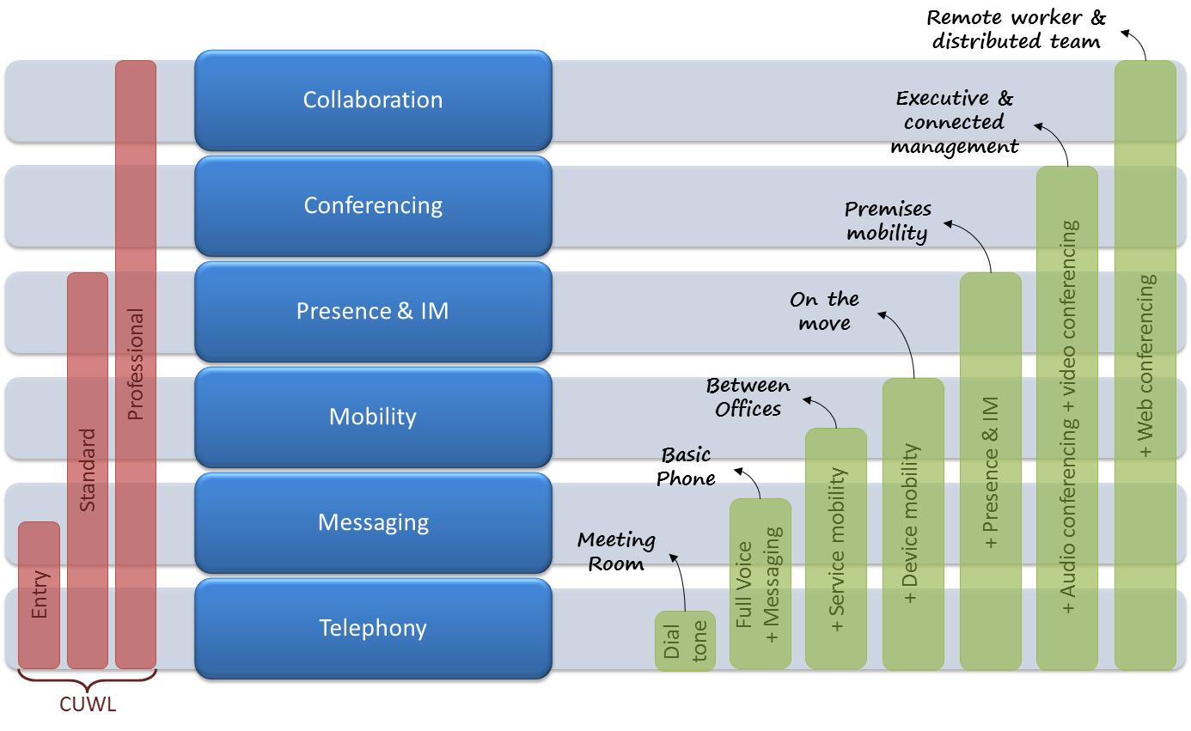

Definitions of those subscriber bundles is:
Basic Phone is Basic Telephony features and Voicemail and directories
On the Move is device mobility and extends UC capability out to mobile devices (phone and tablet), soft phone capability.
Desktop Integration adds presence and IM capability, client software. This is using communicator and instant messaging.
Conference and Collaboration adds Meeting Place Software and desktop video and audio conferencing
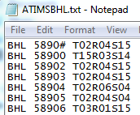

Determining the rent amount
List Len Dumps from the PABX
Import List len into ISDN program
Export ATIMS file to file directory E:\ISDN\ATIMS
Schedule task on Telmax to update TEC field from ATIMS file
Directory field TEC is updated with a concatenation of three values TEC, RSC and SFC.
This

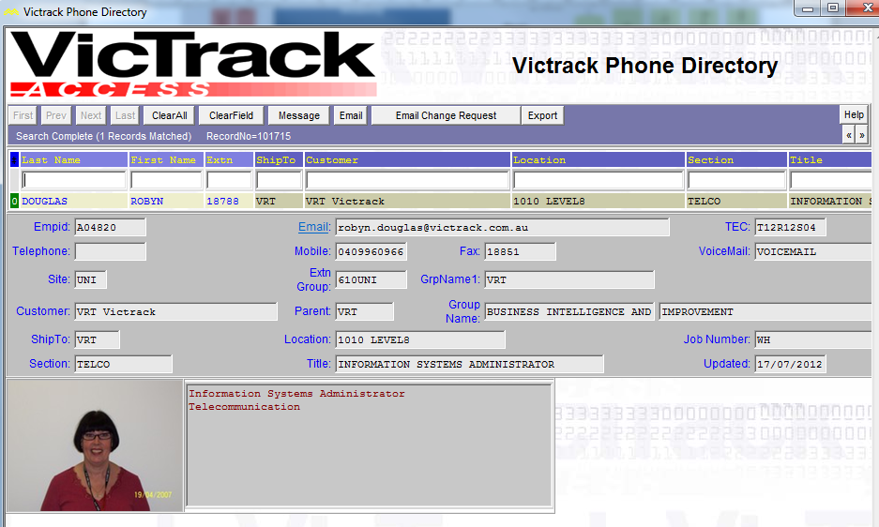

The existing TEC values used are:
TEC
0 | UNKNOWN
1 | PULSE
2 | TONE
3 | PULSE / TONE
12 | D-TERM
13 | D-TERM DATA
14 | HOTLINE
15 | 120 D-TERM
16 | DATA MODULE
18 | VIRTUAL
22 | EMULATOR
50 | Basic Phone Subscription and Analogue Phone
51 | Basic Phone Subscription and Gold Class Phone
52 | Basic Phone Subscription and Premium Class Phone
53 | Basic Phone Subscription and Platinum Class Phone
54 | On the Move Subscription and Gold Class Phone
55 | On the Move Subscription and Premium Class Phone
56 | On the Move Subscription and Platinum Class Phone
57 | Desktop Integration Subscription and Gold Class Phone
58 | Desktop Integration Subscription and Premium Class Phone
59 | Desktop Integration Subscription and Platinum Class Phone
60 | Conference & Collaboration and Gold Class Phone
61 | Conference & Collaboration and Premium Class Phone
62 | Conference & Collaboration and Platinum Class Phone
63 | Basic Phone Subscription
64 | On the Move Subscription
65 | Desktop Integration Subscription
66 | Conference & Collaboration Subscription
67 | Analogue Phone
68 | Gold Class Phone
69 | Premium Class Phone
70 | Platinum Class Phone
71 | Conference Phone
72
73
74
RSC
0 | UNKNOWN
1 | INTERNATIONAL / UNRESTRICTED
2 | STD AUSTRALIA WIDE / NON RESTRICTED 1
3 | STD VICTORIA ONLY / NON RESTRICTED 2
4 | LOCAL & MOBILE CALLS / SEMI RESTRICTED 1
5 | INTERNAL & LOCAL CALLS / SEMI RESTRICTED 2
6 | INTERNAL & EMERGENCY CALLS / RESTRICTED 1
11 | BUSIED OUT / RESTRICTED 2
12 | STD AUS WIDE *961/ FULLY RESTRICTED
SFC
0 | UNKNOWN
1 | UNKNOWN
4 | STANDARD PHONE
7 | RESTRICTED
8 | CALL WAITING
9 | SECURITY PIN
12 | VRT FEATURE
13 | POST PHONE
15 | 120 EXHANGE

The Product Manager believes that due to the mobility of the instruments that billing will be a bulk amount. This will use the “Recurring” batch type and appear under a separate batch type heading but on the same invoice.

Alternatively, Product Manager suggested that the Subscriber and phone model would be added to Call Manager as a combined subscription.

David Wells has proposed that where we provide a combined cost of Subscription and Instrument that we predefine which instrument are available and they are classified as High, Medium and Low. Also conference and analogue handsets need to be included in the classification. Outstanding for Adam to define the instrument for these classifications. Clarification is required regarding the following statements – All users get an ear piece. How do we deal with Executive ear pieces?

To minimised the development the thought is that the subscription description will be added into the directory page into a spare field of the web directory but for billing purposes will be converted into a numeric TEC value. This would minimise the work required in modify NewPP Import functionality. We may need additional data extracted from the import data but we do not have any samples presently.

BatchtypeID:

This will be an automatic batch type, which will have the Add transaction button available for once off occasions. It will have same program type as Telmax Rent and Calls. The batch will be included under the "Import Data Automatic" data input group and will import a separate set of files to be included in the invoice.

Revenue Batchtype ID is 664
The batch name is “VicTrack Unified Communications”, which will appear on the Invoice.

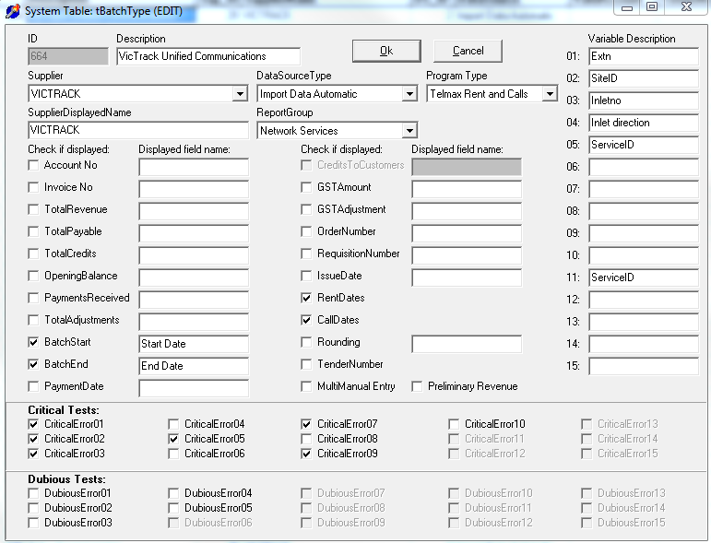
Note: The variable fields are presently populated in Var01 –Var15. Existing fields collected are extn, siteid, inletno, inlet direction and serviceid (extension group). The possible fields may be username…

SystemID: The systemID will join together the various Service Types belonging to this batchtype, so that there can be a varied price for different customers.

Revenue system ID is 760

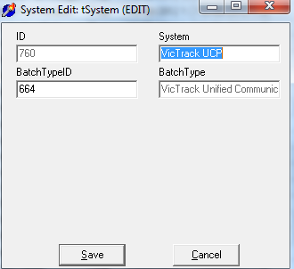

ServiceType: Service types are not determined yet as David and Adam need to define the subscriptions and features, then a numeric TEC value assigned.

SupplierID: VicTrack is the supplier for Unified Communications
Application: The application has been added as Unified Communications Services so that any billing can extract all Unified Communications ServiceIDs in one extraction.
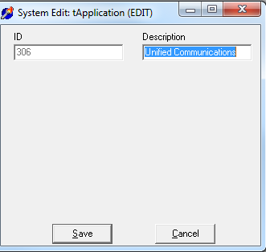
Person: Not populated yet.
ServiceID: The ServiceID naming convention should ???
Subledger No need to create a subledger for revenue as this new product will have a new revenue natural account (or element)
StatusID Leave empty
CustomerID PP will allow for multiple customers and independent pricing for the Base Package or a variation of the Base Package, by simply creating a separate service type.
BillingPeriod From billing period control eg 2012/10

BatchStartDate Default to first of month for Billing Period eg 1/10/2012.
BatchEndDate Default to last of month for Billing Period eg 31/10/2012.

DataCollectionDetail
The data collection will be populated as follows:
SequenceNo Generated by the extract routine
ServiceID Supplied in the Telmax file
TxnDate Supplied in the Telmax file
TxnTime Supplied in the Telmax file
Origin Supplied in the Telmax file
Destination Supplied in the Telmax file
Duration Supplied in the Telmax file
Callcode Supplied in the Telmax file
RateDescription Supplied in the Telmax file
DialledNumber Supplied in the Telmax file
GSTFlag In all imports where VRT is the supplier, the GST flag should be set to N when the customer is also VRT and Y otherwise.
AmountExGST The calculated rate from tRates table for the appropriate ServiceType.
GSTAmount will need to be calculated
AmountIncGST will need to be calculated
FromDate Supplied in the Telmax file

ToDate Supplied in the Telmax file
Transaction Type ???
Var01 Extn
Var02 SiteID
Var03 Inletno
Var04 Inlet direction
Var05 ServiceID
Var06 Leave blank
Var07 Leave blank
Var08 Leave blank
Var09 Leave blank
Var10 Leave blank
Var11 ServiceID
Var12 Leave blank
Var13 Leave blank
Var14 Leave blank
Var15 Leave blank

Trates The rates table will hold the base values so that these values can be varied over time.

Critical Error 1 If the initiation finds the ServiceID is unknown - included
Critical Error 2 Additional Service - included
Critical Error 3 Omitted Service - included
Critical Error 4 Unexpected Calls - included
Critical Error 5 Valid Split Service - included
Critical Error 6 System Reference Correct - included
Critical Error 7 If the existing ServiceID or Service is terminated - included
Critical Error 8 Incomplete Quetzal data - not included
Critical Error 9 Extra Split Service - included
Critical Error10 Customer centre unallocated - not included

TELMAX21

The Telmax21 System has a module for the Cisco Unified Call Manager. (v 3 thru V8.x). With the Unified Call Manager, call data is not polled by the billing system, instead it is pushed to the billing system by the C.M using FTP or SFTP. To maintain a consistent interface to the Telmax21 data collection system, we have implemented the concept of a virtual Call logger with the Telmax21 server. The raw data sent by the C.M is stored on the Telmax21 and can be polled/re-polled and processed as with any other external call logger. The module will be installed onto the new VM Ware Telmax21 system with disk space for the virtual logger to be allocated in the database partition, an additional 20 Gig of disk space should be added, (mounted) to store the Cisco Raw data, and processed calls is recommended. The installation will include the configuration changes required to the Telmax21 Routes G/W and Directory.

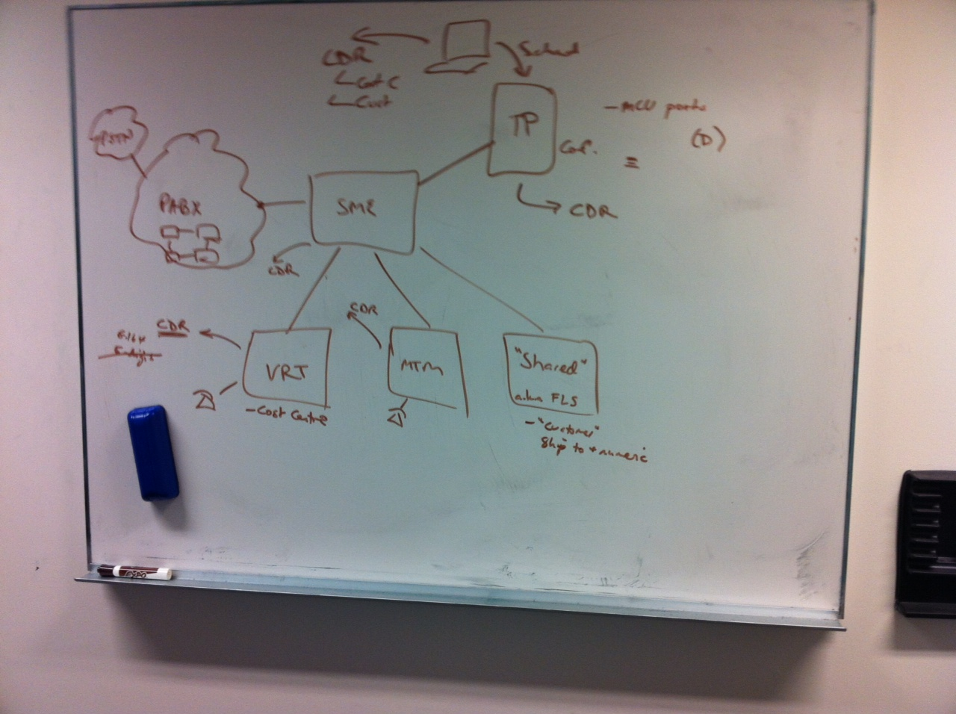

TP Video conference facility is using external capability phone numbers 10250-10299 it interfaces to UC and will not be invoiced by any transaction data. Ports will be assigned to customers and will be invoiced accordingly as a recurring cost.

David Wells has provided a drawing showing the interface to existing PABX network. This shows that there is a SME (Transit site) that calls transit through from one customer to another. Please note that there is a Shared site for the smaller customers. Also there is a platform for the Video conference facility. Unsure presently, about the capture of data, data format, reporting and billing requirements for this service.

David has indicated that the inletno, outletno and dialledno if an internal extension will be shown in the CDR as the full number e.g. 96198788 as this is what is recorded in Active Directory.

Phones are not tied to a person so if we are leasing then the customer must tell us where the instrument is.

DATA COLLECTION AND FILE TRANSFER
