Curtin University

Trans-Mit Pty Ltd

Quotation to include Mobile call Importing, Administration, and Reporting Module into the Bilmax21

Contact : Rod Sheppard

Telephone : 03 9574 8956

email : rod@transmit.com.au

website : www.transmit.com.au

Project Background

Curtin University are seeking additional reporting features in the Bilmax21 to provide Mobile call importing, Management and Web Reporting, including personal reporting and call cost recovery. Those staff who are issued with a mobile phone are required to pay for calls that are deemed to be of a personnel or private nature rather than work related.
Scope of Work
To provide a software package that is able track, manage and cost recover private use for Curtin Universities mobile phones with the minium of management overhead.
The following key tasks will be undertaken.

- Integrate existing Curtin University Bilmax21 Customisations into the Current Bilmax 21 Software, thus providing the new features as described above.. .

- Load and configure the new Bilmax21 including the Mobile module, Management Reports and YTD onto the Telmax21 server... This would include any cosmetic changes including logo and column heading names.

- Configuration of the mobile details into the Bilmax21 database from information provided by Curtin University.

- Set-up of the integration with Curtin Active Directory to Provide personal Mobile Users access to Bilmax21 Login.

- Users are to authenticate against the Active Directory when logging on to view their reports

- Addition features descrived below.

Minimum feature set is,
- The ability to record the details of each mobile phone including, make, model, SIM and IMEI codes, date purchased, contract start and end dates, puk code etc
- The individual mobile owners to only have access to reports on their own mobile
- A method that easily allows users to check for and identify private use calls
- Managers to have access to all the phones allocated to their departments.
- The ability for the Administrator to upload Optus mobile phone data.

Solution

In response to the above Scope of Works Trans-Mit are pleased to propose the following solution for consideration by Curtin University.
The Bilmax21 web based reporting suite that forms part of the Telmax21 has the ability to take in external billing data for services such as mobile phones and produce integrated reports The cost of mobile phones now accounts for a significant part of an organisations telecommunication costs.
Whilst most of the key suppliers of mobile services offer some form of electronic bill they are unable to provide a consolidated cost report of all the services a organistion may wish to provide to their management team. Using the electronic bill from the carrier this is imported into the Telmax21 database including the call details
The Mobile 21 module facilitates the importing process, a number of checks are conducted to validate the data..
The Bilmax21 provides users with a set of consolidated reports specific to their area of responsibility. The reports are accessed using Internet Explorer from the users desktop and provide,

- Details on both outgoing and incoming calls
- Summary and detail level information
- Dynamic sort and filtering features
- Graphical representation
- Services from different suppliers in the one set of reports

In additions to the reporting features the Bilmax21 can provide

- Validation of key parameters in the carrier bills
- Asset management and tracking
- Identification of personnel use calls

By investing in the Bilmax21 Curtin University will have full ownership and control of a single reporting system. This provides independence from changes to carriers and suppliers that can affect the continuity of reporting.

Integration with existing Bilmax21 cost centre reports

The mobile calls and charges will appear as an other service type in the Bilmax21 like the existing service types and possible other imports in the future as per example below

Service Type | Project | Description | Total Cost
Equipment and Service Charges (8024) | 00000 | INFORMATION TECHNOLOGY DIRECTOR | $43.40
Fixed Line Call Charges (8023) / Call Breakdown | 00000 | INFORMATION TECHNOLOGY DIRECTOR | $11.09
Mobile Calls and Charges (XXXX) | 00000 | INFORMATION TECHNOLOGY DIRECTOR | $150.35
Miscellaneous Charges | 00000 | INFORMATION TECHNOLOGY DIRECTOR | $25.00
Desktop SMS | 00000 | INFORMATION TECHNOLOGY DIRECTOR | $2.50
Remedy Service and Support | 00000 | INFORMATION TECHNOLOGY DIRECTOR | $161.50
Data/Internet usage | 00000 | INFORMATION TECHNOLOGY DIRECTOR | $45.00
 |  | Total | $438.84

Whilst retaining the core Telmax21 and Bilmax21 functionality already in place it is proposed to load and configure the new services module and run the Mobile21 configuration application.
As you will see from Fig.1 the services module is a web based configuration screen which integrates with the existing Telmax21 database structure.
The administrator creates a record for each mobile phone and can then assign it to either a person or group. There are certain fields that are mandatory.
The mandatory information is then used during the importing process to verify against the carrier billing data and in the Bilmax21 reports to display information about the owner and phone.
The Bilmax21 detailed mobile phone report has a feature that allows individual calls to be tagged as being private use. By applying a filter it will hide the non private calls and only display the private use ones with a total. This can then be printed and used as record when paying the amount owing to the cashier.
The mobile reports will be made available on a monthly basis the same as the other Bilmax21 reports. The frequency of the private use payments may vary from user to user and could be monthly, quarterly or six monthly, the repayment process and frequency is this independent of the report generation.

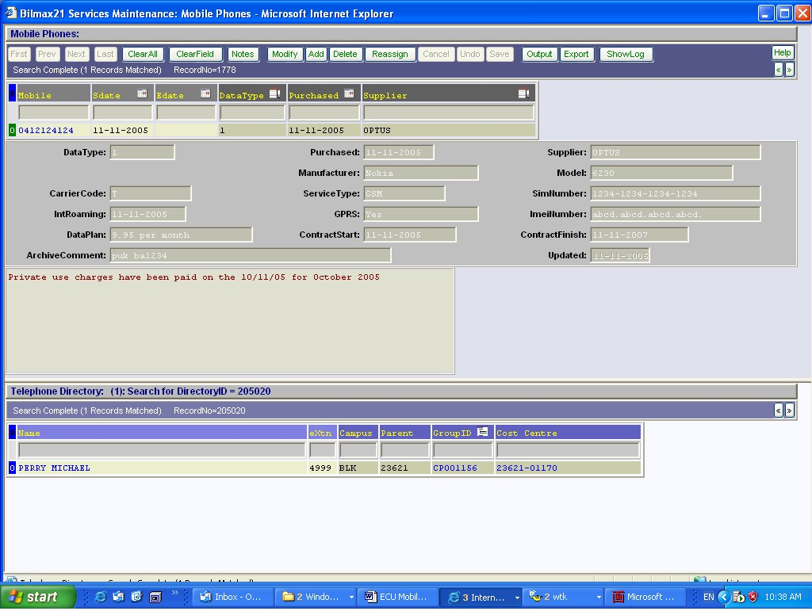
Mobile services data input and search screen
Fig. 1

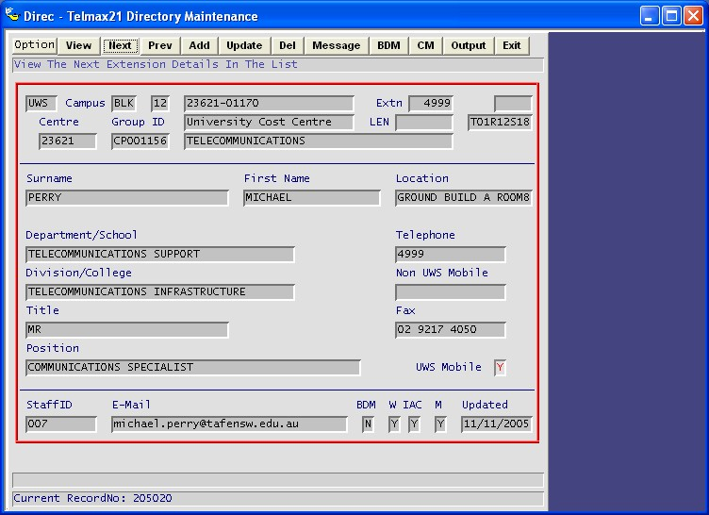
Telmax21 Directory Maintenance Screen which links to Mobile21 services
Fig. 2

Data Importing

The importing of supplier data is done using the screen in Fig 3 the data is normally supplied on CD or downloaded from the supplier’s web site through a login process. In either case providing you can browse to the CD or the downloaded file you will be able to import the data.
The importing program verifies the data against set parameters and the details contained in the services reference tables in Fig 1 If there are any errors detected, the administrator will be notified, and depending on the error a re-verify of the data can be carried out.

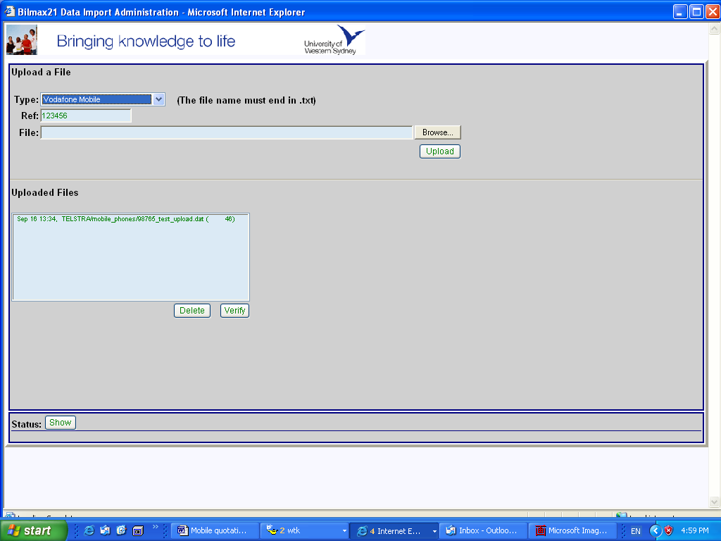
Data Importing Screen
Fig. 3

Bilmax21 Web Based Reports
The Bilmax21 has been designed to take billing information for multiple sources and merge it into a single dynamic reporting suite Fig. 4 shows a summary level report with three services.
You simply drill to the lower level reports by clicking on the links until you reach the detail level as shown in Fig. 5.
The individual mobile phone owners will only have access to view the mobile phones assigned to them by the administrator.

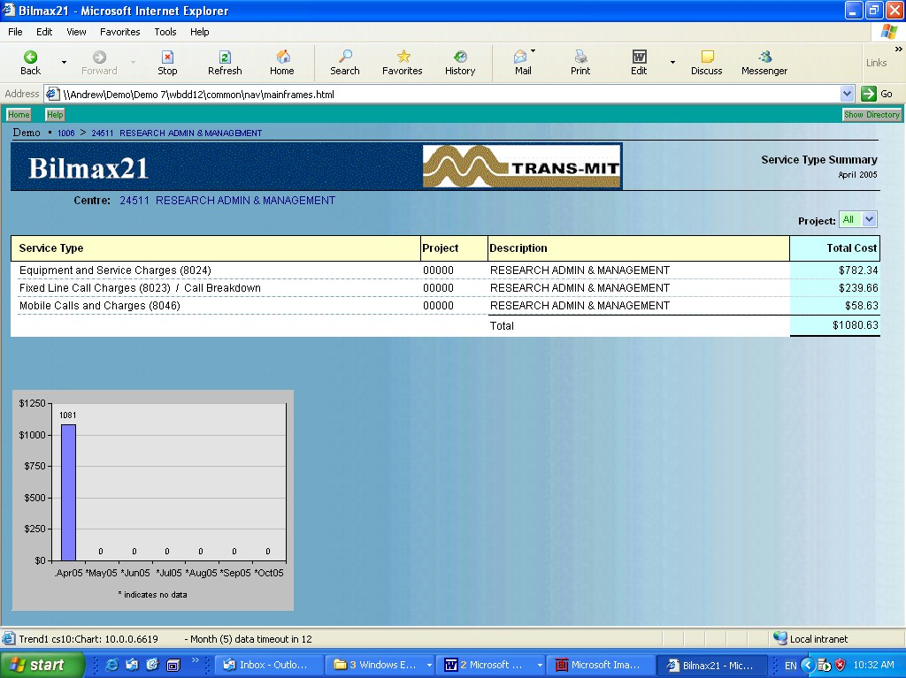
Bilmax21 web based report summary report with multiple services
Fig. 4
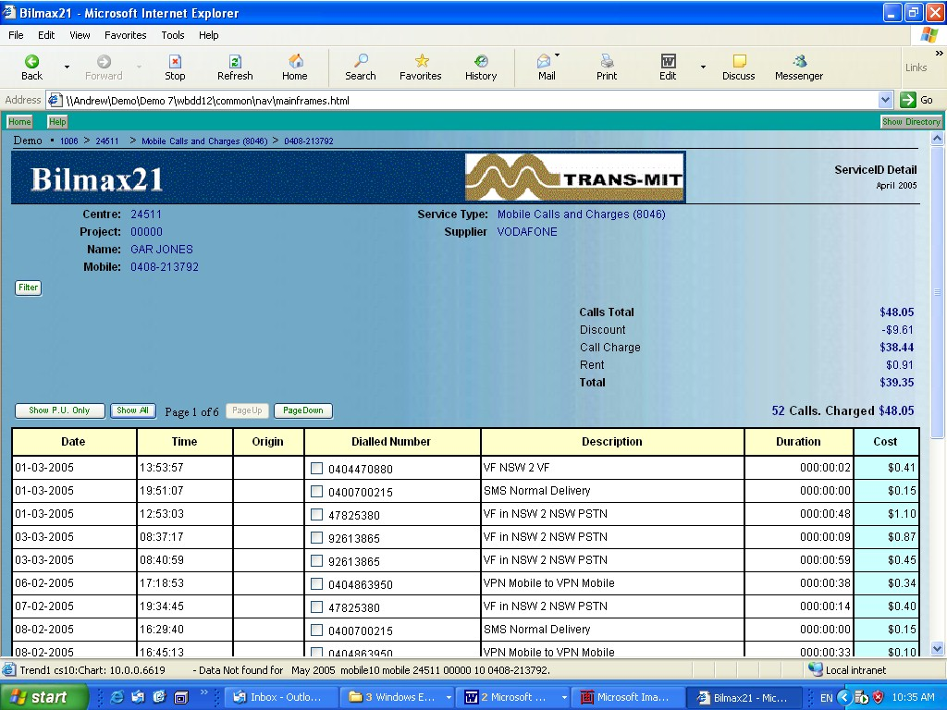
Bilmax21 report showing detailed mobile phone
Fig. 5

Addition features

  - Automated daily import into the Telmax21 Directory from provided csv data.
  - Report on Mobile Personal vs. Business usage for previous months to have a columns Date of review, Personal Cost, Business Cost., this would be either an addition to the existing Mobile Service detail or a new report. Report is to include mobiles that have not been reviewed.
  - A modification to the Mobile Import processing to add the ability to apply a service and Mark-up charge for voice and data calls. This would require an Administration screen to maintain the mark-ups based on Call Categories.
  - A feature in the Mobile detail report to store a list of personal numbers that are used to pre-populate the personal call tick box. The list we have new personal numbers automatically added. The addition of a drop list for these numbers so the user can select and delete numbers. Modification of the Dialled Number Column header to include note about personal usage tick box.
  - The ability for Cost centre Managers to see individual personal calls that have been selected by uses of mobiles.
  - The creation of a separate CSV data file with mobile charges for export to the finance system.
  - A report of mobiles with No calls for x months, & usage that has exceeded x% threshold. (After discussion of this feature, it was decided that the Trend Graphs were sufficient for this requirement).
  - Modification to the user email notification to include the amount charged for each service, including a one-line total for each mobile for Administration users.
  - Modification of the Mobile maintenance Module to include the creation of an audit trial text file. As well as a button to display/print/clear the audit added to the Admin Menu.
  - Modification of the Mobile Maintenance Module to allow selection and export of Mobiles based on search criteria not only from the top window, but also from the button Directory window. This includes the ability to search using (!= [not blank]) as a substitute for adding addition [Y/N] fields.
  - . Modification of the Mobiles Detail Report to include Private/Business section in the totals.

Summary

The key features and advantages that will be achieved by implementing the Mobile21module are:
- Automatic verification of services billed
- Automatic generation of end user reports
- On-line viewing of detailed mobile calls and charges
- Management and tracking of the mobile phone assets with details of each mobile recorded
- Identification of private use
- Web based management reports and YTD
- Additional features as described.

Pricing

- Bilmax21 Mobile Import, Administration, and Web Reporting module, Including the Importing interface for Optus mobile phone services. Plus Management Summary reports and YTD. $8,250
- Customize, install, configure and test software, including integration with active Directory $3,300
Sub-total $11,550

- Additional Features.
1. Daily Directory Import. No Charge
2. Personal vs. Business Report management Report. No Charge
3. Service and Mark-up for Mobile Calls. $850
4. Personal Mobile Number pre-populate and droplist. $300
5. Mangers to view users personal calls at details. No Charge
6. Separate CSV for Mobile Charges Export to finance. $175
7. No calls for x months (Trend Reports Graph) No Charge
8. User/Admin email to include Mobile costs $175
9. Mobile Maintenance Audit Trial & View/Print/Clear $450
10. Mobile Maintenance to search/export mods. $450
11. Mobile Detail Report Private/Business Totals. No Charge
Sub-total $2,400

Total Cost $13,950

Notes
- All prices are exclusive of GST
- Delivery 4 to 6 weeks after receipt of order
- Quotation is valid for 30 days

