UNIFIED COMMUNICATION

Unified Communications has three components to the billing. There is Calls, Rental for Capability Bundles and possibly handset once-off, rental or no handset to consider in the modeling of the invoice process. The existing batchtype “Rental and Calls” only has Rental and Calls.

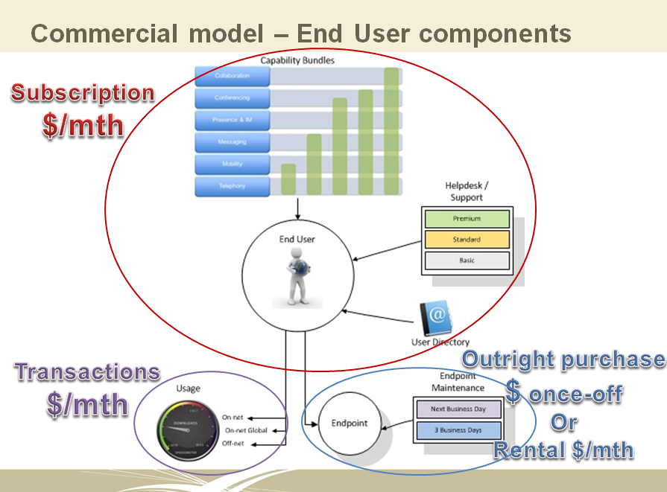

The import process and its interface to the billing functions are listed below. It has allowed for the second import for UC phones. Two batch imports means two different reports can be applied.
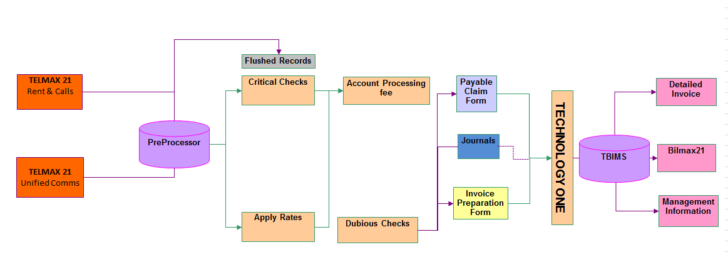

Billing Modification
This is specifically written for the billing team and the developers so the terminology used is geared to their understanding. The solution is my initial thoughts and I am expecting this to change once I have consulted with the David Wells, Billing Team Members and the developer.

The Telmax21 System has a module for the Cisco Unified Call Manager. (v 3 thru V8.x). This work has already been configured and only the collection of live data and testing is outstanding.

List of Activities and involved in import and reporting for the implementation of Unified Comms, of which the BSS supporting suppliers will need to provide that functionality.

2.1 Craig Halliday, MDB Consulting
- Add new invoicing report Need to decide what this new report would look like.

If we use an existing format then this will not cost anything. I have included a sample bill below for the recurring amounts.

The Front page shows the Batchtype name e.g. VicTrack Rent and Calls.

The second image is the Summary records, which shows the fields – Serviceid, Location, User, Cost Centre Ref., Rental, Calls, Other, Admin, Total

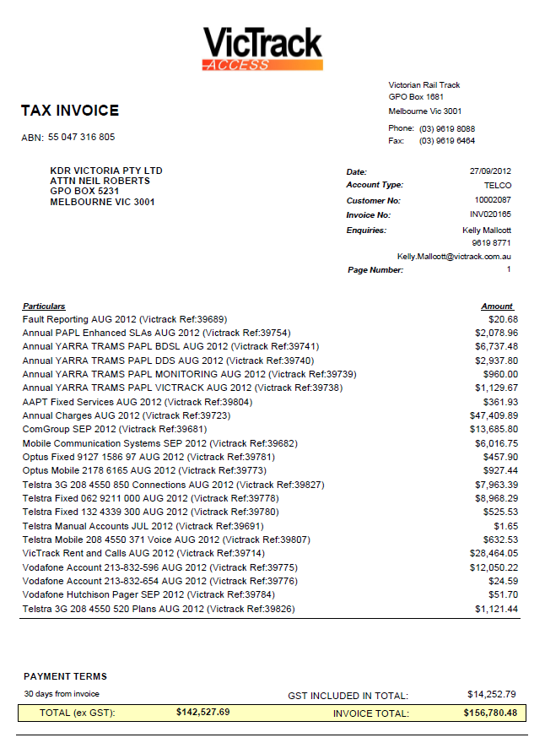

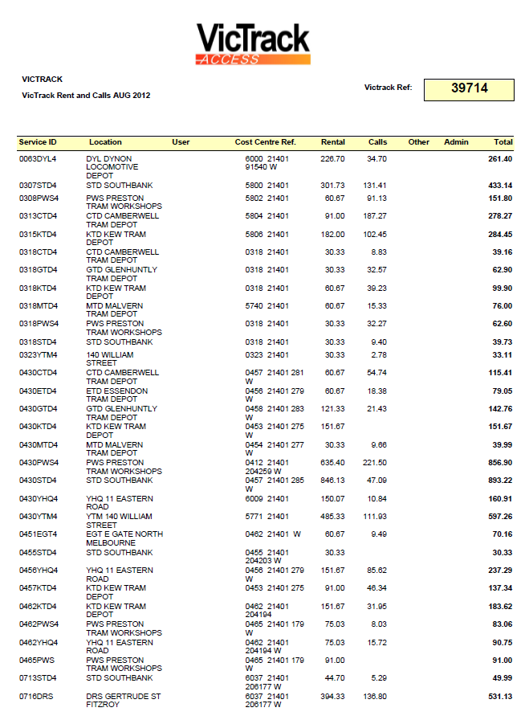
Invoice Detail

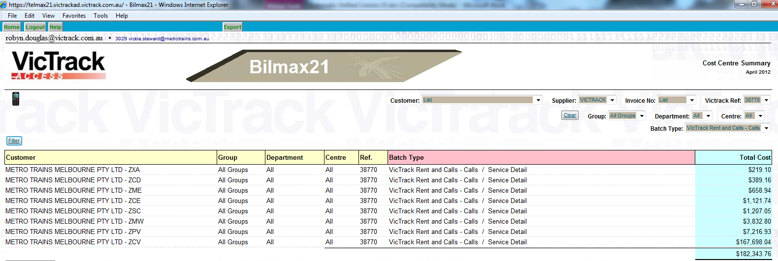
Bilmax Cost Centre Summary (allows customer to see multiple shiptos across multiple invoices to see total costs for a single item type.

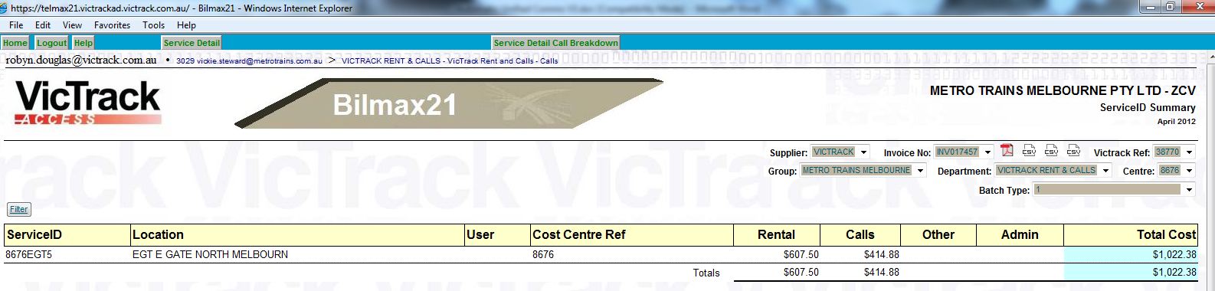
Bilmax ServiceID Summary Report

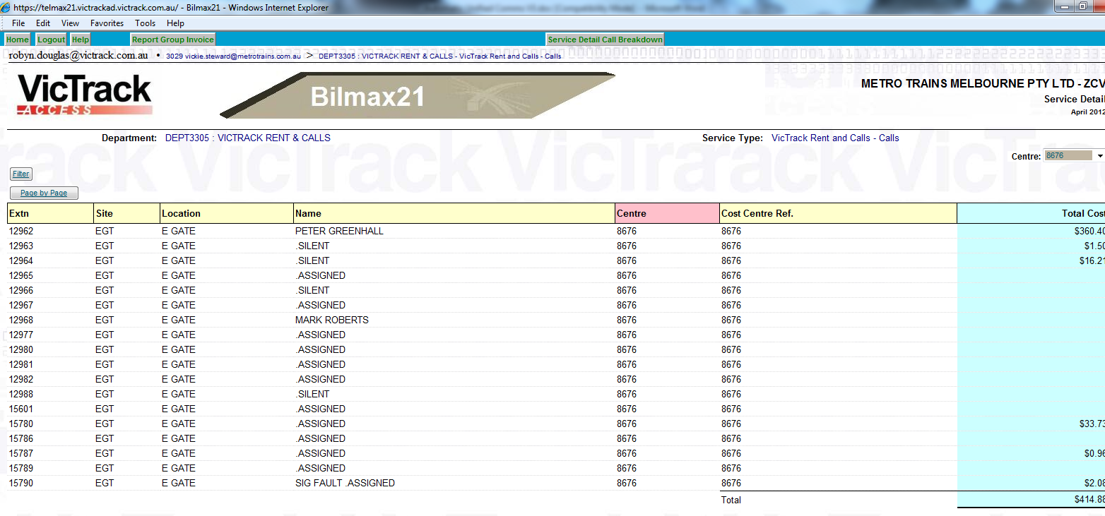
Bilmax ServiceID Detail Call Breakdown

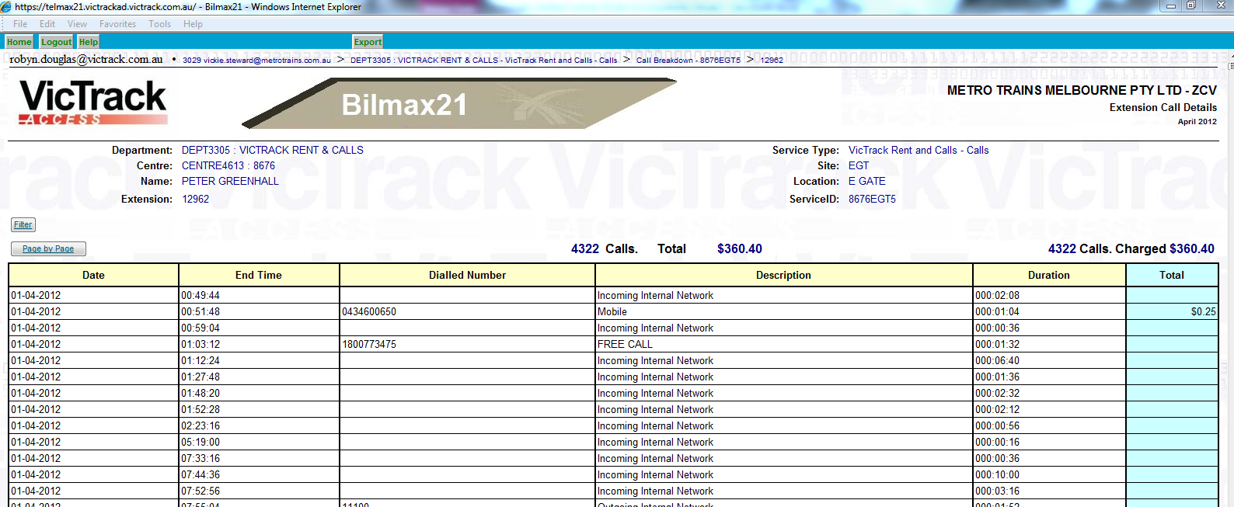
Bilmax Extension Call Detail report

2.2 Ron Cranston, Trans-Mit
- Import Function –. The import process will need to be modified to allow a second import from the same source.
- Ignore the missing S9 and V9. There is a new file name format for the Cisco R9 and C9. c9ccm_MMYYYY.txt (Call Record froM The Cisco Unified Call Manager)
r9ccm_MMYYYY.txt (TEC values for extension with the CIsco site)

O/S what about switchboard?
(ie. OPASSISTDIALNUMS="'11900', '11911', '11912', '11914', '11918', '11921', '11922', '11924', '11966', '19024', '19000', '11111', '999'"
- except for PAR Div UNA, TLM, and siteid 201)

2.3 Rod Sheppard, Trans-Mit
- Project has paid for the implementation of the Call logging interfacing and capturing of data from the Call Manager.
Additional work that will need to be done on the Telmax21 is:-
- Add modification to correct Subscription information against Directory AD
- Allocate new fields in Telmax Directory21 for UC instrument, MAC address and subscription description against extension number and automatic updating. A new field for instrument updatable (need to know if phone is leased or brought outright).
- Update TEC T value for the combined phone type and subscription David Wells still to advise how we are going to update RSC and SFC
- Phone type to be supplied by David Wells with MAC address which TransMit will import to the Telmax
- Separate R9 and C9 to exclude Cisco from NEAX data. No files for V9 Voicemail.
- Create a polling alert for “No Data” and “Polling Failed” for zero calls
- Generate an email if there is a polling alert and automatically log it into VQSM
- Create a batch program to request the month’s data
- As data collection is common there should be only one Site in Telmax for UCP
- Polling to be configured for 30 minutes polls in the Cisco call manager
- Include all the new features e.g. Video conferencing
- TP Video Conferencing not including presently as it indicates CDR which is not defined.
- Bilmax report to match the invoice generated by TBIMS
- Extract Subscription from CMR/CDR????? And combine with phone Type to provide TEC value. This needs to be automated by Trans-Mit
- Directory21 to have look up fields for the Subscription, MAC and instrument, IP address is not required
- David Wells to provide CMR specification
- David Wells to indicate fields for subscription calculation by TransMit
- Automatic directory updates from the AD information if we get email, subscriber name. This is still to be defined. More discussion required. Telmax requires unique join field which needs to be identified.
- Phones which are pool phones for Premise Mobility are assigned virtual phone numbers when no-one has logged onto them. These need to be included in the directory. Need to do testing to see what is supplied in the CDR. Spare pool numbers will be programmed to dial 000 only and should belong to the same extension group and only be an expense to the system expenses.
- Storage of the mac address will need to be included in the call data records. Rod will put this data into the account number field.
- David Wells needs to provide Rod Sheppard two lists. One is a list of handsets, mac address and some fixed numbers. Second list is the subscription list. As the TEC is a combination of phone type and subscription Rod will need both bits of information.
- Due to VicTrack’s security requirement, Rod will need to quote for the moving of files from a nominated drive to the Telmax. An additional quotation is required for this part.

2.4 VicTrack IT
- The module will be installed onto the new VMWare Telmax21 system with disk space for the virtual logger to be allocated in the database partition, an additional 20 Gig of disk space should be added, (mounted) to store the Cisco Raw data, and processed calls.

Application Affected
- Newpp
- TBIMS
- Telmax21
- Bilmax21

Unified Communication Products

End User Subscription – bundle Pricing
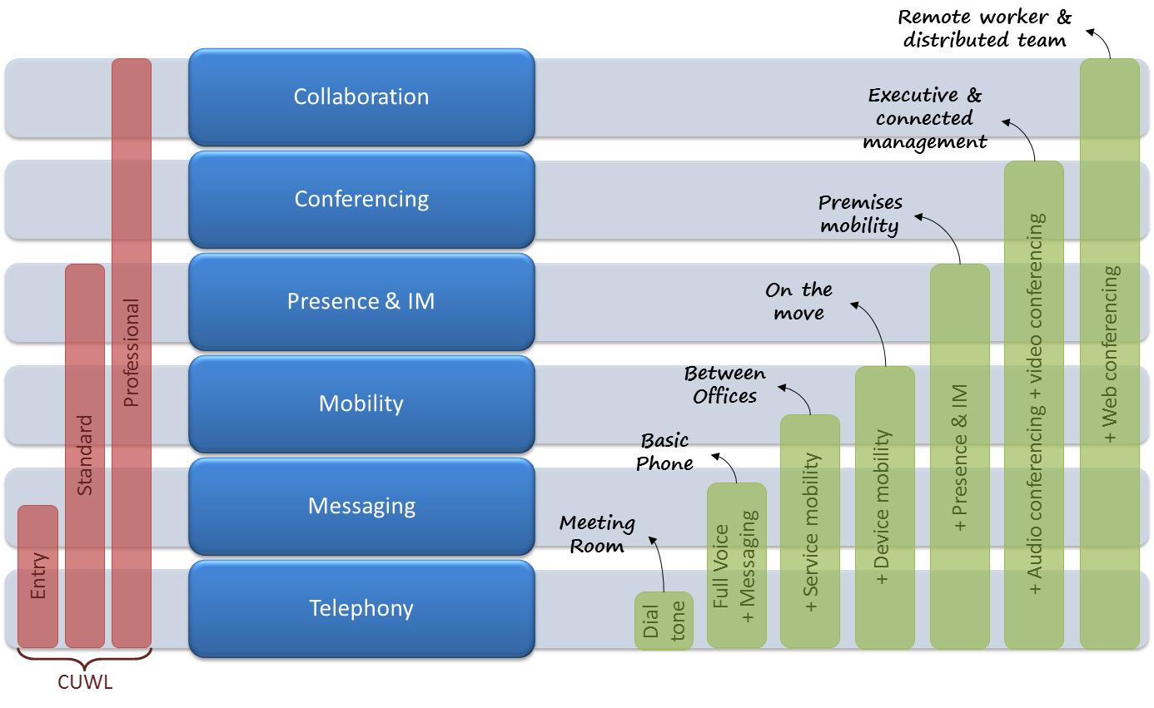

Definitions of those subscriber bundles is:
Meeting Room is basic tone profile designed for a meeting room or foyer phone scenario
Basic Phone is Basic Telephony features and Voicemail and directories
Between Offices adds mobility features such as extension mobility, single number reach, simultaneous ring, dial-via-office, VM-to-email
On the Move is device mobility and extends UC capability out to mobile devices (phone and tablet), soft phone capability.
Premises mobility adds presence and IM capability, client software. This is using communicator and instant messaging.
Executive adds Meeting Place Software and desktop video and audio conferencing
Remote Worker and Distributed Team adds full Meeting Place integration (desktop video, audio, web conferencing)

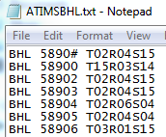

Determining the rent amount
List Len Dumps from the PABX
Import List len into ISDN program
Export ATIMS file to file directory E:\ISDN\ATIMS
Schedule task on Telmax to update TEC field from ATIMS file
Directory field TEC is updated with a concatenation of three values TEC, RSC and SFC.
This

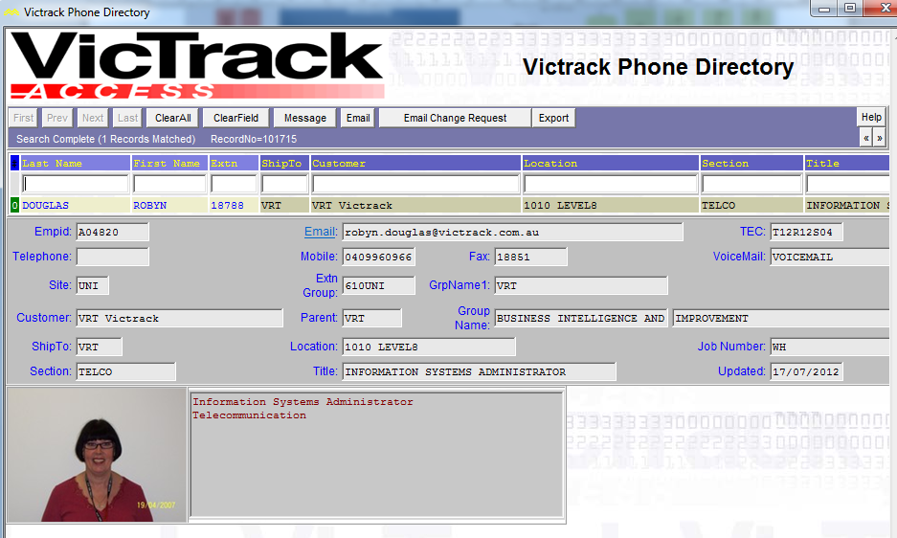

The existing TEC values used are:
TEC
0 | UNKNOWN
1 | PULSE
2 | TONE
3 | PULSE / TONE
12 | D-TERM
13 | D-TERM DATA
14 | HOTLINE
15 | 120 D-TERM
16 | DATA MODULE
18 | VIRTUAL
22 | EMULATOR
50 | Meeting Room and Analogue Phone
51 | Meeting Room and Conference Phone
52 | Basic Phone Subscription and Analogue Phone
53 | Basic Phone Subscription and Gold Class Phone
54 | Basic Phone Subscription and Premium Class Phone
55 | Basic Phone Subscription and Platinum Class Phone
56 | Between Offices Subscription and Gold Class Phone
57 | Between Offices Subscription and Premium Class Phone
58 | Between Offices Subscription and Platinum Class Phone
59 | On the Move Subscription and Gold Class Phone
60 | On the Move Subscription and Premium Class Phone
61 | On the Move Subscription and Platinum Class Phone
62 | Premises Mobility Subscription and Gold Class Phone
63 | Premises Mobility Subscription and Premium Class Phone
64 | Premises Mobility Subscription and Platinum Class Phone
65 | Executive Subscription and Gold Class Phone
66 | Executive Subscription and Premium Class Phone
67 | Executive Subscription and Platinum Class Phone
68 | Remote Worker and Distributed Team Subscription and Gold Class Phone
69 | Remote Worker and Distributed Team Subscription and Premium Class Phone
70 | Remote Worker and Distributed Team Subscription and Platinum Class Phone
71 | Meeting Room Subscription
72 | Basic Phone Subscription
73 | Between Offices Subscription
74 | On the Move Subscription
75 | Premises mobility Subscription
76 | Executive Subscription
77 | Remote Worker and Distributed Team Subscription
78 | Analogue Phone
79 | Gold Class Phone
80 | Premium Class Phone
81 | Platinum Class Phone
82 | Conference Phone
RSC
0 | UNKNOWN
1 | INTERNATIONAL / UNRESTRICTED
2 | STD AUSTRALIA WIDE / NON RESTRICTED 1
3 | STD VICTORIA ONLY / NON RESTRICTED 2
4 | LOCAL & MOBILE CALLS / SEMI RESTRICTED 1
5 | INTERNAL & LOCAL CALLS / SEMI RESTRICTED 2
6 | INTERNAL & EMERGENCY CALLS / RESTRICTED 1
11 | BUSIED OUT / RESTRICTED 2
12 | STD AUS WIDE *961/ FULLY RESTRICTED
SFC
0 | UNKNOWN
1 | UNKNOWN
4 | STANDARD PHONE
7 | RESTRICTED
8 | CALL WAITING
9 | SECURITY PIN
12 | VRT FEATURE
13 | POST PHONE
15 | 120 EXHANGE

The Product Manager believes that due to the mobility of the instruments that billing will be a bulk amount. This will use the “Recurring” batch type and appear under a separate batch type heading but on the same invoice.

Alternatively, Product Manager suggested that the Subscriber and phone model would be added to Call Manager as a combined subscription.

David Wells has proposed that where we provide a combined cost of Subscription and Instrument that we predefine which instrument are available and they are classified as High, Medium and Low. Also conference and analogue handsets need to be included in the classification. Outstanding for Adam to define the instrument for these classifications. Clarification is required regarding the following statements – All users get an ear piece. How do we deal with Executive ear pieces?

To minimised the development the thought is that the subscription description will be added into the directory page into a spare field of the web directory but for billing purposes will be converted into a numeric TEC value. This would minimise the work required in modify NewPP Import functionality. We may need additional data extracted from the import data but we do not have any samples presently.

BatchtypeID:

This will be an automatic batch type, which will have the Add transaction button available for once off occasions. It will have same program type as Telmax Rent and Calls. The batch will be included under the "Import Data Automatic" data input group and will import a separate set of files to be included in the invoice.

Revenue Batchtype ID is 664
The batch name is “VicTrack Unified Communications”, which will appear on the Invoice.

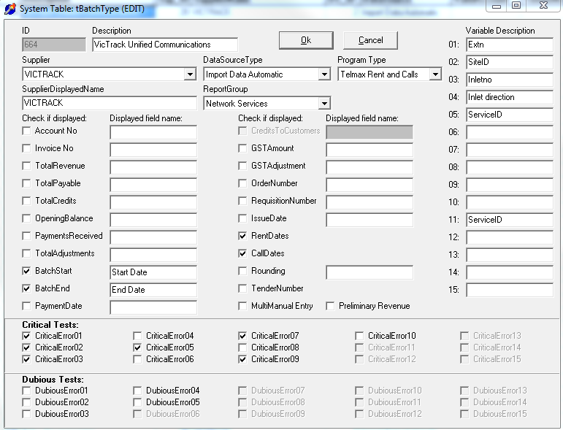
Note: The variable fields are presently populated in Var01 –Var15. Existing fields collected are extn, siteid, inletno, inlet direction and serviceid (extension group). The possible fields may be username…

SystemID: The systemID will join together the various Service Types belonging to this batchtype, so that there can be a varied price for different customers.

Revenue system ID is 760

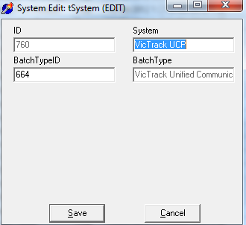

ServiceType: Service types are not determined yet as David and Adam need to define the subscriptions and features, then a numeric TEC value assigned.

SupplierID: VicTrack is the supplier for Unified Communications
Application: The application has been added as Unified Communications Services so that any billing can extract all Unified Communications ServiceIDs in one extraction.
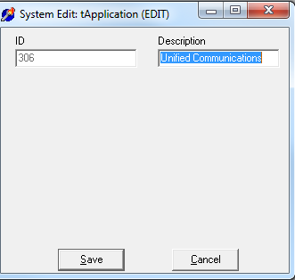
Person: Not populated yet.
ServiceID: The ServiceID naming convention should ???
Subledger No need to create a subledger for revenue as this new product will have a new revenue natural account (or element)
StatusID Leave empty
CustomerID PP will allow for multiple customers and independent pricing for the Base Package or a variation of the Base Package, by simply creating a separate service type.
BillingPeriod From billing period control eg 2012/10

BatchStartDate Default to first of month for Billing Period eg 1/10/2012.
BatchEndDate Default to last of month for Billing Period eg 31/10/2012.

DataCollectionDetail
The data collection will be populated as follows:
SequenceNo Generated by the extract routine
ServiceID Supplied in the Telmax file
TxnDate Supplied in the Telmax file
TxnTime Supplied in the Telmax file
Origin Supplied in the Telmax file
Destination Supplied in the Telmax file
Duration Supplied in the Telmax file
Callcode Supplied in the Telmax file
RateDescription Supplied in the Telmax file
DialledNumber Supplied in the Telmax file
GSTFlag In all imports where VRT is the supplier, the GST flag should be set to N when the customer is also VRT and Y otherwise.
AmountExGST The calculated rate from tRates table for the appropriate ServiceType.
GSTAmount will need to be calculated
AmountIncGST will need to be calculated
FromDate Supplied in the Telmax file

ToDate Supplied in the Telmax file
Transaction Type ???
Var01 Extn
Var02 SiteID
Var03 Inletno
Var04 Inlet direction
Var05 ServiceID
Var06 Leave blank
Var07 Leave blank
Var08 Leave blank
Var09 Leave blank
Var10 Leave blank
Var11 ServiceID
Var12 Leave blank
Var13 Leave blank
Var14 Leave blank
Var15 Leave blank

Trates The rates table will hold the base values so that these values can be varied over time.

Critical Error 1 If the initiation finds the ServiceID is unknown - included
Critical Error 2 Additional Service - included
Critical Error 3 Omitted Service - included
Critical Error 4 Unexpected Calls - included
Critical Error 5 Valid Split Service - included
Critical Error 6 System Reference Correct - included
Critical Error 7 If the existing ServiceID or Service is terminated - included
Critical Error 8 Incomplete Quetzal data - not included
Critical Error 9 Extra Split Service - included
Critical Error10 Customer centre unallocated - not included

TELMAX21

The Telmax21 System has a module for the Cisco Unified Call Manager. (v 3 thru V8.x). With the Unified Call Manager, call data is not polled by the billing system, instead it is pushed to the billing system by the C.M using FTP or SFTP. To maintain a consistent interface to the Telmax21 data collection system, we have implemented the concept of a virtual Call logger with the Telmax21 server. The raw data sent by the C.M is stored on the Telmax21 and can be polled/re-polled and processed as with any other external call logger. The module will be installed onto the new VM Ware Telmax21 system with disk space for the virtual logger to be allocated in the database partition, an additional 20 Gig of disk space should be added, (mounted) to store the Cisco Raw data, and processed calls is recommended. The installation will include the configuration changes required to the Telmax21 Routes G/W and Directory.

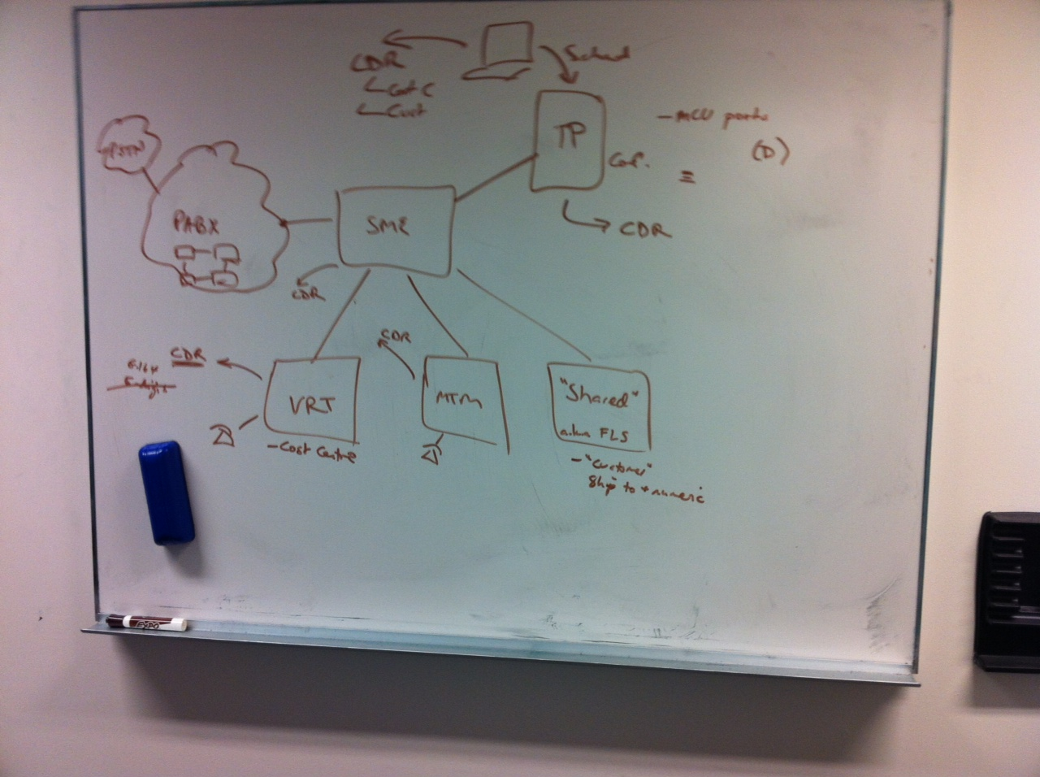

David Wells has provided a drawing showing the interface to existing PABX network. This shows that there is a SME (Transit site) that calls transit through from one customer to another. Please note that there is a Shared site for the smaller customers. Also there is a platform for the Video conference facility. Unsure presently, about the capture of data, data format, reporting and billing requirements for this service.

David has indicated that the inletno, outletno and dialledno if an internal extension will be shown in the CDR as the full number e.g. 96198788 as this is what is recorded in Active Directory.

Phones are not tied to a person so if we are leasing then the customer must tell us where the instrument is.

