

Re-Engineering Project

Pre-Processor Manual

Version Draft 2 December 2005



Pre-Processor Overview
The VicTrack Access Pre-Processor is one part of a larger Re-Engineering project undertaken by VicTrack Access to consolidate and update functionality of a number of disparage and multi platform systems that grew in a largely un-coordinated manor over a number of years and had been developed by a number of different contactors.
The primary objectives of the overall Re-Engineering project was to produce a product that consolidated the many systems and programs that constitute the cost recovery revenue and expenditure activities of the group into a common operating environment developed and supported by a reduced number of contractors.
As well as the improvements in the processing of accounts and billing of the VicTrack Access customers the production of more detailed reporting of the services provided was seen as vital to the quality of service provided to customers and afforded better analysis of individual customer activities.
In board terms the Re-Engineering project has three main elements.
Pre-Processor
The Pre-Processor was developed by Trans-Mit and is the key to the whole Re-Engineering project in that it is as the name suggest is the primary stage of the data gathering, processing and warehousing the other two elements are focused on using the data collected and processed by the Pre-Processor to provide a range of management and customers orientated reports.
TBS
The TBS was developed by MDB and fundamentally takes the data generated by the Pre-Processor to provide various management reports and provides the interface to the VicTrack financial systems to produce the actual invoicing.
Bilmax21
The Bilmax21 is a web based reporting applications developed by Trans-Mit and provides customers with a fast and powerful report tool that can provide detailed transaction level reporting of services provided to customers by VicTrack Access and like TBS it derives its data from the Pre-Processor.
About the Manual
The manual has four sections,
Section 1 details the routine operation of the system,
Section 2 details the administration of the system
Section 3 details information into the techniques, programming methods and procedures used in the development of the Pre-Processor.
Section 4 details the reference information
The Pre-Processor has been implemented utilising the base information and knowledge gained in the development of it’s predecessor the TAS
The setting up of the system is complete and much of the work involved one off processes none of which are covered in this manual.
It is not the intention to reproduce in this manual every screen view possible, but rather to provide a comprehensive understanding of the functionality and features of the system. The intuitive look and feel of the product along with the design criteria makes navigation around the application easy and self explaining.
VicTrack Access may choose to develop Work Procedures in keeping with their standard operating processes that detail tasks assigned to individual operators and users of the system.
The Pre-Processor will continue to evolve as the VicTrack Access business model and supplier data changes the operational aspect of the Pre-Processor will remain in the main the same.

SECTION 1 Operator Guide
Getting Started
General
Before you can begin to access and use the Pre-Processor you will require approval from the Manager Billing Services to obtain an username and password form the System Administrator
The approval form will specify your level of access and functionality available to you and be used by the Systems administrator to set-up user profile.

Login
Once you have received your login details and your workstation has had the relevant software installed by the System Administrator you can commence the login process by clicking on the Pre-Processor short cut on your desktop a login box will pop up and you enter your username and password and click OK. Depending upon your level of access you will then see a screen that looks similar to the one below. You are now ready to begin work

Procedures
The tasks and procedures you will be required to preform will be determined by the Manager of Billing as will their order and priority. The Pre-Processor is a powerful management tool with built in checks and validation to minimise the possibility of errors occurring but if something occurs that you believe may incorrect of wrong then please notify the Manager of Billing so that the matter can be addressed

Security
Username and password are your key to the system and should be treated with care and if written down stored in a secure place and should not be given out to anyone. The system logs details of who accesses the system and what activities you have undertaken during each session.

Administration
Other than what your level of access allows you to access on the Pre-Processor applications all other tasks will be under the control of the System Administrator and any matters relating to the general administration should be directed through the Manager of Billing for investigation and or rectification

Importing of Invoicing and Billing Data
General
The fundamental propose of the Pre-Processor is to import invoices and billing data from suppliers. These may be from both third party and internal sources and come in different forms and formats. These have to be interpreted by the Pre-Processor so that they can be processed into standard format without loss in integrity and accuracy of data contained in the source data.
It is not a simple matter of converting the format but applying a series of test and checks designed to validate that the data is correct and as expected. These are covered in more detail later in the manual. There are 3 basic forms of data Electronic, Keyed and Automatic that can be imported and within these there are many formats which typically vary from each supplier.

By way of example of this, mobile telephone suppliers all provide the same basic information in their billing data about calls made, monthly charges and credits etc but each supplier requires a separate processing routine specific to their format in the Pre-Processor to convert it into a common format.

There are hundreds of different suppliers and this manual will not cover them all but will concentrate on the principles of each form with examples on the most common data sources. Specific

Electronic
The Electronic form is used when a supplier supplies their bill in an electronic format normally on CD or possibly by downloading from their website. This requires the need for a person to provide some level of manual intravenation to locate the data source and point the Pre-Processor towards the location

AAPT
Optus
Telstra Fixed
Telstra Mobile
Telstra VRT Fixed
Vodafone

Keyed
The keyed form is typically used for smaller bills when there is only a hardcopy of the bill available and the person has to type in the details
Motorola
ComGroup
Electricity
ACA Licenses
Annual Charges

Automatic
The automatic form imports the data directly from other in-house applications were the location of the data is always the same
Quetzal Faults
Taxi Directorate
Radio Faults
Labour & Jobs
TIMS
Service records

Batch Creation and Processing
General
The Batch processing sub-module is where all the importing and processing of data is controlled from initiating an import to the finalisation of the process. Depending upon your level of system access certain functions may not be available to you.

Main Screen
By selecting the Batch icon from the left hand panel you will be presented with the screen in fig1 it opens up with a summary list of all the batches that are deemed to be work in progress from this screen you can navigate around to check what stage each batch is up to in the importing process. With the correct permission levels you can also move the batch onto the next stage by resolving critical and dubious errors

Initiated
A batch is initiated by the completion of the initiate screen with the relevant details required from the supplier’s hard copy of the bill or invoice this information is then used to during the actual importing process to check and validate the import process. One can initiate a number of batches before committing them to the processing phase this allows for a more efficient work practise, as well as the ability to cross check the details before committing them to processing.

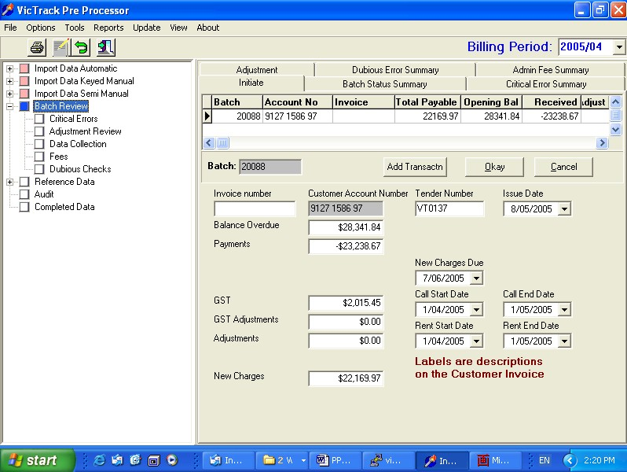

Import Data
Once a batch is initiated by then selecting the OK button you commence the process of reading in the data. Depending upon the data source

Batch Status Summary
The Batch status summary screen gives the operator a method to quickly check what stage a batch is at in the billing period and from this they can manage the batches through to final release status. There are number of stages within batch processing which will require operator intervention to move a batch to completion status. This may involve resolution of errors or simply acceptance and release to the next stage

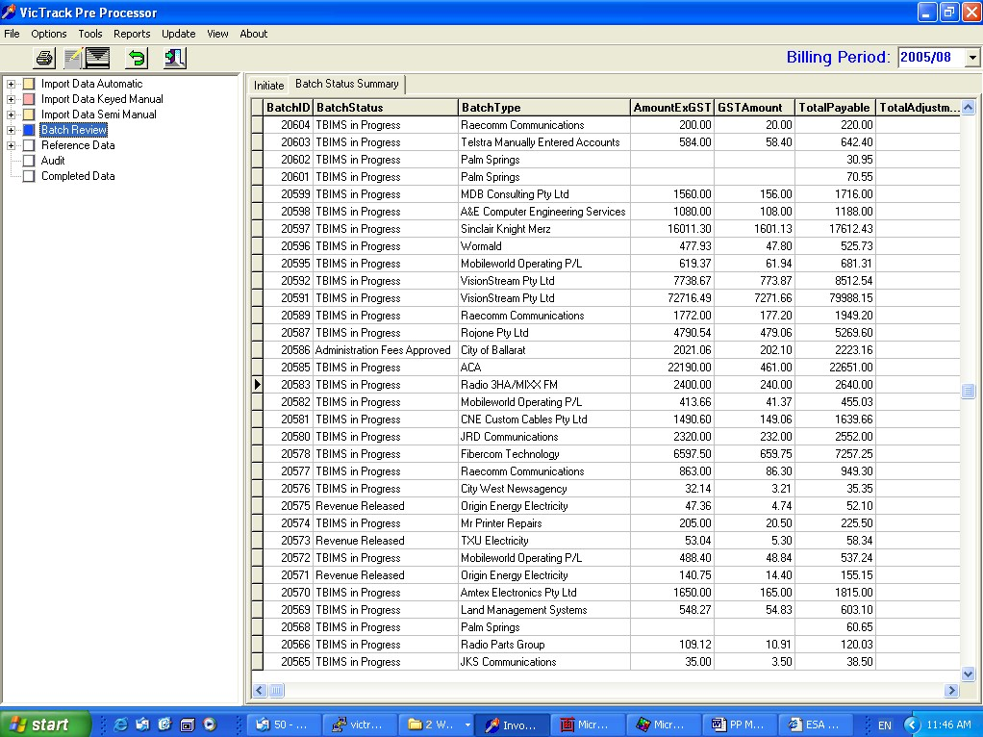

Critical Errors
There are a number of predetermined events that can be constitute a critical error during the importation process depending upon the data source whilst they do stop the reading of the data you cannot progress the batch to the next stage until these critical errors are resolved which requires manual intervention from the operator. The resolution of these errors will typically require updating of the reference data or issuing requests for credits from the supplier

Unexpected Calls
Split Costs
No Account Additions
No Account Omissions
Tariff & Rates

Critical Errors
Detail
Summary
Resolution

Expenditure Released for Payment
Once a batch has reached this stage of the process it has been accepted subject to management approval for the payment of the supplier bill or invoice by selecting OK then the financial system will be notified of the same

Administration and Discount Fees
Depending upon the arrangement with a particular customer the Pre-Processor will apply additional fees or discounts the Admin Fee Summary shows these types of fees
Summary
Detail

Dubious Errors
Like the critical errors the dubious errors are predetermined and need to be addressed by the operator they are of less importance and generally be dealt way quickly

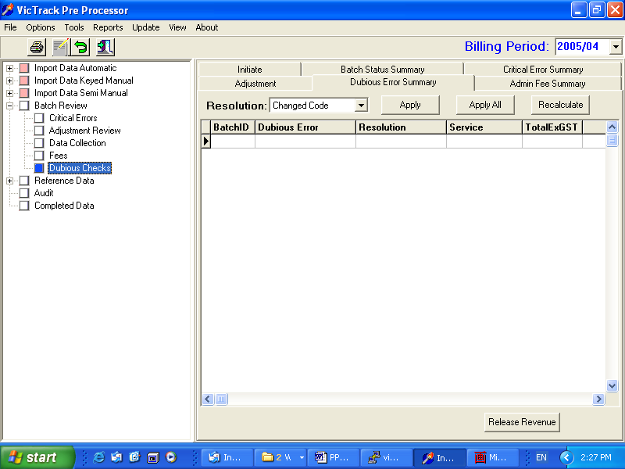

Rental Variations for same Service Type
Value Range
Calls less than Rent
Activity Change

Dubious Errors
Detail
Summary
Resolution

Revenue Released to TBS

Expenditure Released to TBS

Split Costs
There are situations that arise from time to time that services are split between ship to’s An example of this is were one pays the rental costs and another the call costs for the one service

Bill Splitting

Lost Revenue

Delayed Billing

ServiceID

Telstra Codes

Reference Data

General
Reference data relates to the information stored in the database and in board terms is used to check services provided by suppliers and assign costs to customers. There a large number tables that store this information which are listed and detailed in appendix A. They can be accessed in couple ways either by the selecting from the left hand panel or from a batch summary screen. Given that many of the tables operate the same only a few examples have been documented in detail

Viewing
Viewing of the reference data is achieved by simply clicking on the required to table name from the left hand side window which will open the table in the main window

Adding

Editing

System Tables
tActivity
The tActivity table is used to define

tAgreement
The tAgreement table is used to define

tBatchType
The tBatchType table is used to define

tBatchStatus
The tBatchStatus table is used to define

tCentre
The tCentre table is used to define

tCriticalType
The tCriticalType table is used to define

tCustomer
The tCustomer table is used to define

tDataCollectionMap
The tDataCollectionMap table is used to define

tDataSourceDetail
The tDataSourceDetail table is used to define

tDataSourceType
The tDataSourceType table is used to define

tDepartment
The tDepartment table is used to define

tDiscount
The tDiscount table is used to define

tDestination
The tDestination table is used to define

tDubiousResolution
The tDubiousResolution table is used to define

tDubiousType
The tDubiousType table is used to define

tDubiousValidResolution
The tDubiousValidResolution table is used to define

tElement
The tElement table is used to define

tFunction
The tFunction table is used to define

tGroup
The tGroup table is used to define

tOrigin
The tOrigin table is used to define

tLocation
The tLocation table is used to define

tParameter
The tParameter table is used to define

tPerson
The tPerson table is used to define

tRate
The tRate table is used to define

tServiceID
The tServiceID table is used to define

tServiceSplit
The tServiceSplit table is used to define

tServiceType
The tServiceType table is used to define

tStatus
The tStatus table is used to define

tSubledger
The tSubledger table is used to define

tSupplier
The tSupplier table is used to define

tSupplierServiceCode
The tSupplierServiceCode table is used to define

tSystem
The tSystem table is used to define

tTransactionGroup
The tTransactionGroup table is used to define

tTransactionType
The tTransactionType table is used to define

tUser
The tUser table is used to define

tUserFunction
The tUserFunction table is used to define

tValidAcctServType
The tValidAcctServType table is used to define

Audit
All adds, modifies and deletes form the database are recorded and stored for future reference. The main purpose of this feature is to allow recovery of data and training of staff. Access to this is normally restricted to senior staff level

Reports
There are a number of standard reports that can be generated by the operator depending on the particular function they are using. The design of the Pre- Processor should eliminate most of the need to run hard copy reports and in many cases it is impractical due the amount of data involved.

SECTION 2 Administrators Guide

General
This section relates to the administration of the Pre-Processor application and does not include either the server hardware or other third party software be it operating or application that may co exist on the same system.

User access levels and logins
Those users granted Pre-Processor administration rights will have full access to all features and functions. They will be able to add, modify and delete the access rights to lower level users
System Tables maintenance

Standard reports

Custom reports

Back-ups

Audit

Server

Install of client software and configuration

Database integrity checking

SECTION 3 Developers Reference Guide

Overview
The Developers Reference Guide provides a overview of the development

Development environment

Development methodology and rules

Database schema

Interfaces and dependencies

Data sources
Electronic
Keyed
Automatic

Batch Creation and Processing
Billing periods

Reference Data

Critical and Dubious Errors

Audit

Reports

Glossary
Appendix
Specifications and Requirements
Database Configuration
Table Definitions

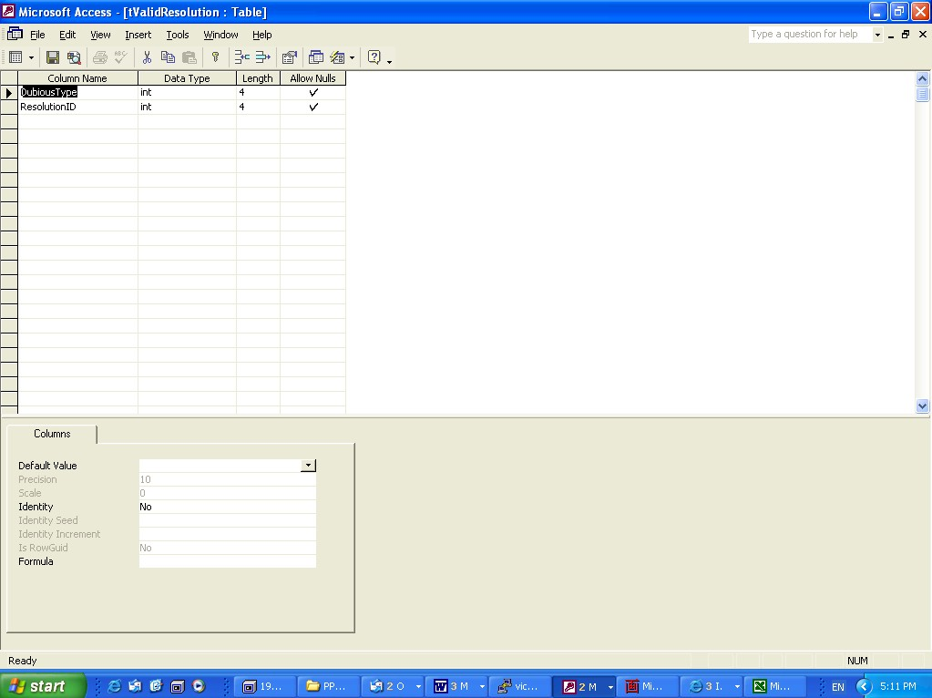

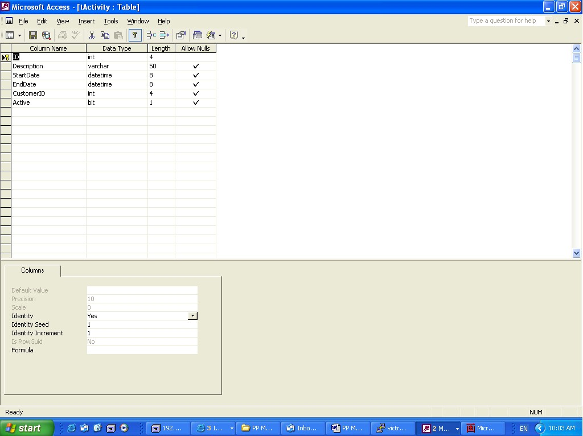
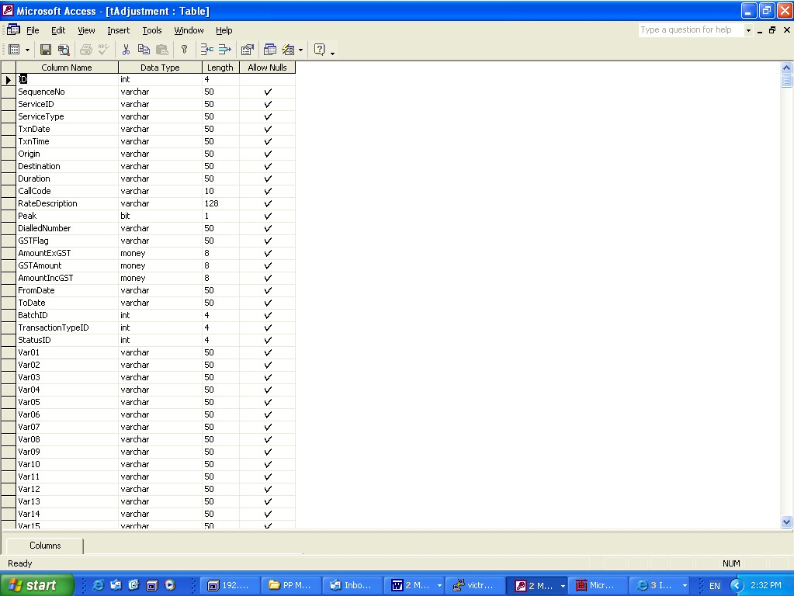
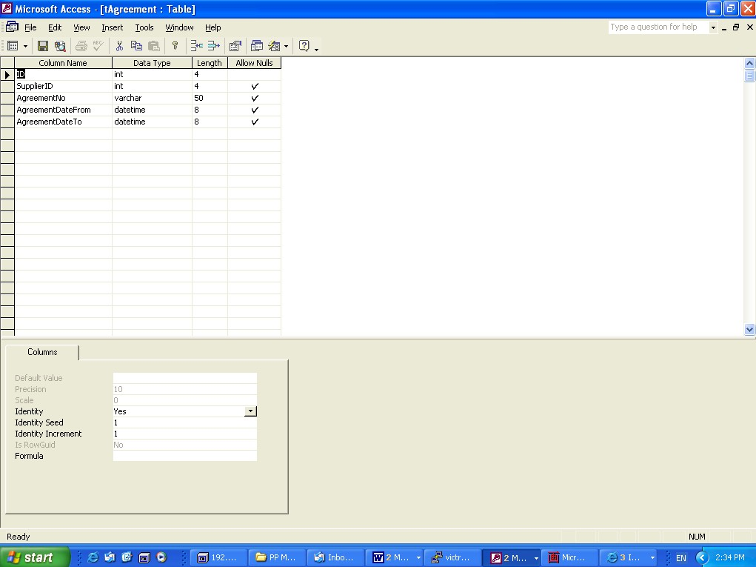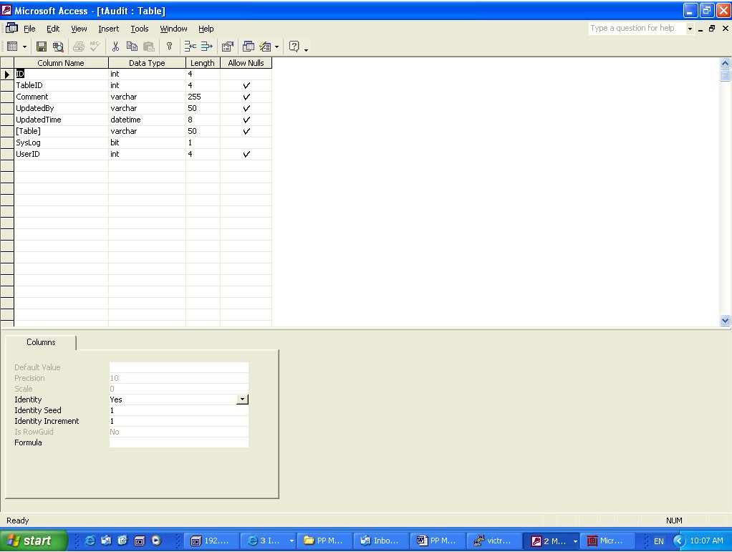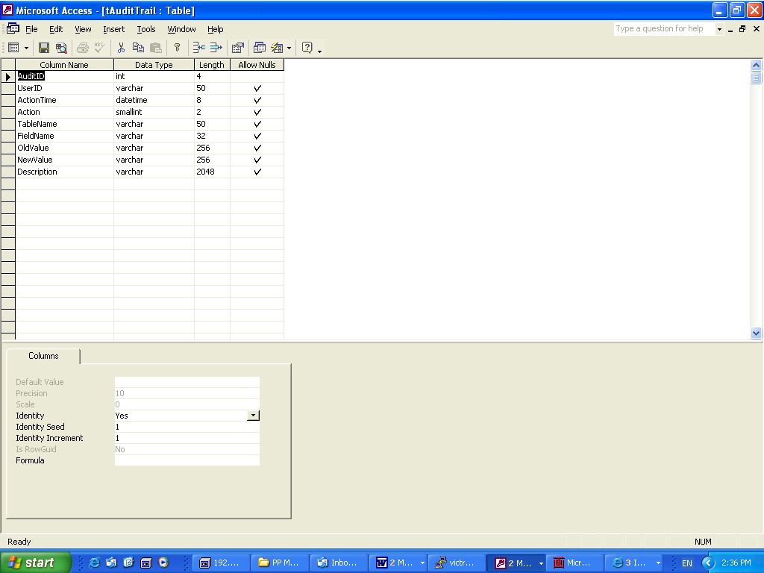
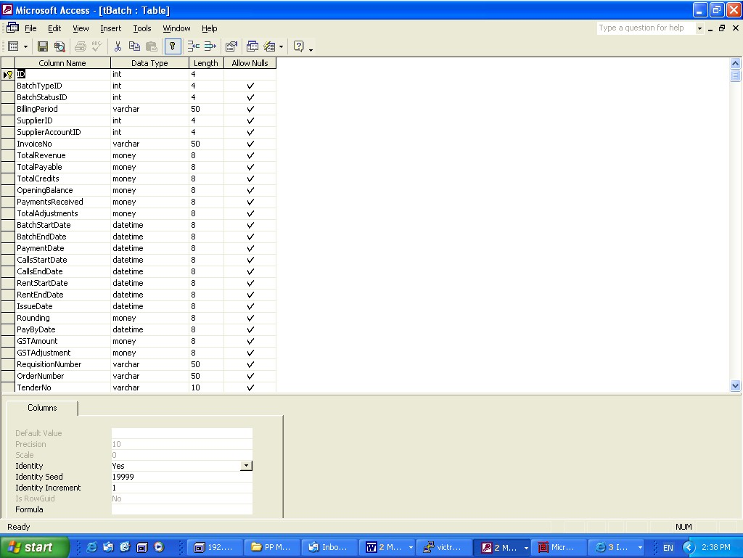
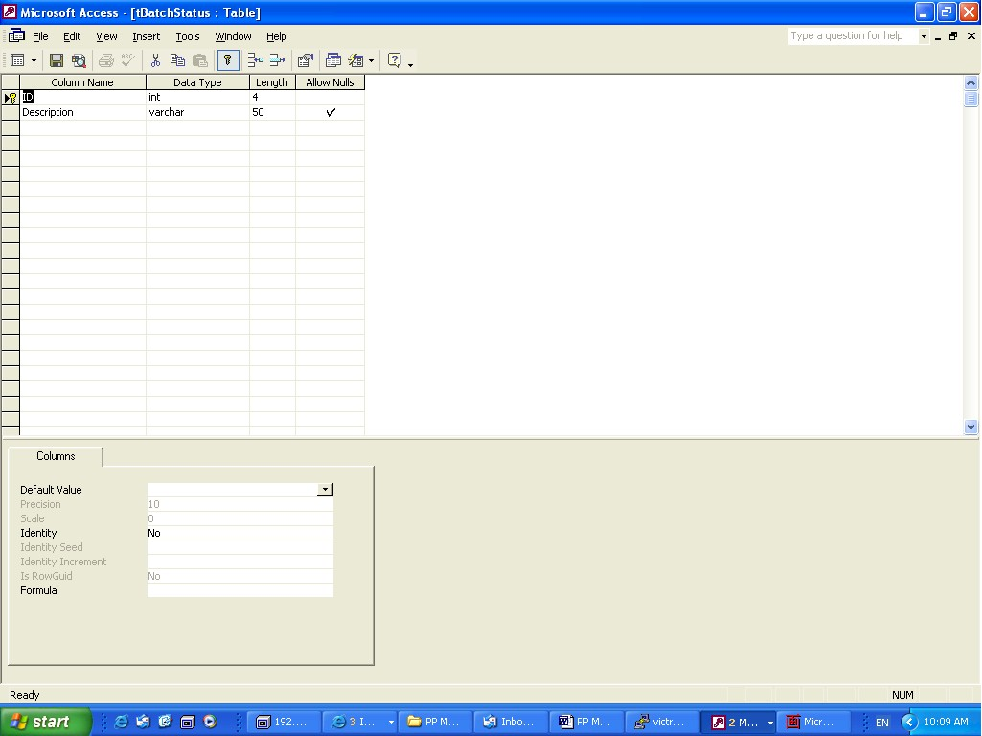
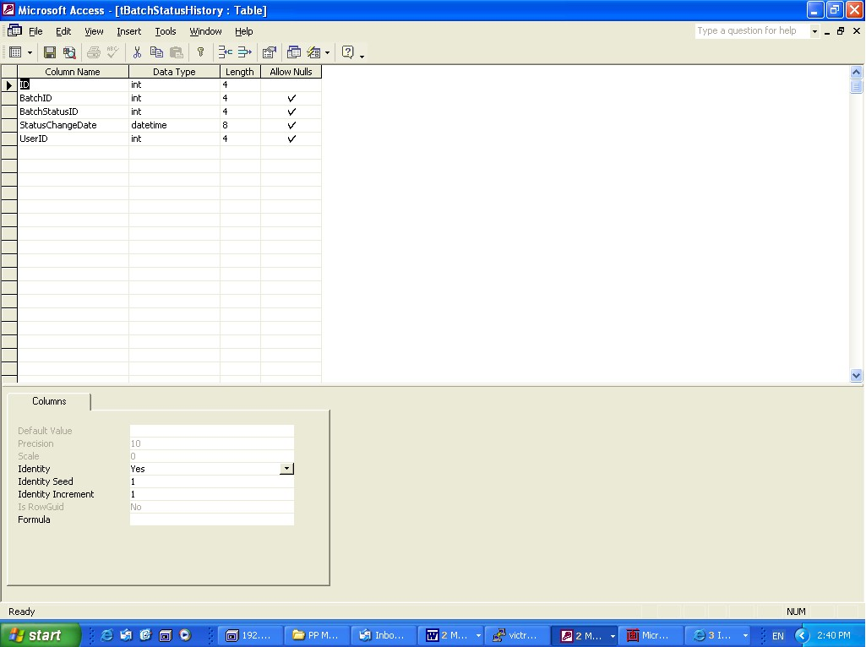
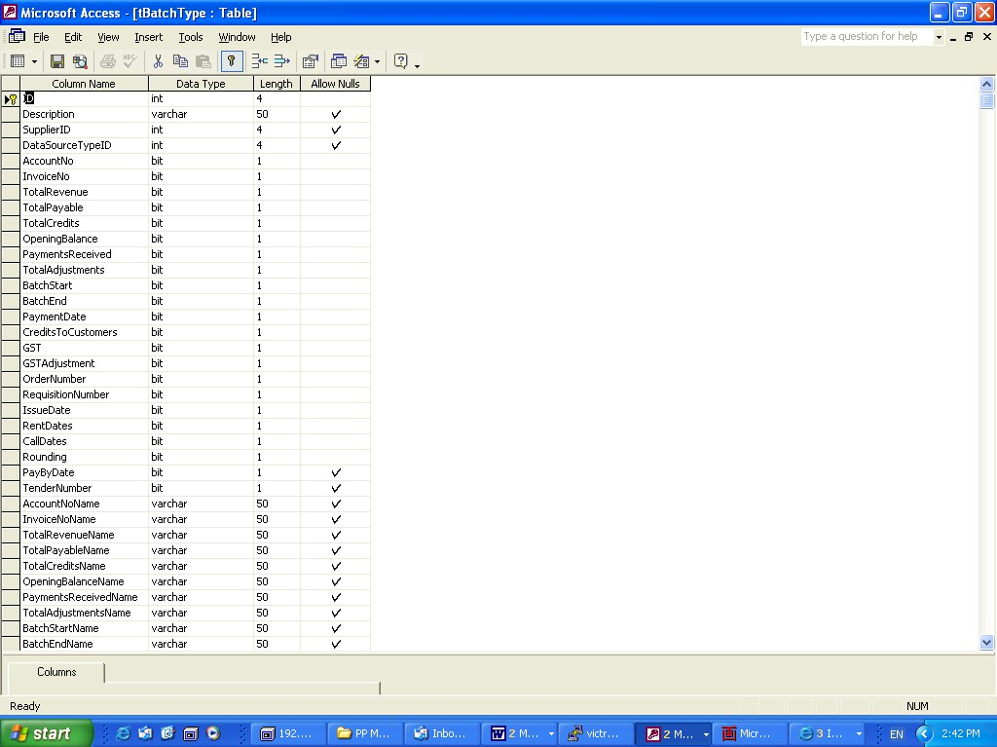
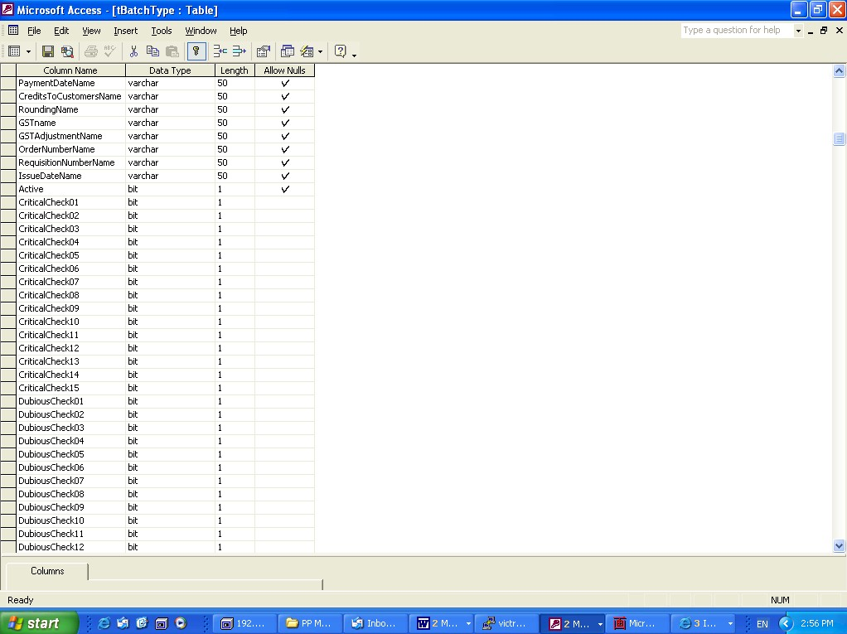
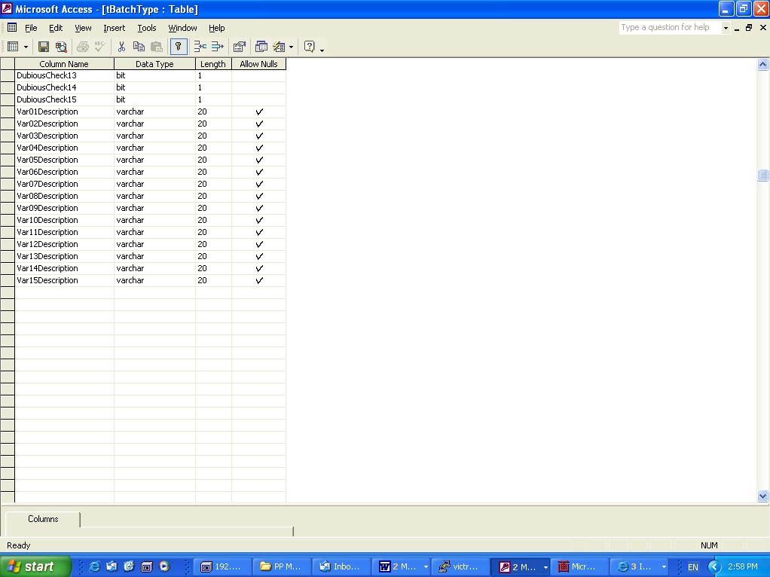
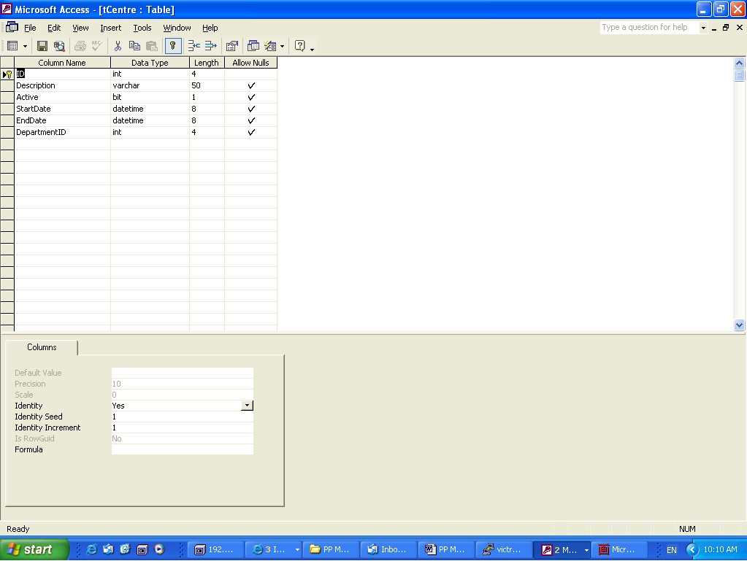
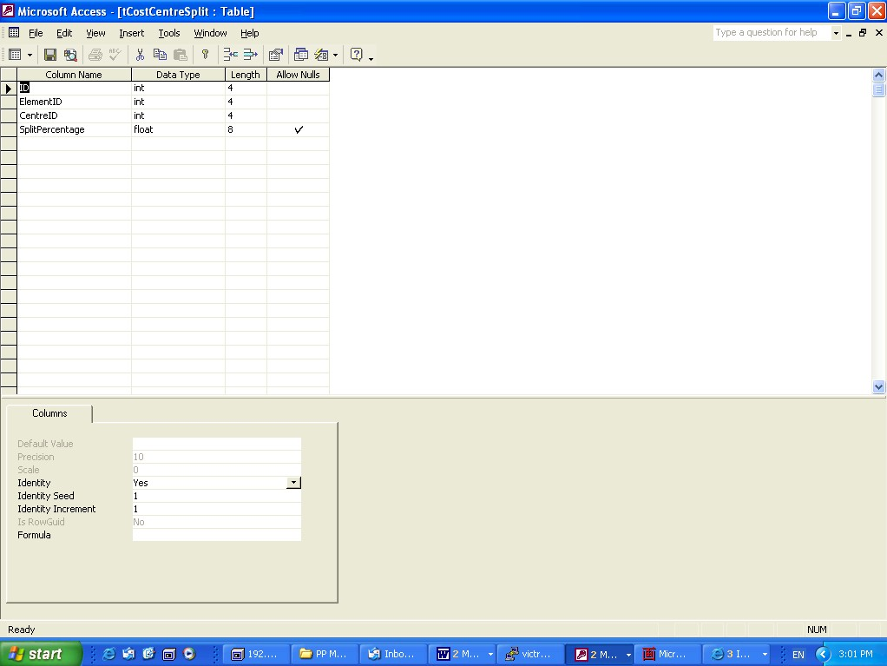
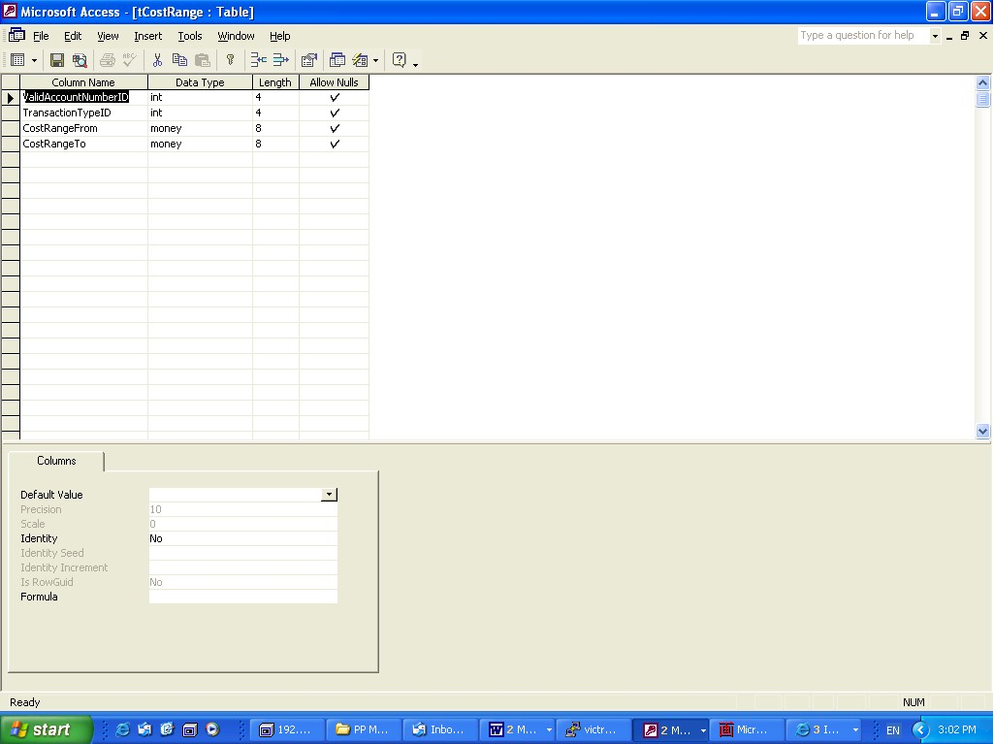
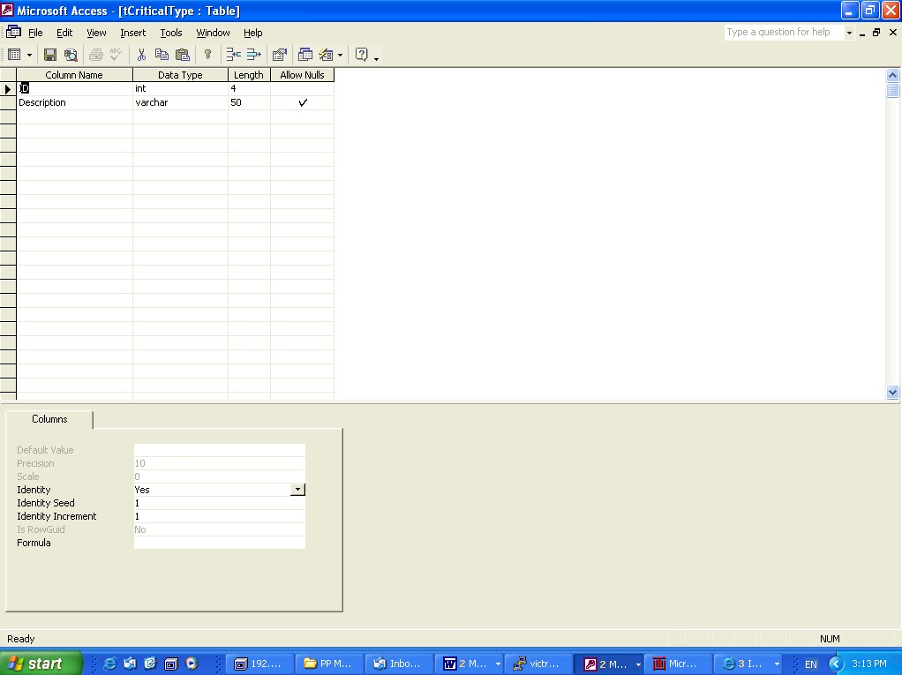
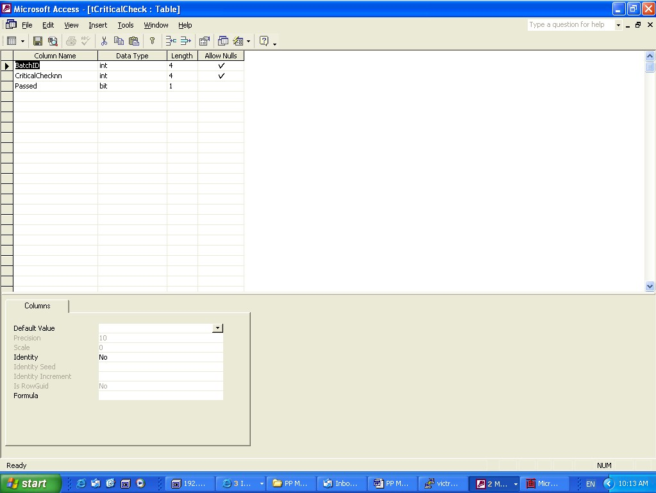
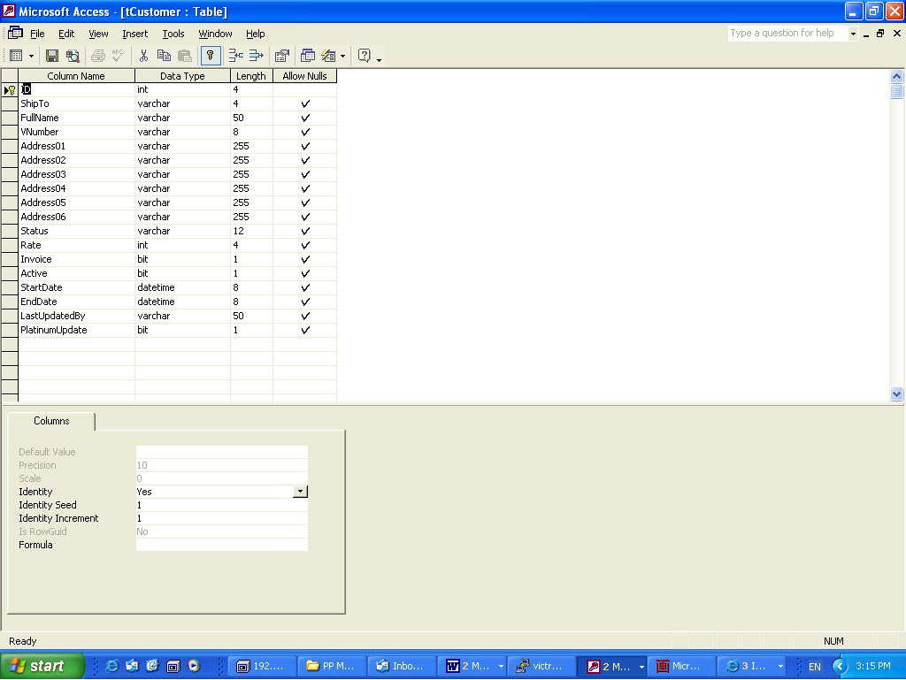
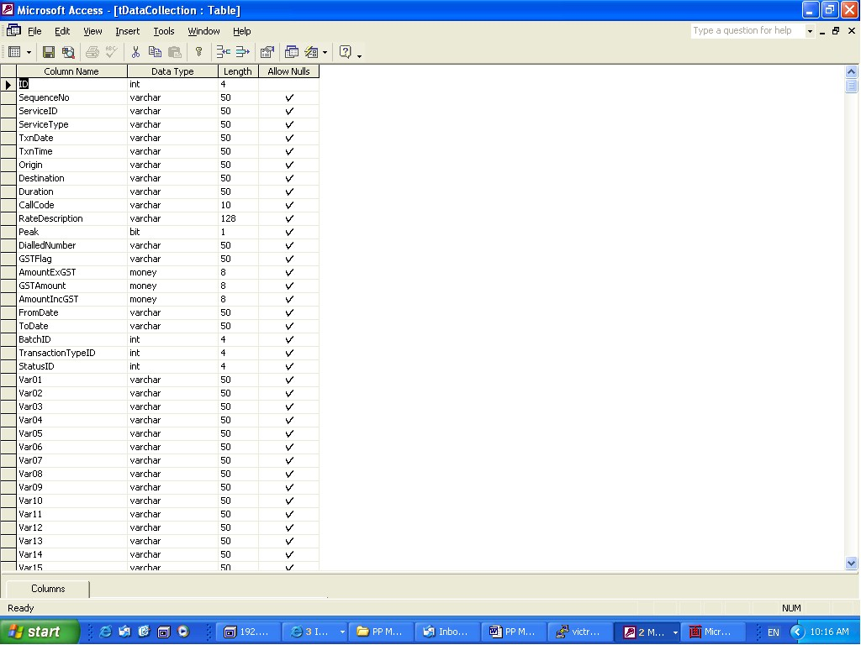
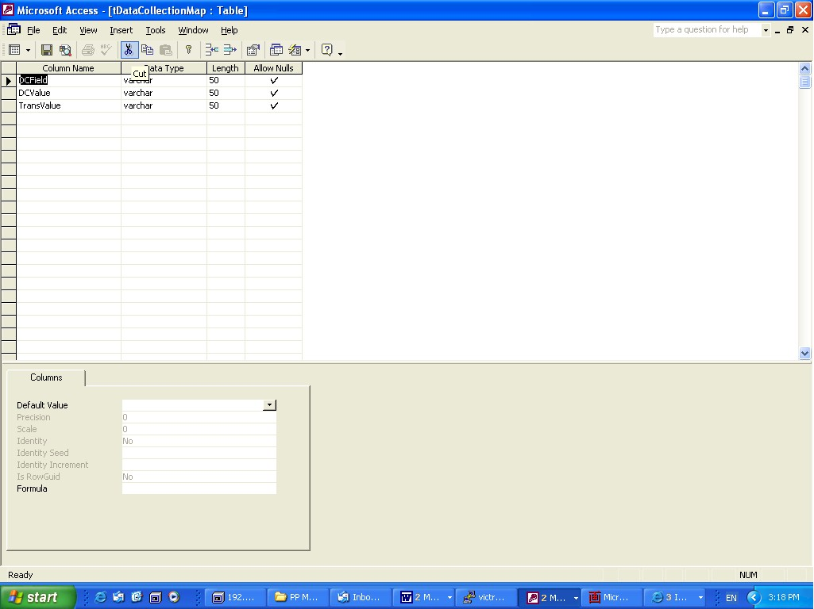
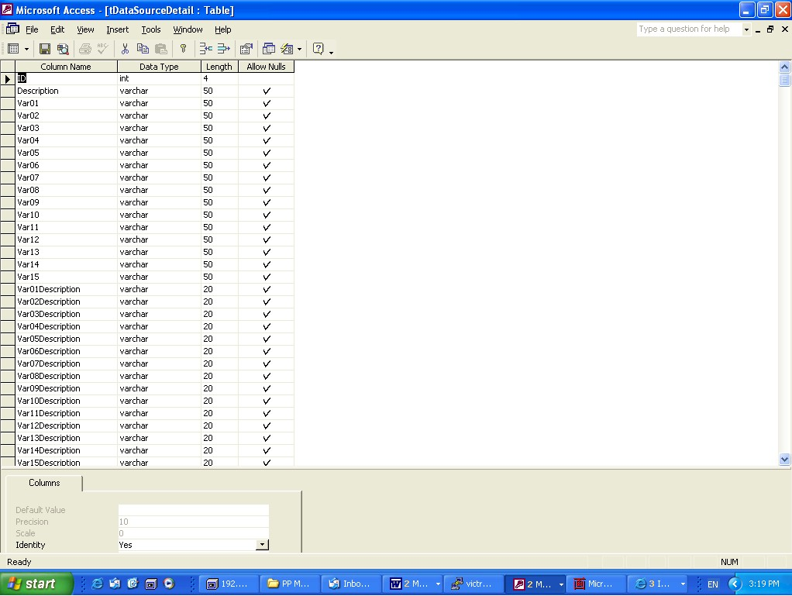
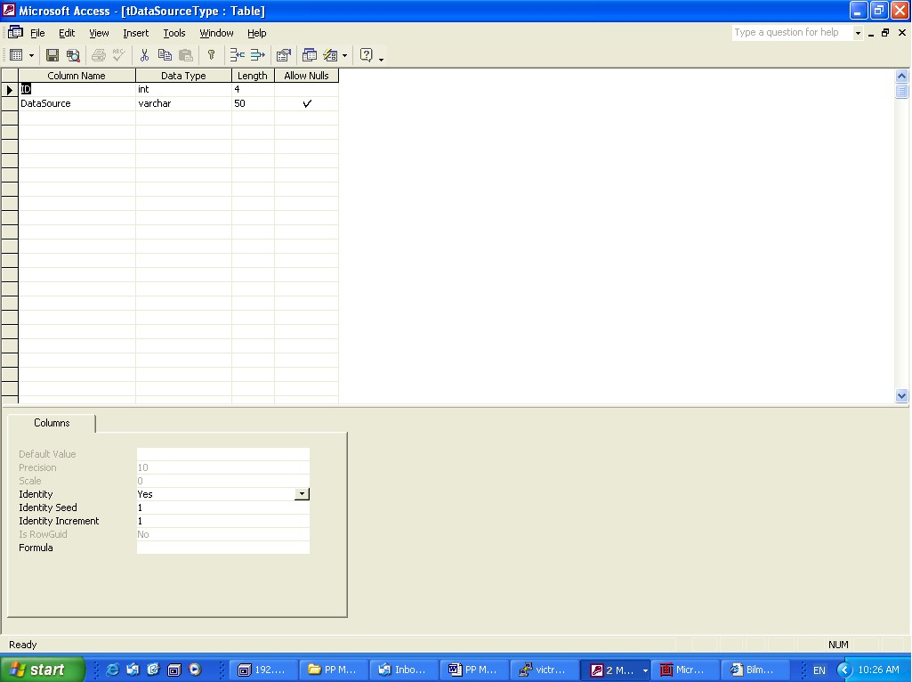
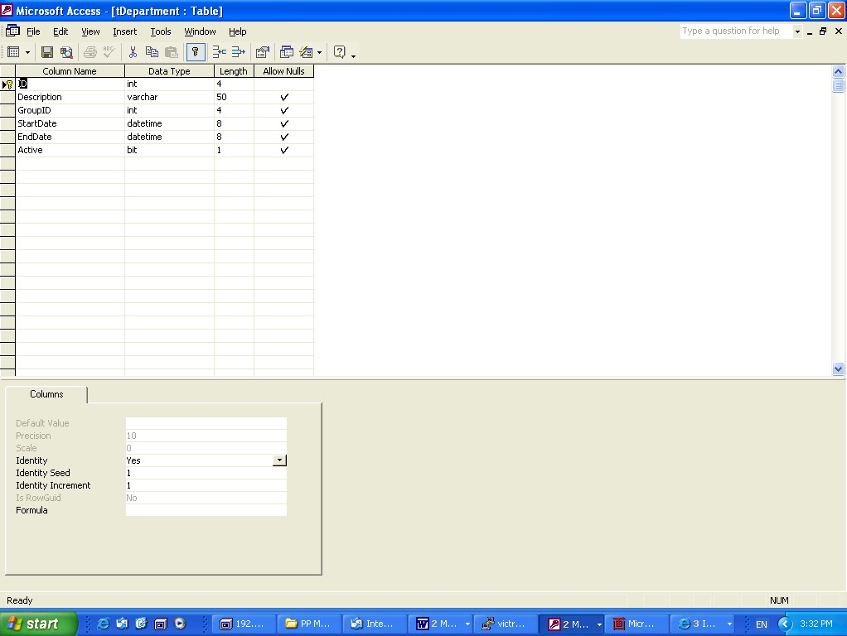
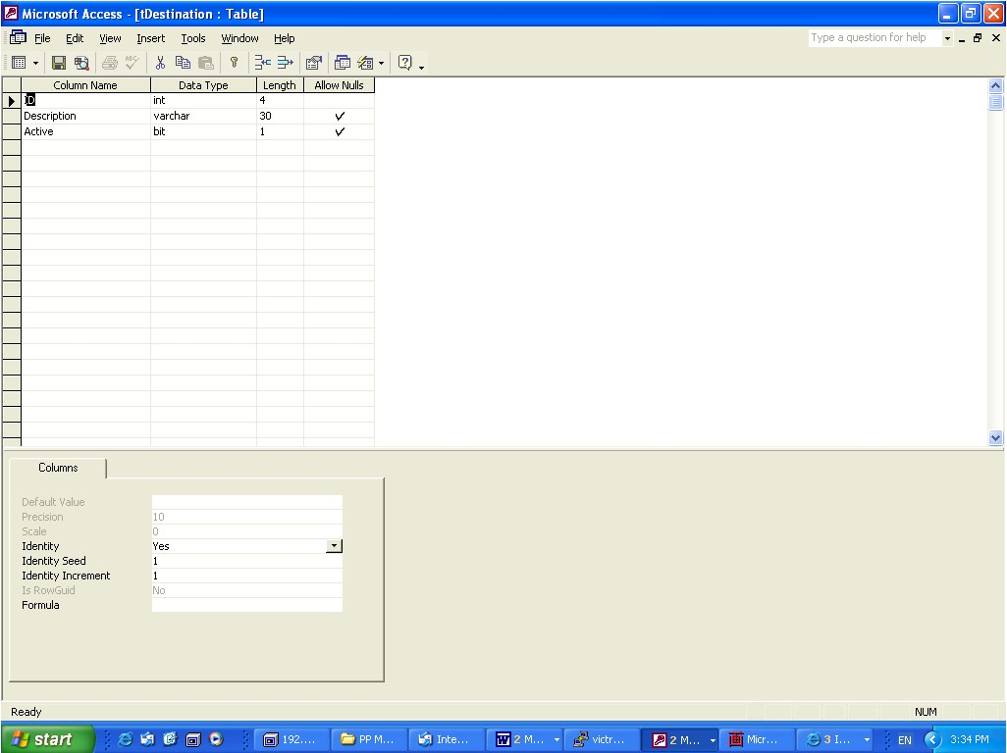
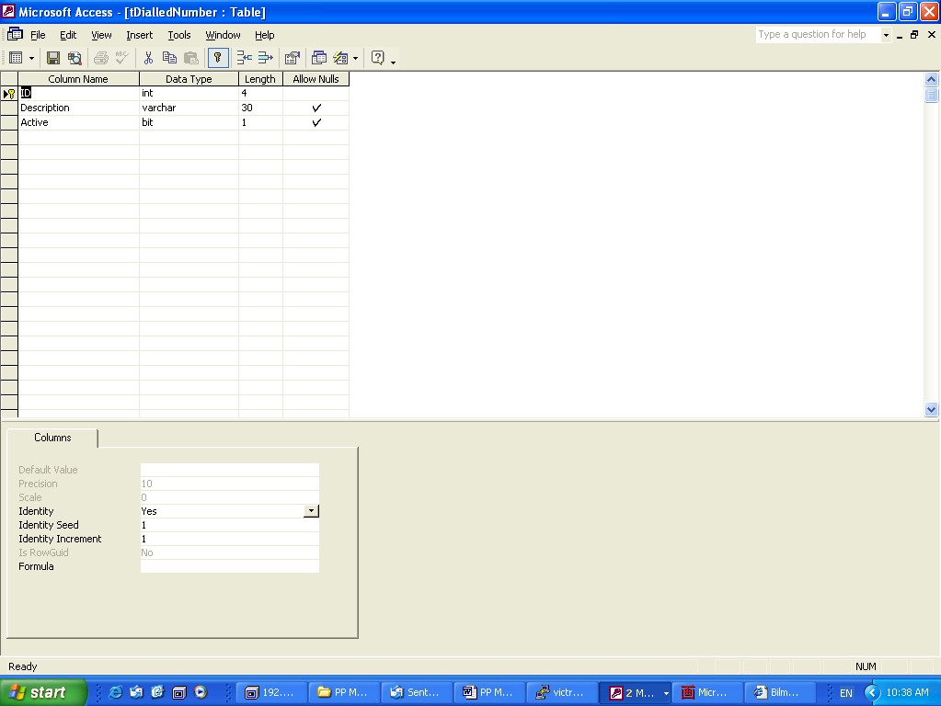
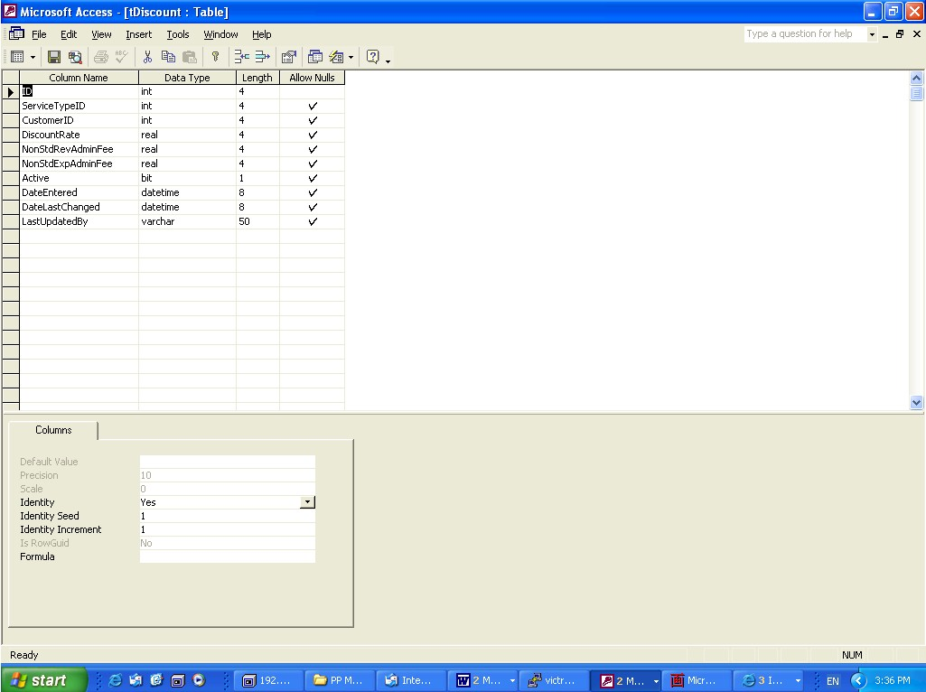
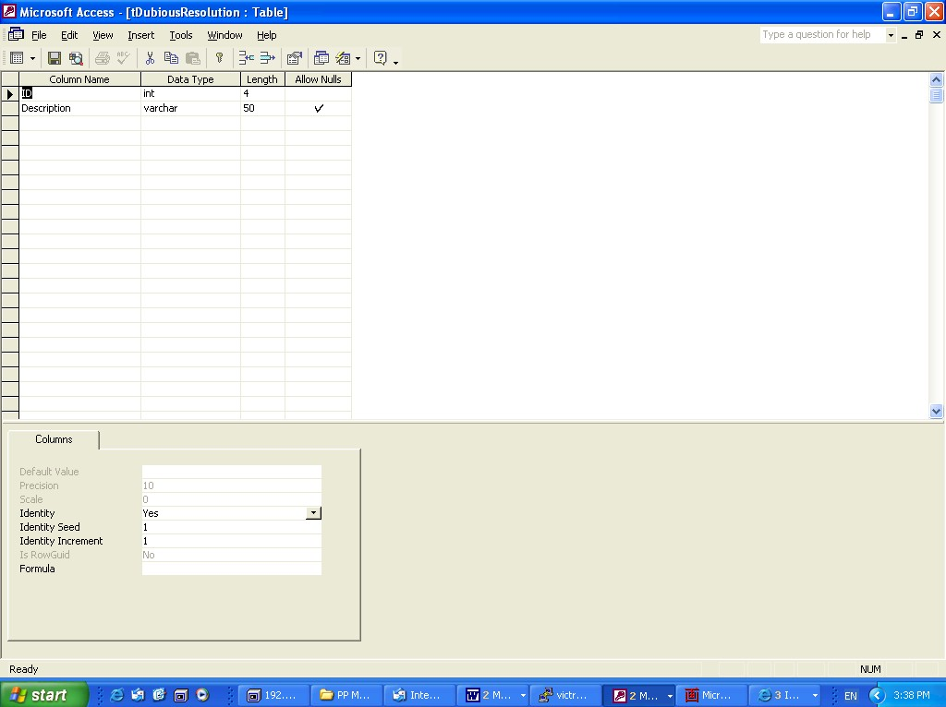
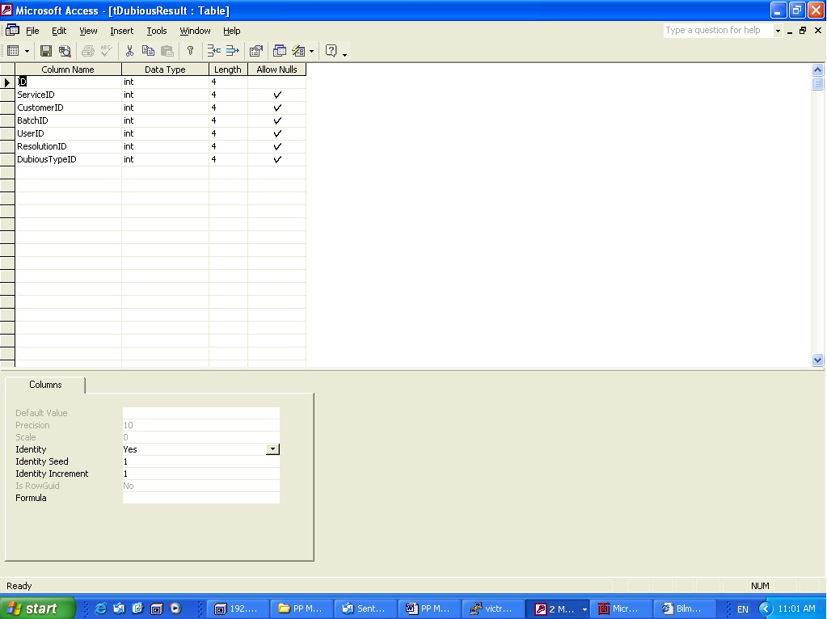
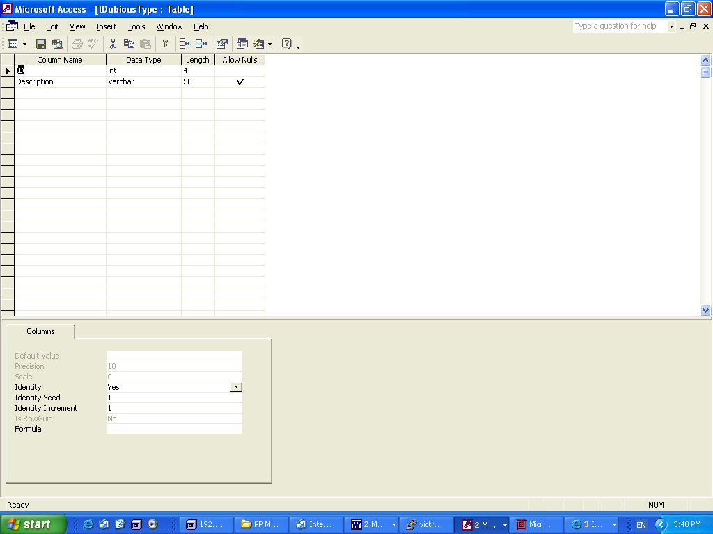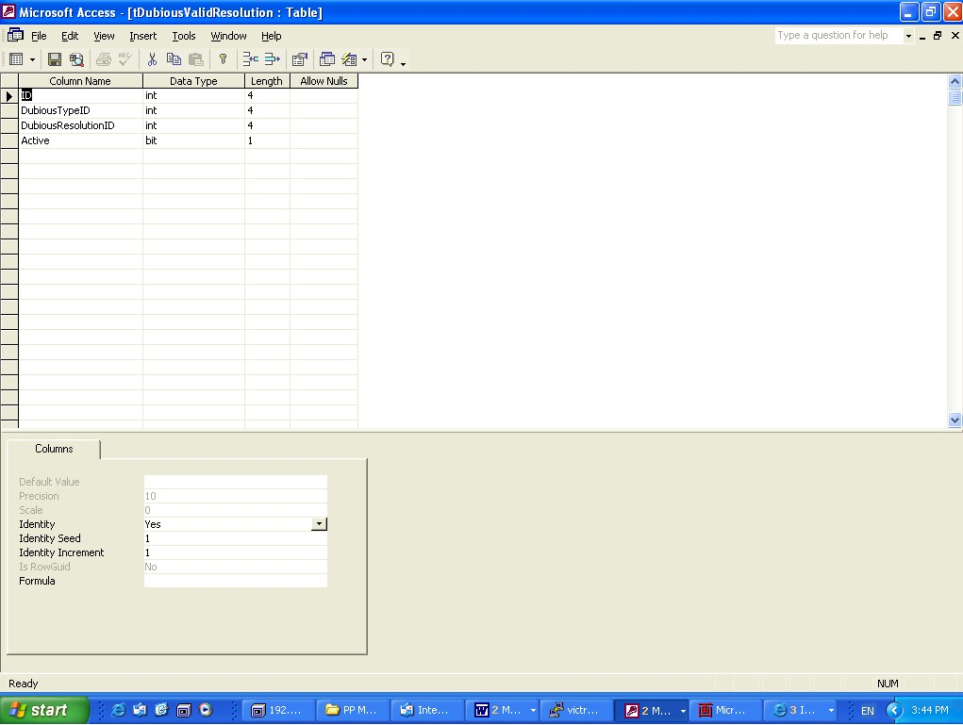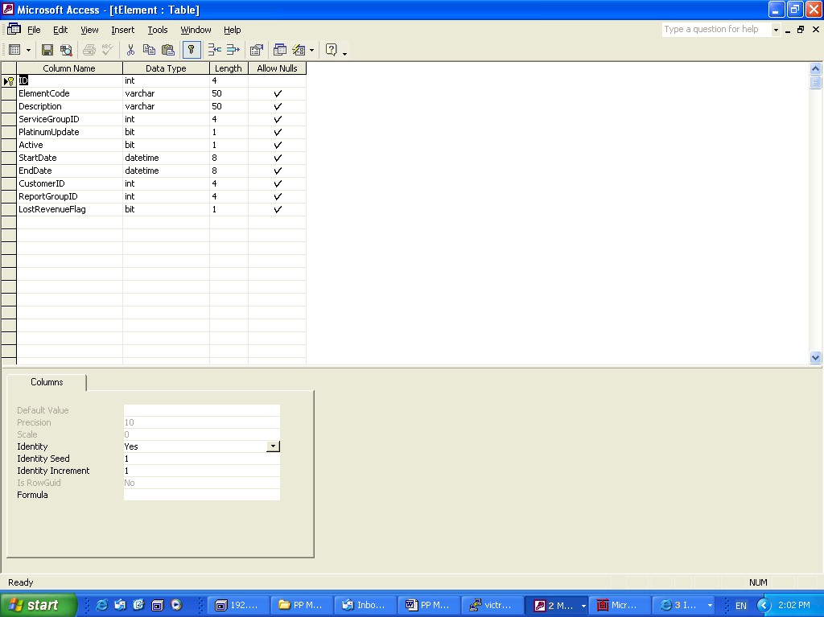
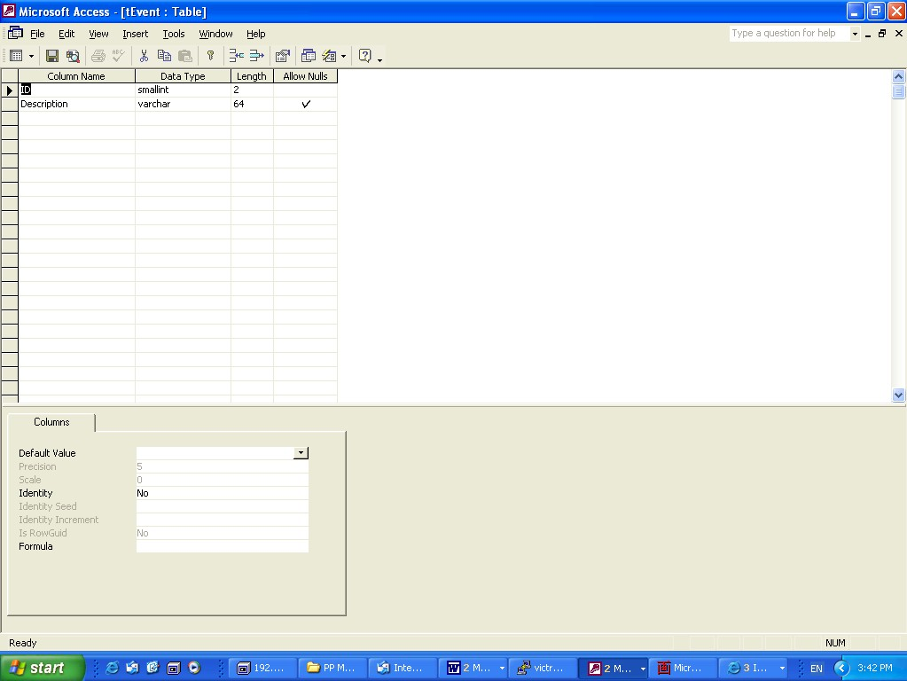
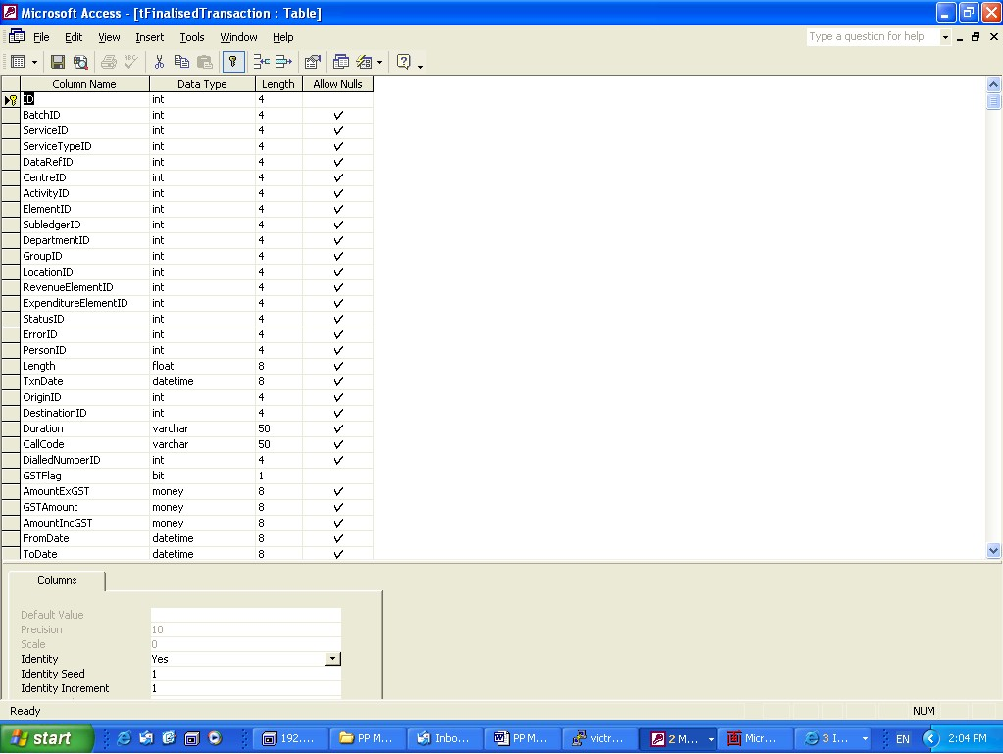
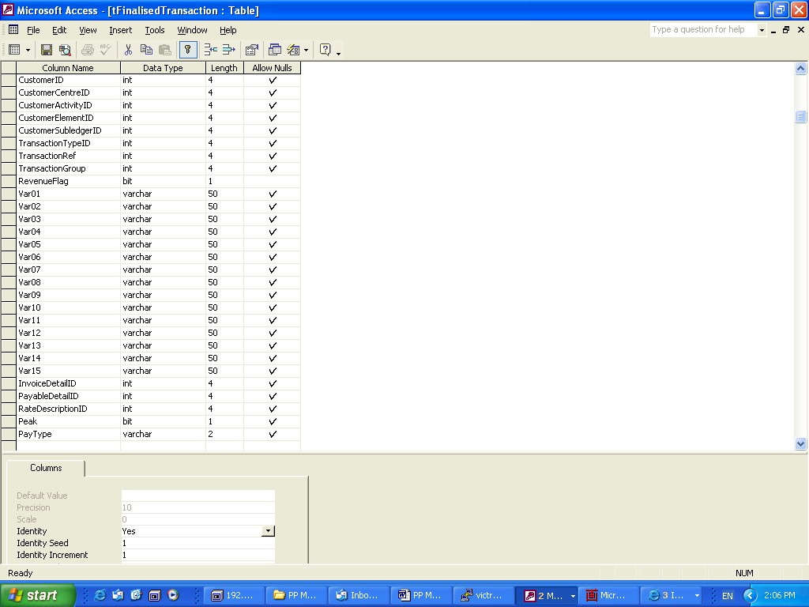
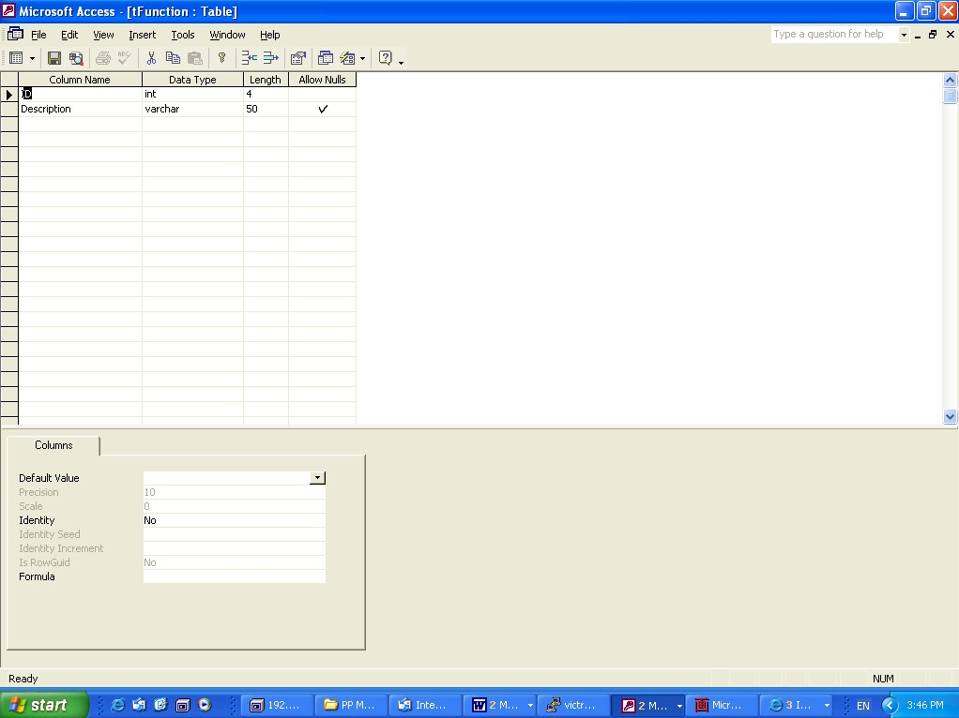
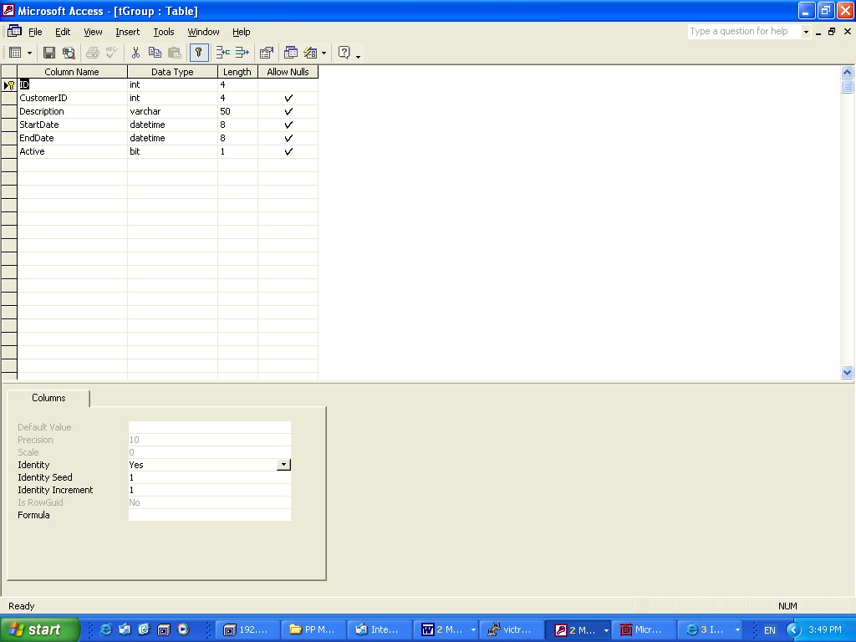
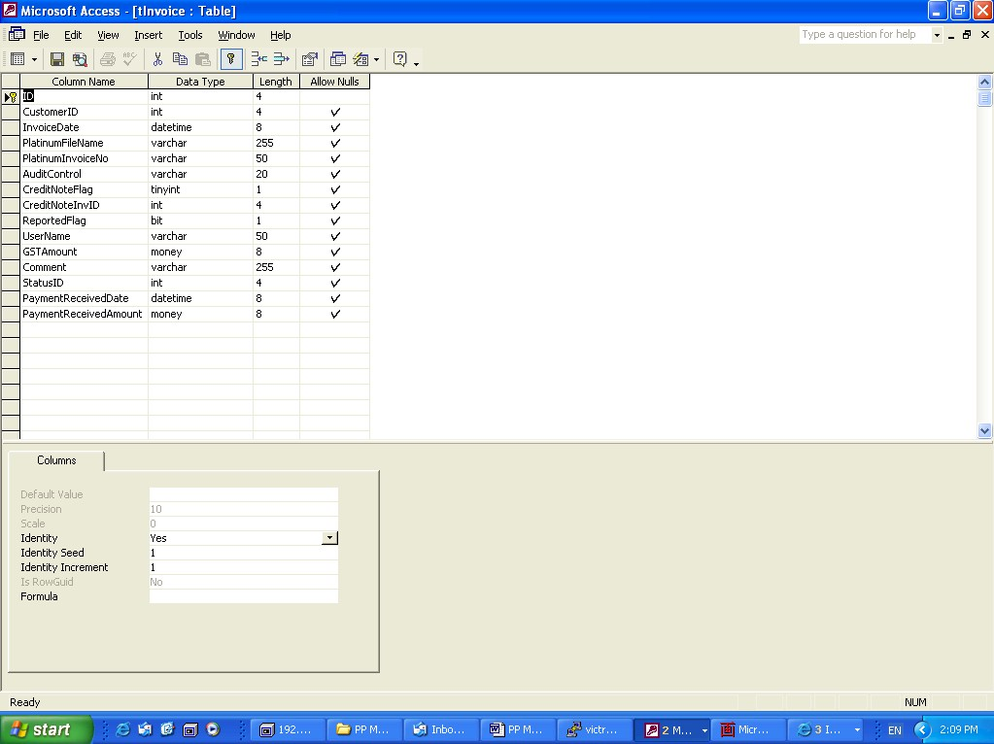
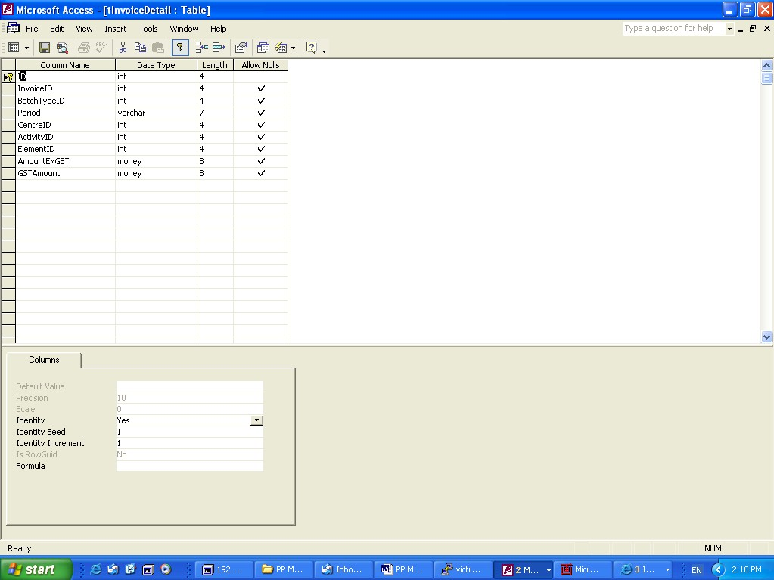
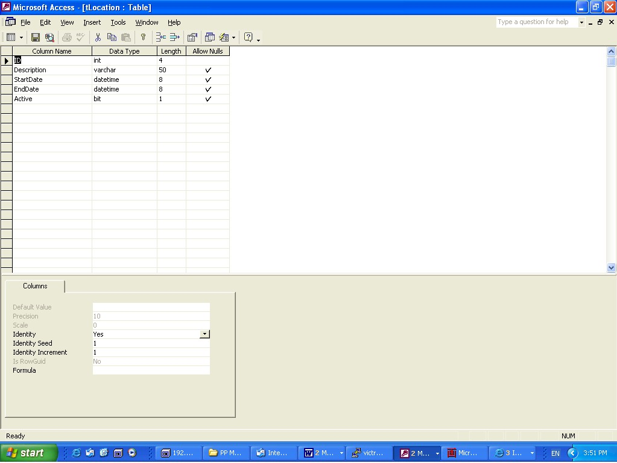
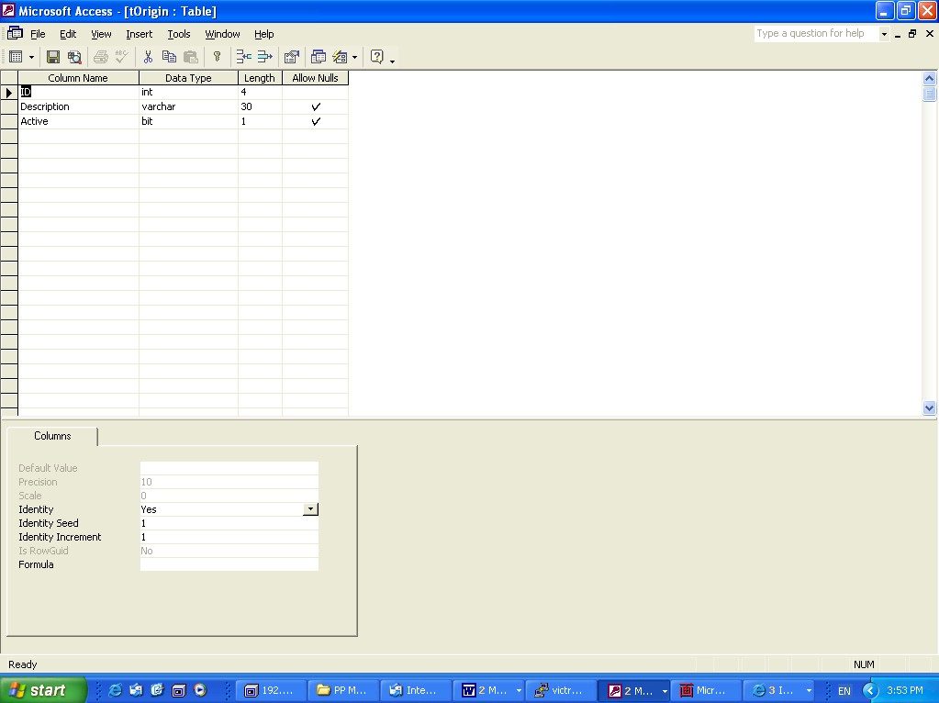
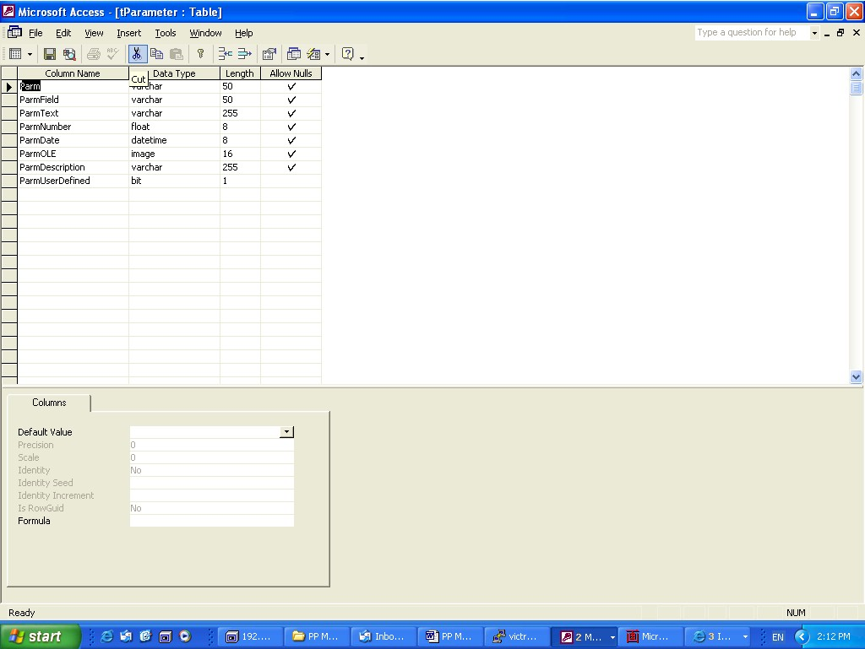
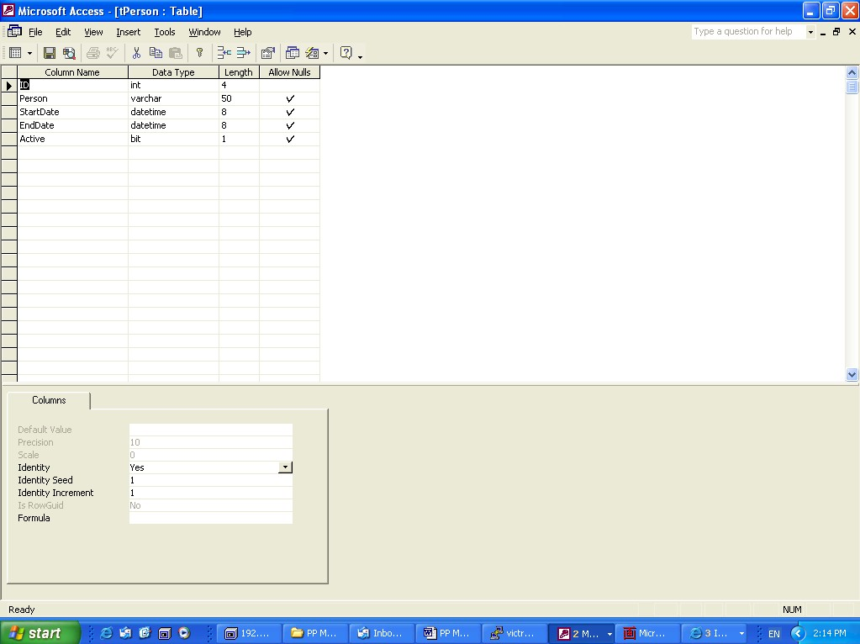
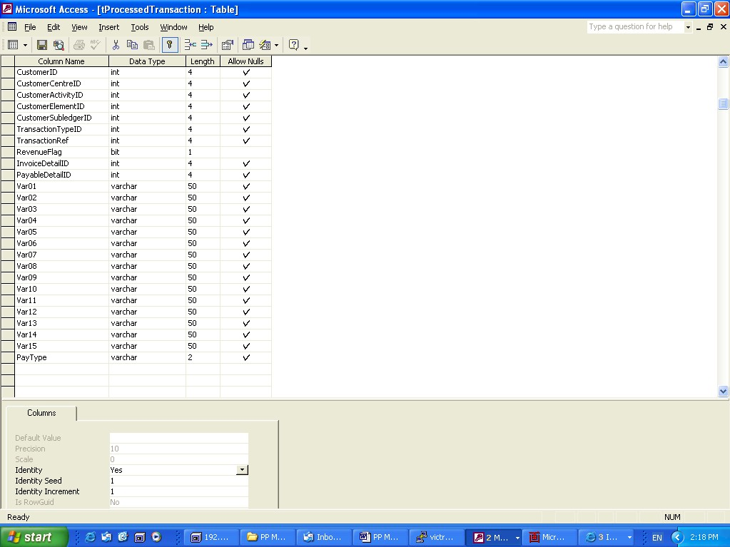
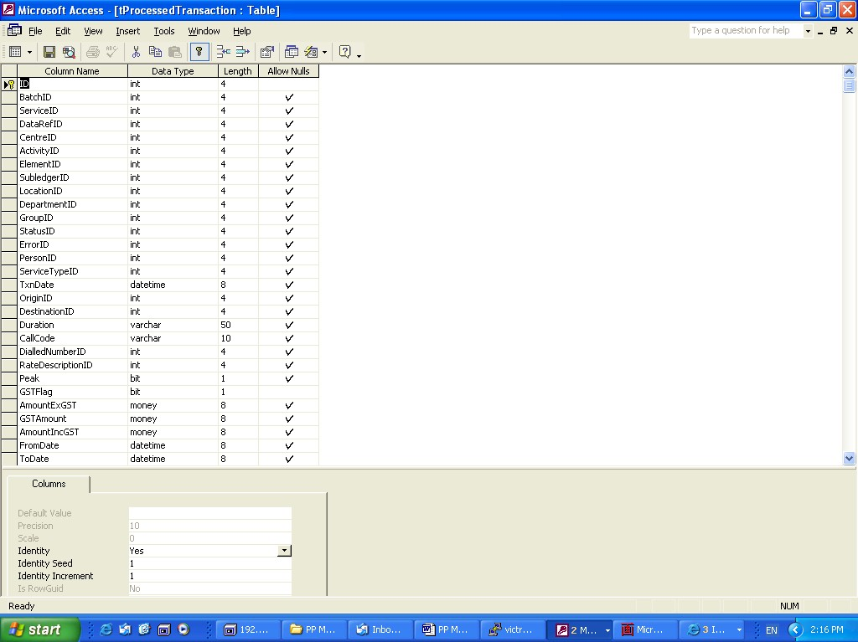
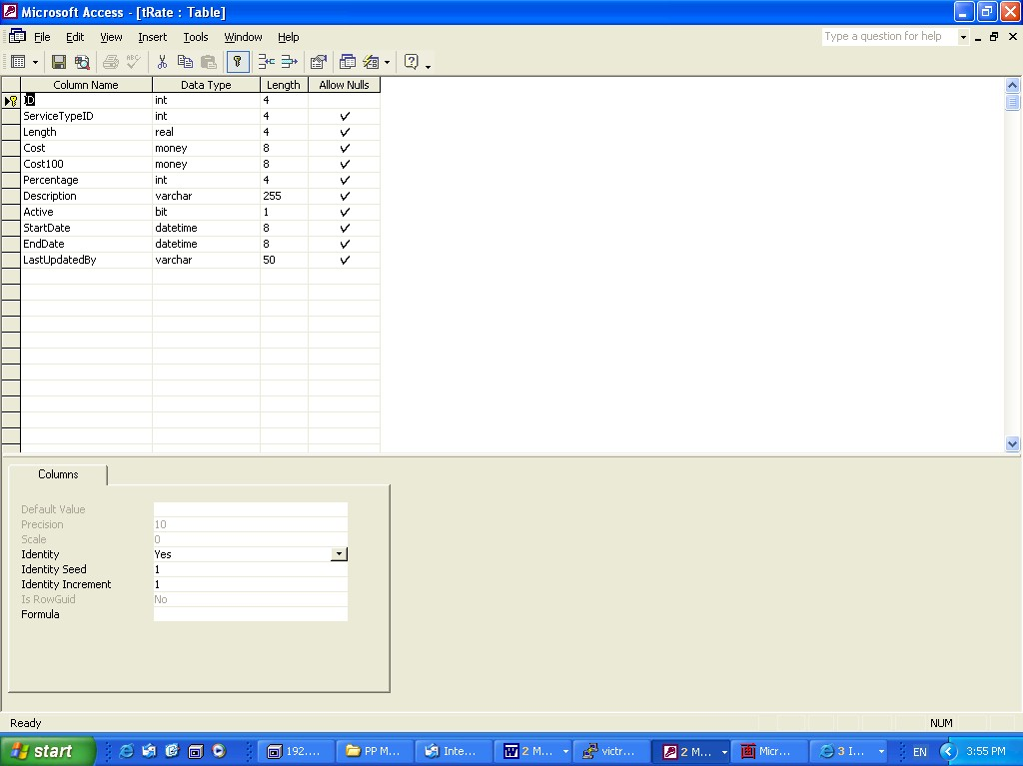
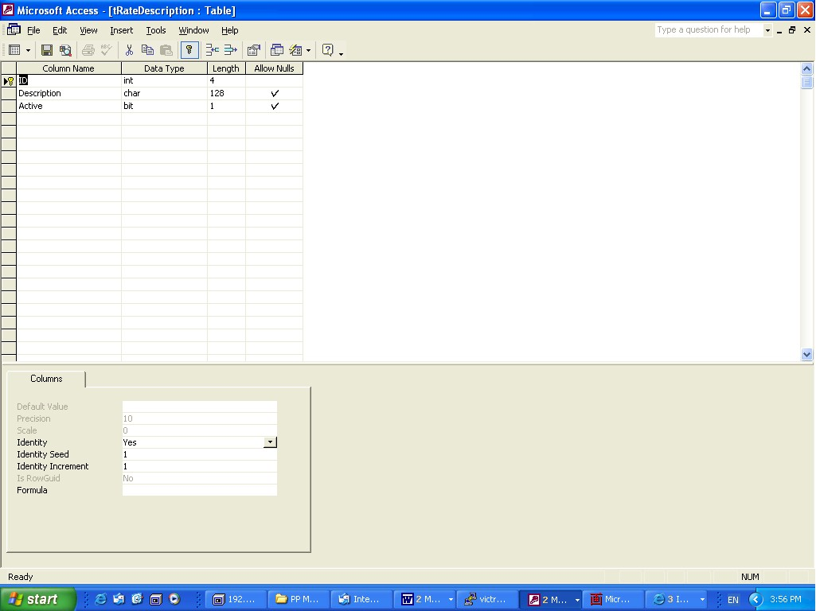
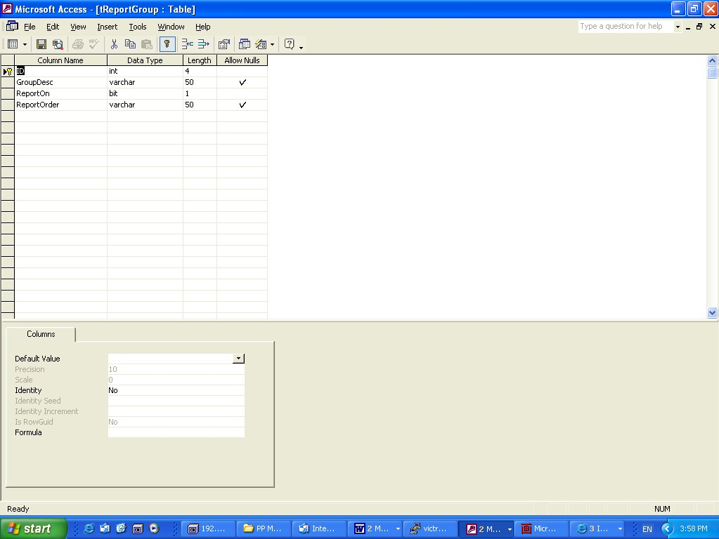
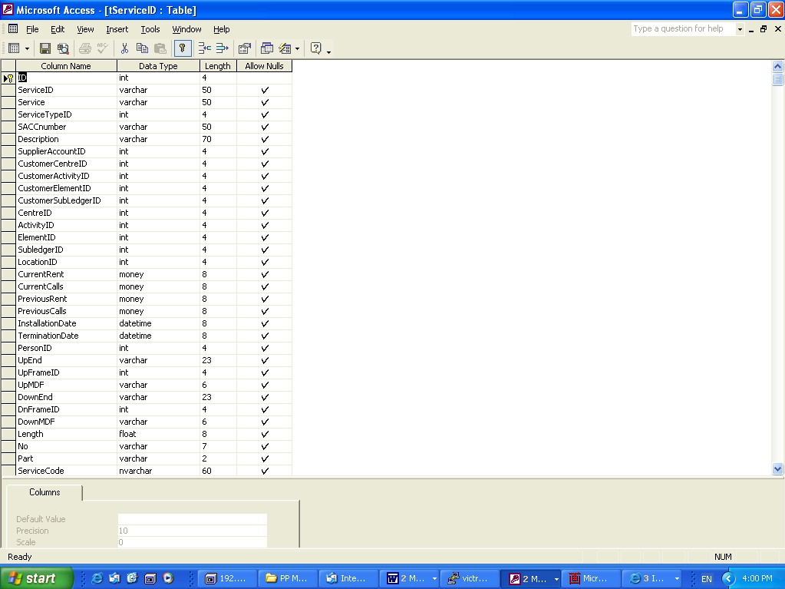
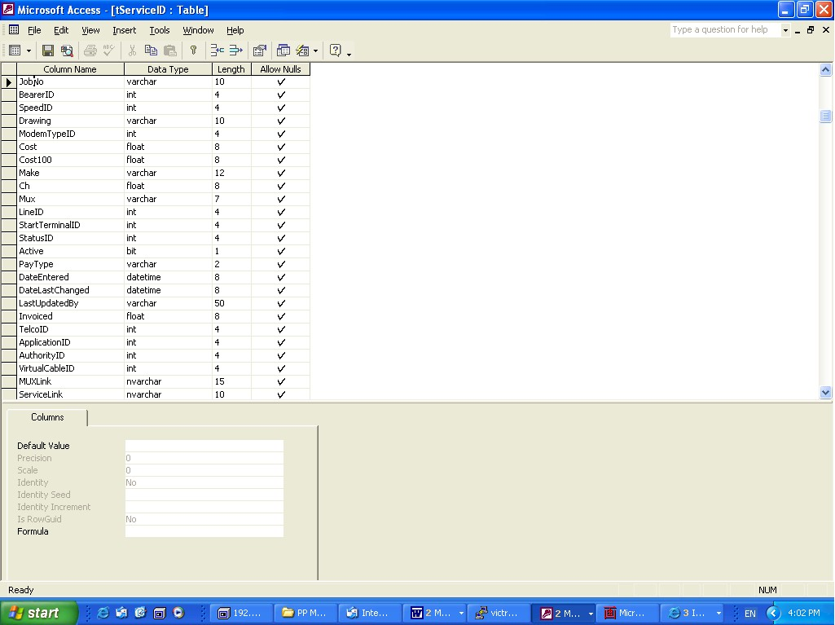
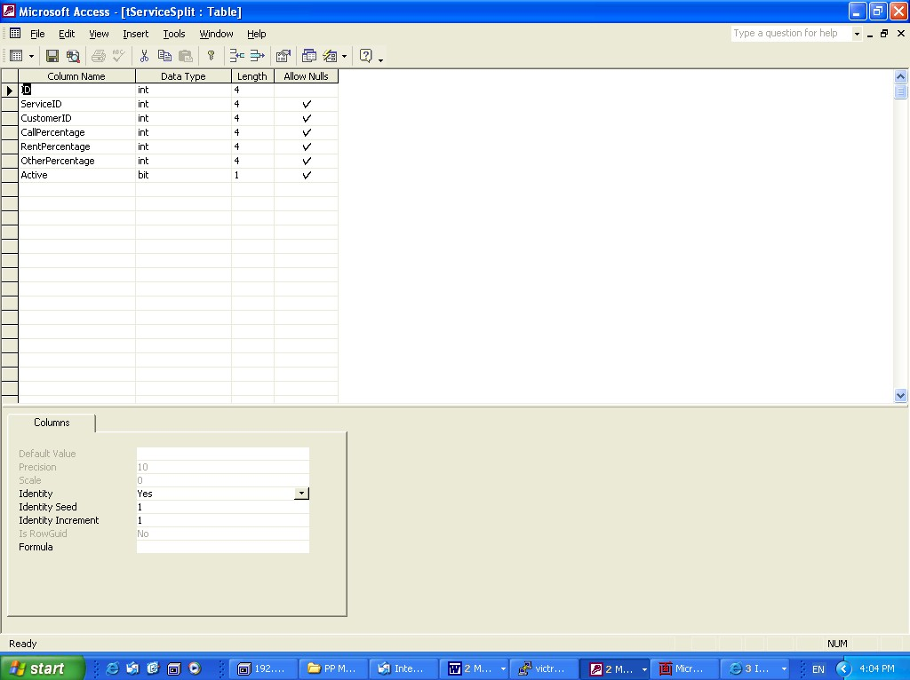
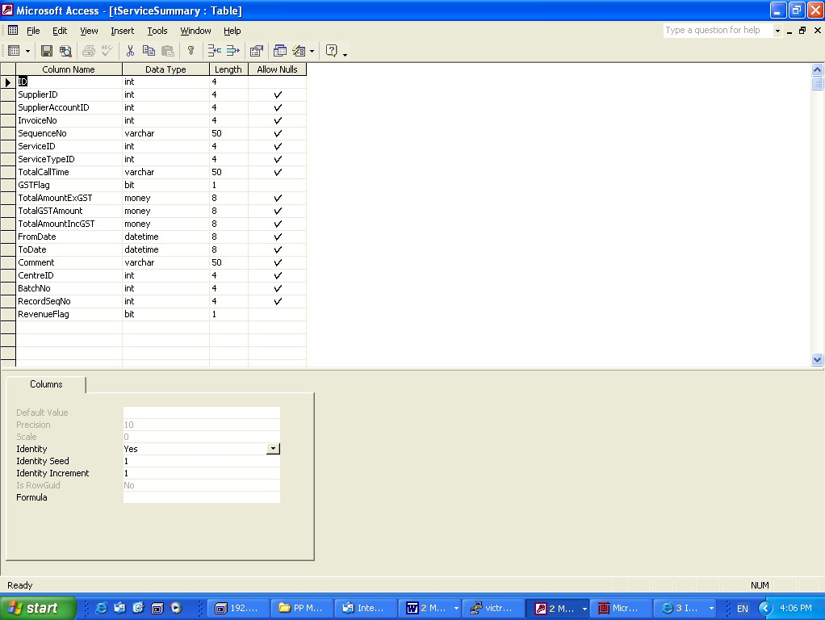
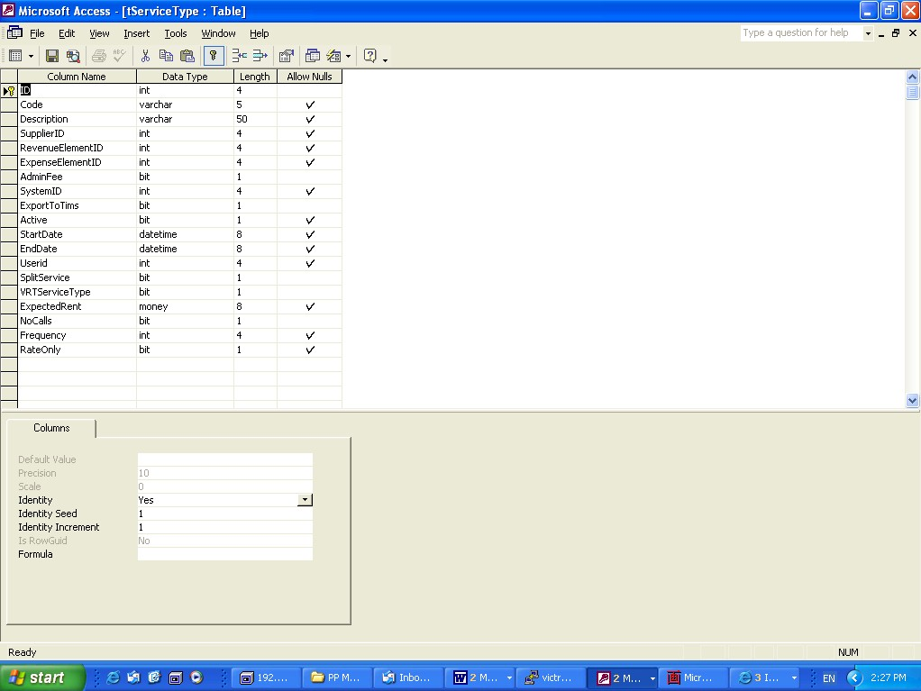
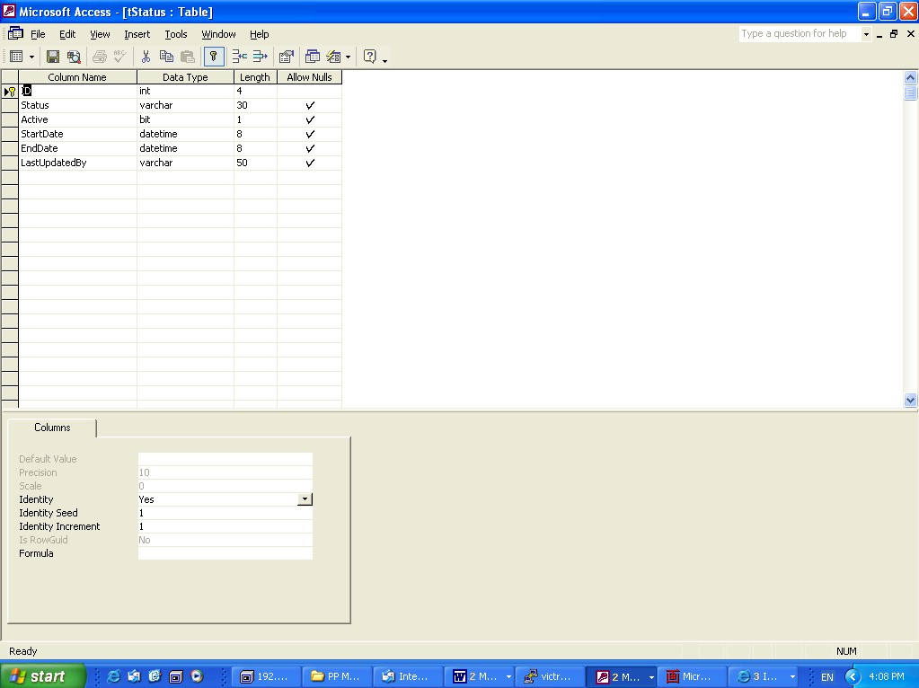
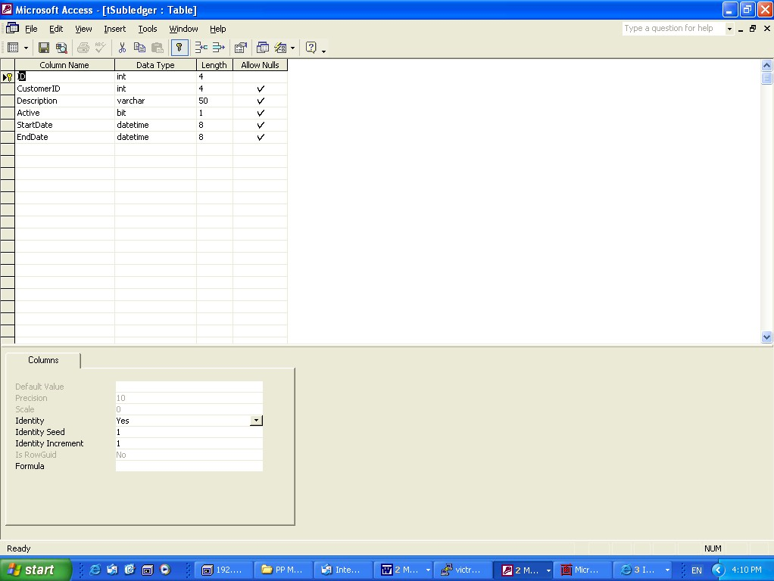
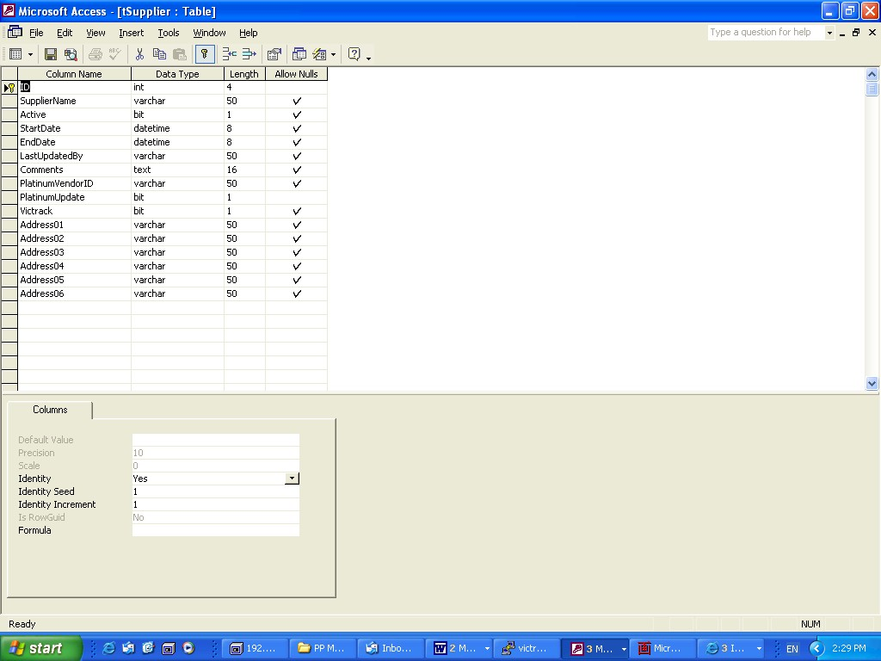
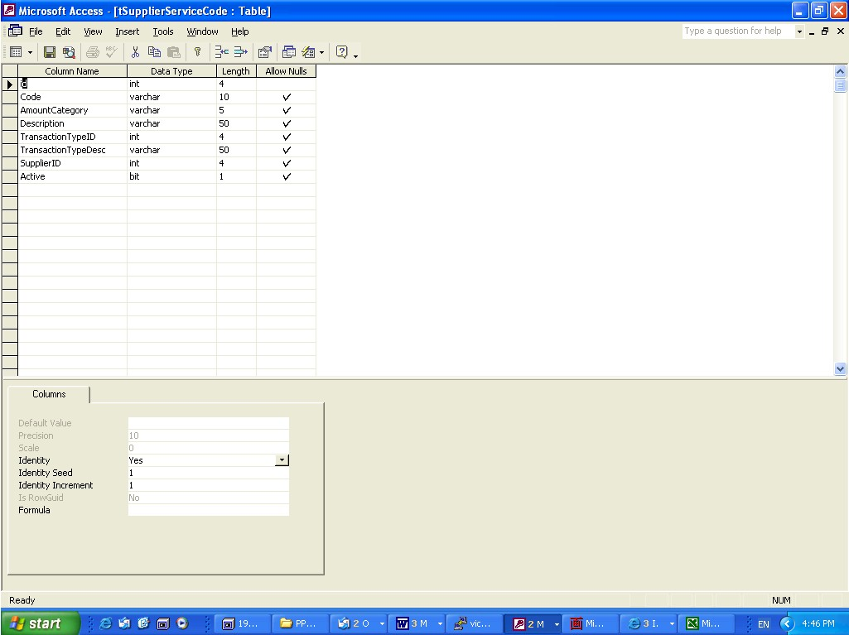

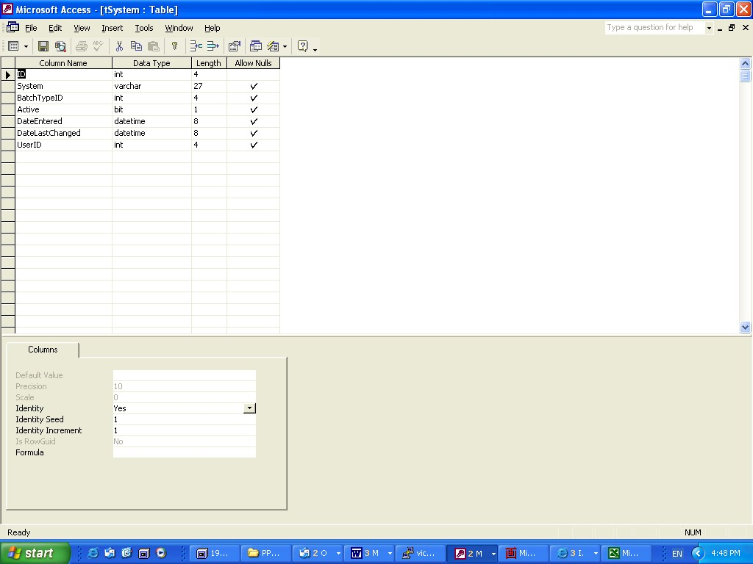
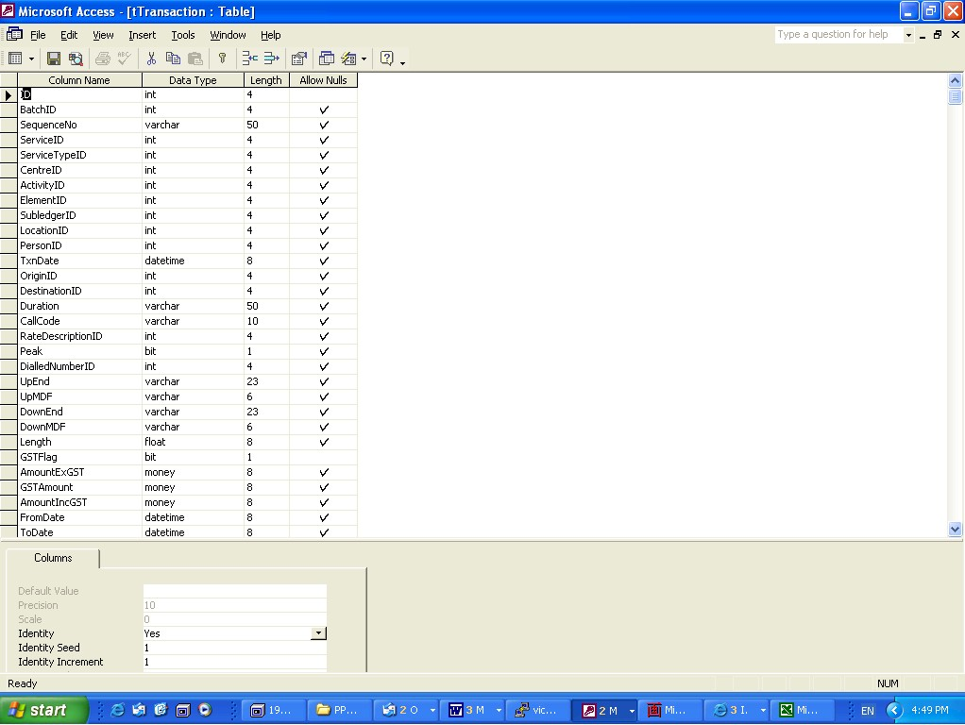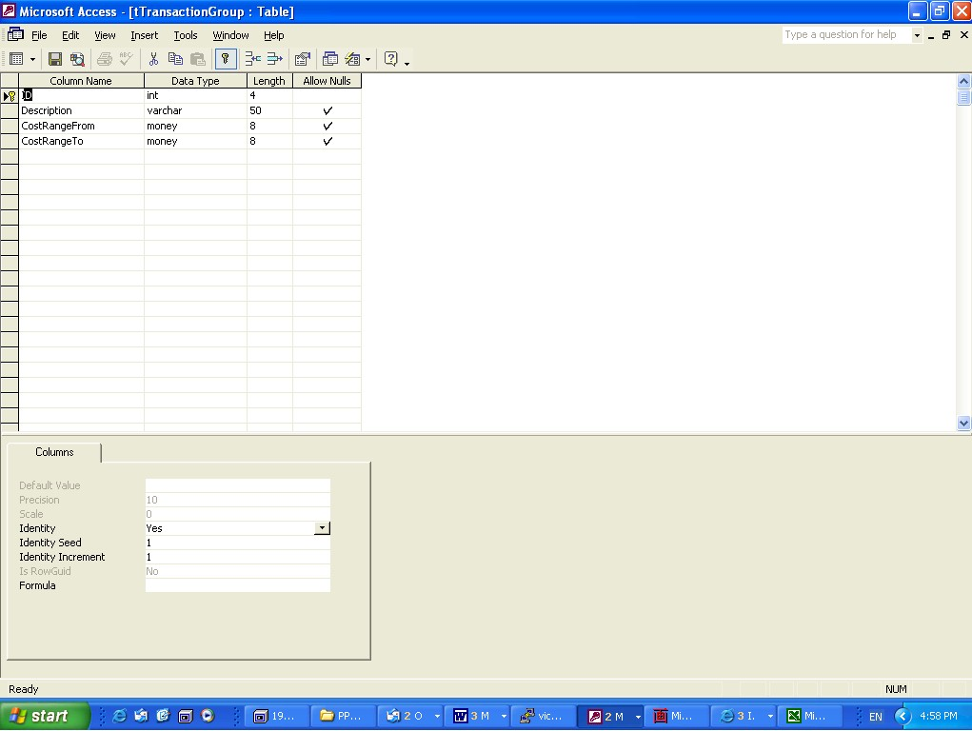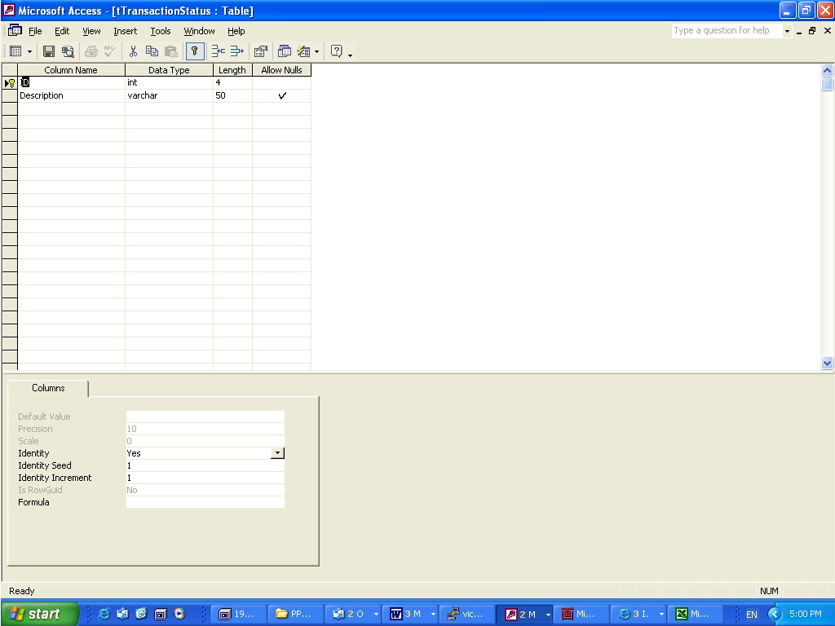
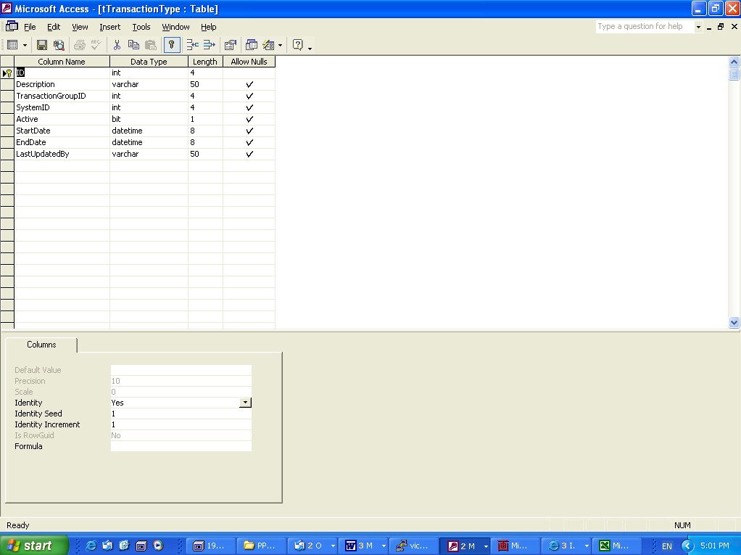
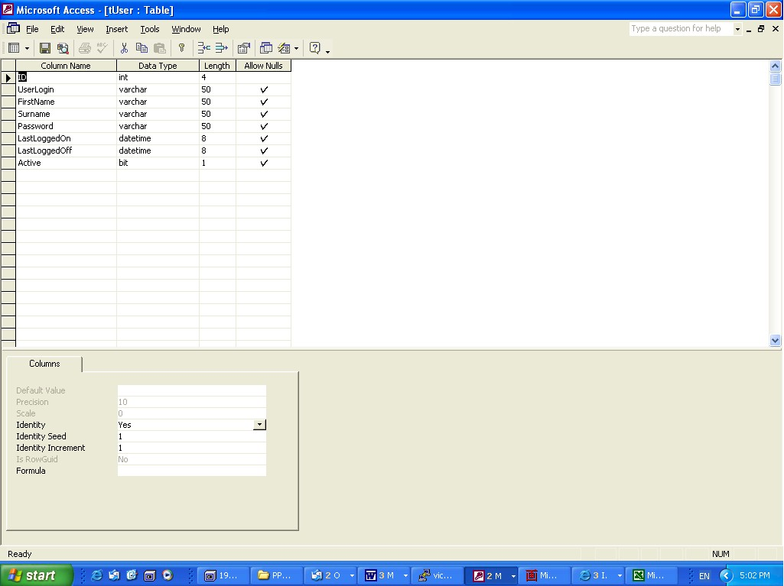
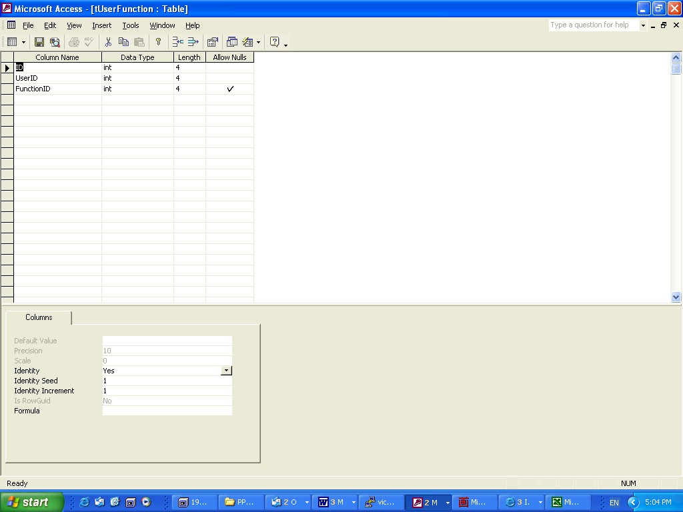
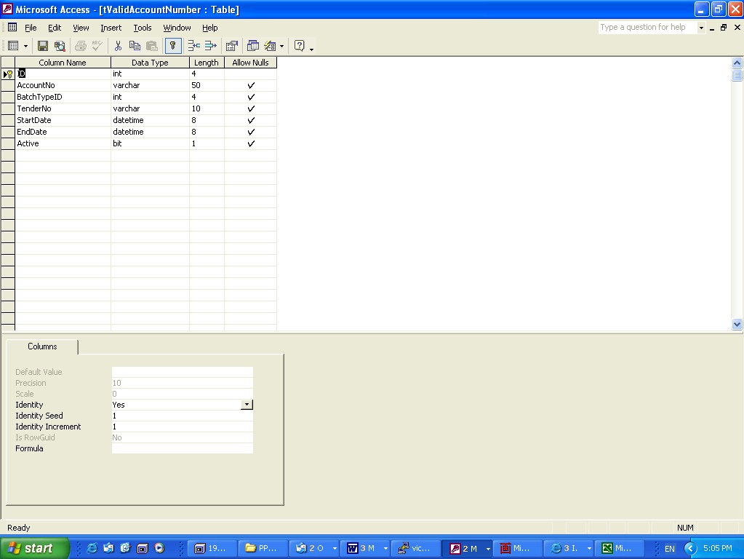

Index

Batch Processing
Main Screen

Initiated
Assist user to see that he has not missed a bill.
Type in some detail from the Hardcopy into the batch table.
PP could anticipate the date ranges - rentfrom, rentto; Callfrom, Callto.
Payment Made for last bill. Adjustment Balance from Last bill
See if opening balance is the same as closing balance of last bill

Imported Data

Batch Status Summary

Critical Errors
Optional equivalent to rejects in TAS
optional as there may not be any errors

Critical Checks passed moved Data to the Transaction table
in the Audit table you will see the re-running of the Critical checks by whom and how many times.

SERVICEID NOT IN tServiceID table
If a critical error occurs when importing a carrier bill then if the service is flagged to be not included then it has a transaction type of "Adjustment". All Transaction types = Adjustment are to be visible in the adjustment section of the batch review. Drill down should be available for all adjustments in the Batch window.

Unexpected Calls
Add new critical check which rejects a ServiceID which has Unexpected Calls. This uses the NOCALLS flag in servicetype to produce rejects for ServiceID that should not generate calls.

1. ServiceID exists
2. New ServiceID is included in the import data. (Batchs provide a list of accounts which are linked to ServiceID table and the accountid field.)
3. New If a ServiceID did not get imported but is linkedto the ServiceID table with that accountID.
4. New SplitService check (#1)
5. New Adds up individual amounts and check to see keyed in Batch total from the Hardcopy front page.
6. New ServiceID has Unexpected Calls (#18)

Split Costs
No Account Additions
No Account Omissions
Tariff & Rates

Where an amount billed is based on a calculated rate, that billed amount can be checked by the PP doing its own rates and tariff calculation. A table of service types, tariffs and rates can be used to check the amount, based on the call type and duration.
For each transaction, the PP will determine the charging method (by analysing the transaction type), find the rate applicable for that transaction (call), and by calculating its duration, determine the expected charge of the call.
The Tariff table will include Flagfall Cost, Initial Period, Initial Cost, Additional Period and Additional Cost for each Transaction Type, for each Service Provider and each Batch Type (which determine which pricing agreement is used). It is suggested that agreement numbers and periods are stored against the batch type.
If the actual charge varies by more than a specified percentage (configurable by the user), the call will be highlighted as dubious (non critical).
Users will be able to adjust the percentage parameter, and re-run the check.
What we need to determine here is 1) were we charged the right amount, 2)if were were charged the correct amount do we get any return 3) if were are been charged an incorrect amount what do we get. I have put something in the screen drop document that sould suggest the call types (ratedescription) which will produce a list of serviceids which could be filtered to all, correct and incorrect??
I don't think that we want all the details returned but want a list of services as indicated in the screen drops and a total for each service for each call category.

Add an agreement table which has fields ID, startdate, enddate, supplierID, agreement number. Need to supplier Ron a copy of the Telstra agreement and a mobile phone agreement to test this agreement table and this check.

What we need to determine here is
Are we charged the right amount?
Which transaction types are correct amount?
Which transaction types are incorrect?
I don't think that we want all the details returned but want a list of services as indicated in the screen drops and a total for each service for each transaction type.
Calls Less than Rent Check
For bills from Carriers, the total of the calls for a service will be compared with the rent for that service. Any rents that are higher than their calls will be flagged as dubious (non critical).
The PP will compare the total expenditure amount for transaction types which are flagged as “calls”, with the total expenditure amount for transaction types which have been flagged as “rent”, for each service.

I think that this one is self explanatory
Activity Change Check
For specified batch types, this check will compare the average value of the summarised transactions (all types) for a Service ID with the previous batch’s average for that Service ID. The previous batch average will be stored against the Service ID each time the batch is released.

When Release occurs the rent summary and call summary are to populate 2 new fields in the ServiceID table called CurrentRent and CurrentCalls and the values previously stored in those fields will be moved to another two new fields PreviousRent and PreviousCalls. We would want a system parameter for the default variance percentage - 10% but would like the ability to apply a different %

Critical Errors
Detail
Summary
Resolution

Expenditure Released for Payment

Administration Fees
Summary
An admin fee transaction may be created for revenue and/or expenditure transactions. If applicable, a single admin fee is created for each grouping of ServiceID Revenue transactions and ServiceID Expenditure transactions within the batch.
The element stored against these transactions will be drawn from a system parameter (AdminFeeRevenueElement or AdminFeeExpenditureElement). The amount stored against each of the admin fee transactions is calculated using a percentage based system parameter (AdminFeeRevenueRate for the revenue transactions and AdminFeeExpenditureRate for the Expenditure transactions).
For each ServiceID, the PP will first check the tServiceType table (field AdminFee) to determine whether admin fees are applicable. If tServiceType.AdminFee is false, then no admin fee is created. A transaction is created to record the lost revenue due to not charging an admin fee. This record in the tTransaction table will be given an element derived from a system parameter (LostAdminFeeRevenue) and will be given a status of InfoOnly. In this way, these lost revenue transactions can be easily excluded from further calculations, but will enable TSG to track lost revenue caused by not charging fees or discounting.
The Admin Fee can be calculated either by using the default Admin fee or by using a specific rate for that Customer/Service Type combination (Non Standard Admin Fee). If a record exists in the tDiscount table for that Customer and Service Type, the PP will check to see if there is a value in the NonStdRevAdminFee field and/or the NonStdExpAdminFee field. If there is, the PP calculates the admin fee (for revenue and/or expenditure transactions) using the value stored here. A transaction will also be created for the variance between the Standard Admin fee (for this ServiceID) and the Actual Admin Fee.

Detail

Discount Fees
Some Customers will be eligible for discounts for certain service types. Discounts are to be calculated after admin fees have been applied. For each grouping of ServiceIDs within a batch, the PP will check the tDiscount table for the appropriate Customer and Service Type. If this combination is not found, then no discount applies. If a record is found for that Service Type and Customer, the percentage held in the DiscountRate field is applied to the total value of the revenue transactions in the batch for that ServiceID. The resulting amount is then stored as another newly created transaction with the same revenue element as the revenue transactions (with a negative revenue value). Also created will be another transaction for the amount discounted, with an element used for these transactions drawn from a system parameter (LostDiscountRevenueElement). This will enable TBS to track the amount of revenue lost due to discounting.

Discounts should be calculated after all admin fees have been applied. They should only be calculated on transactions that are not InfoOnly, i.e. Lost Revenue transactions should be ignored in discount calculations.
If the customer for this service type is eligible for a discount of 10% and the total revenue for that Customer/ServiceID for the batch was $8.56 (as in the first example above) the transactions would look like this:
Date | ServiceID | Value | Transaction Type | Element | Revenue/  Expense
18/8/03 | 0413 757 149 | -$0.86 | Discount | 1046 | Revenue
18/8/03 | 0413 757 149 | $0.86 | Discount | ???? (lostRev) | Info Only

The last transaction represents the amount that will not be charged due to a discount being given. This enables the revenue lost due to discounting to be tracked.

Dubious Errors
Rental variations for the same Service Type.
Changed code ( which means that the rental was correct)
Sent query to Carrier ( which means requested carrier for correction of rent) Carried Forward ( which means that you did not do anything this time )

Value Range
The system will allow ranged parameters to be set-up for transaction types within a batch type. These parameters will consist of a minimum value and a maximum value. Separate parameters can be allocated to each transaction type, and for each Customer, allowing different rules to apply to different categories of service.
For example, on a specific bill, Local calls may be set to be between 15c and 15c, meaning that any local call that is not 15c will be flagged for investigation. This would allow VicTrack to ensure that any agreements on fixed call prices are being honoured.
On the same bill, mobile calls may be set to be between 0c and $40 (for example). Any call outside of this range would be flagged for investigation. This would highlight possible billing errors.
On the same bill, another range could be set for rents.
At the completion of this and the following tests, the user will be presented with a list of all items which are flagged as dubious with the reason why. The user will be able to view them, filtering and sorting them on all fields. The user will be able to be able to print a report of any of these views.
All items flagged for investigation will require acceptance by the user (setting an “accepted” flag and action) before the batch can be progressed to the release stage.
At any stage, parameters can be adjusted and the Value Range test could be re-run.

I believe that there needs to be a screen for input for the value range testing and have put a screen drop of the WinEBS as a suggested format. I like the idea of the offending serviceids down the side. The problem with the Telstra product is that it does the search incorrectly. The criteria said Long Distance Calls greater than $11.00 but instead I got the total call costs greater than $11.00. I would be expecting to see on the top blue line the total std spend and the offending individual calls > $11.00.
I would suggest that the query parameters as shown in the screen drops could be the Transaction Types or the RatesDescription in Datacollection. I know it is not this table that the query is done on but the kind of data that is in that field.
The value range check looks at the transaction types eg Calls which is a Transaction Group and as the parameters are stored against here then applies to all the transaction types which are under that group i.e. Local, STD and Mobile. The parameters should be stored against the Transaction Group - CostRangeFrom and CostRangeTo. The output is provided with the left-hand side of the window includes a list of "Dubious" ServiceID and in the right-hand window shows a total of the transaction group for that ServiceID and detailed below is only the dubious transactions. The check is on transactions not the total of the transactions eg If you put in the costrangefrom 11 ($11.00) and in the costrangeto 9999999 (9,999,999) then it will look for calls in each of the transaction types which met that criteria. The group for that may be $200.00 but the transaction may be a STD call which was $12.00 and that would be the only transaction in the breakdown.

Calls less than Rent
Activity Change

Dubious Errors
Detail
Summary
Resolution

Revenue Released to TBS

Expenditure Released to TBS

Split Costs
Split Costs will be a Critical Error Check
Presently, the only way to know if a serviceID is split is by viewing the user table and see if a Customer number is assigned against the serviceID, which is not viewed during the import stage - 1st Problem. The next time you see if a service is split is when you run the Sundry and the printout shows the serviceID with a "- Shipto" = "- CGE".

It would be good to be able to know if all ServiceID involved in an import are split prior to validation. The only way to achieve this end is to make the SplitCheck a Critical error.

To achieve this the ServiceType table requires a new field called SplitService which is a flag indicating Y/N. So if a servtype has the SplitService flag ticked then PP needs to check the tServiceSplit table and determined the applicable ShipTos (CustomerID), lookup the applicable ServiceID and see if any ServiceID which meet that criteria are not in the tServiceSplit table. Example ServiceType = TQ has tick; tServiceSplit table has 5200BHL, CGE, 0%, 100%, 0%; and 5200BHL, ALF, 100%, 0%, 100%. In tServiceID is 5200PWS, 5200BHL and 5200PWS rejects as its Shipto is CGE and service type is TQ.

DISPLAYING OF CALL DETAILS WHEN A SPLIT IS INVOLVED
PP will create the split transaction for each part of the split including call details, which will be the nominated split value for each shipto - the revenue item will not show the 100% price e.g. call detail will show the 1st split (ALF is 10%) 100 Call is $0.20 so ALF cost is 2c; 2nd split is CGE is 90% so the cost is 18c.

RESOLVING THE SPLIT COST CRITICAL ERROR
a) Must create the split for the "rejected" serviceID.
b) Change the servicetype to one which does not have a SplitService flag ticked.

DISPLAY OF SPLIT COSTS IN THE CD/WEB
Rodney will need to show the transaction type so that the pricing does not seem strange eg the 2c call.

Bill Splitting

Lost Revenue

Delayed Billing

ServiceID

Telstra Codes

Reference Data

Viewing

Adding

Editing

Screens
tActivity
tAgreement
tBatchstatus
tCentre
tCriticalType
tCustomer
tDataCollectionMap
tDataSourceDetail
tDataSourceType
tDepartment
tDiscount
tDestination
tDubiousResolution
tDubiousType
tDubiousValidResolution
tElement
tFunction
tGroup
tOrigin
tLocation
tParameter
tPerson
tRate
tService type
tStatus
tSubledger
tSystem
tTransactionGroup
tTransactionType
tUser
tUserFunction
tValidAccountNumber

Audit

Reports

Administrators Guide

Developers Reference

Glossary

Index

DataCollection Table to Transaction Table
The records are imported into the DataCollection table and the Shipto and ServiceType is populated from the ServiceID table. As it transfers the records to the Transaction table it looks up the servicetype table to find out if the SplitService flag is ticked and allocates the percentage for each of the Transaction Groups (Rent, Calls, Other) and creates transactions for each split and stores the Shipto/CustomerID on each transaction.

Damien and I have determined that there should be an additional "Dubious Check" - Rental variations for the same service type. Presently, I have Ashton looking at the rental cost for serviceIds with the same service type code. I have found that this check has been quite lacking in the past eg Rental for servtype = EX should be $31.77 and everything else should be investigated.

DUBIOUS CHECK - RENTAL VARIATIONS FOR SAME SERVICE TYPE.
Damien and I have determined that there should be an additional "Dubious Check" - Rental variations for the same service type. Presently, I have Ashton looking at the rental cost for serviceIds with the same service type code. I have found that this check has been quite lacking in the past eg Rental for servtype = EX should be $31.77 and everything else should be investigated.

DUBIOUS CHECK - CALLS LESS THAN RENT CHECK
To assist "3.3.2.6 Calls Less than Rent Check" to occur correctly and for services which should have calls. I would like to add a new field to be added to ServiceType table which is called "NOCALLS" which is a Y/N flag.
ACTIVITY CHANGE DUBIOUS CHECK
Activity change check output is to provide a list of ServiceID and provide transaction group totals for the current month and the previous month. The variance percentages must provide an input screen . A default value is to be stores in the Transaction Group table but the manual input is not override the stored value.

There was discussion about this next statement and whether that will be the method used for the current month and previous month, if so we have to add four new fields. When Release occurs the rent summary and call summary are to populate 2 new fields in the ServiceID table called CurrentRent and CurrentCalls and the values previously stored in those fields will be moved to another two new fields PreviousRent and PreviousCalls.

DUBIOUS CHECK RESOLUTIONS

At present the only tables included for this function is the tDubiousTypes and tBatchType. tDubiousTypes has the id and the description of the Dubious type. tBatchType has the field ValType1 to ValType8, so that "dubious transactions" can be applied to particular accounts.
RESOLUTION TABLE
Add another new Dubious Resolution table which shows the acceptable resolution codes for each dubious transaction check.
Dubious Check 1 - Rental variations for the same service type.
Changed code ( which means that the rental was correct)
Sent query to Carrier ( which means requested carrier for correction of rent)
Carried Forward ( which means that you did not do anything this time )
Dubious Check 2 - Calls Less than rent.
Ticked "No calls flag"
Checked History and no action required
Check History and action required
Carried Forward ( which means that you did not do anything this time )
Dubious Check 3 - Tariff & Rates Check
Call cost comply with agreement
Sent query to Carrier ( which means requested carrier for correction of call rate)
Carried Forward ( which means that you did not do anything this time )
Dubious Check 4 - Activity Change Check
Checked History and no action required
Check History and action required
Carried Forward ( which means that you did not do anything this time )
Dubious Check 5 - Value Range Test
Sent results to Customer
Carried Forward ( which means that you did not do anything this time )
At present the only tables included for this function is the tDubiousTypes and tBatchType. tDubiousTypes has the id and the description of the Dubious type. tBatchType has the field ValType1 ot ValType8, so that "dubious transactions" can be applied to particular accounts.
A new table is required that records the dubioustypes against the serviceid and the resolutions of those types and by whom and when.
Need another new DubiousResolution table which shows the acceptable resolution codes for each dubious transaction check.
Dubious Check 1 -
Dubious Check 2 - Calls Less than rent.
Ticked "No calls flag"
Checked History and no action required
Check History and action required
Carried Forward ( which means that you did not do anything this time )
Dubious Check 3 - Tariff & Rates Check
Call cost comply with agreement
Sent query to Carrier ( which means requested carrier for correction of call rate)
Carried Forward ( which means that you did not do anything this time )
Dubious Check 4 - Activity Change Check
Checked History and no action required
Check History and action required
Carried Forward ( which means that you did not do anything this time )
Dubious Check 5 - Value Range Test
Sent results to Customer
Carried Forward ( which means that you did not do anything this time )
Also I want the "Dubious Transactions" to not slow up the processing of the account, so I want that to be done after the release.
I want to do an additional "Dubious Transaction" which checks the rental for all similar type services. So I require a quotation for this. For this new check to work, I additionally require a new field to be added to the servicetype table which is called ExpectedRentAmt.

DUBIOUS TYPES
To assist "3.3.2.6 Calls Less than Rent Check" to occur correctly and for services which should have calls. I would like an additional field to be added to ServiceType table which is called "CallsOccur" which is a Y/N flag.
3.3.2.5 Tariff & Rates Check require tables as well but this is similar to the TIMS tariff tables so maybe Rodney can provide you with the necessary table structures. Here we are looking for a check against the offered pricing when we tender our voice traffic and ensure that the carrier provides the pricing offered. Damien believes that the local calls will be calculated by the 3.3.2.4 Value Range Test and only the STD, IDD and mobile will be validated.
I would like that the requirements for this part can be retained under an agreement name and have a to and from date so that we can see historically what pricing that we have been offered.
Additionally, the carrier would have to be recorded.

It is expected that these "Dubious Transactions" would be done on the TBS tables and on the Revenue Transactions only. Two things will be done after the release and the file is transferred to the ReleasedTransaction table is the payments will processed (expenditure transactions) and the dubious transactions will be validated (revenue transactions). Finally, after the dubious transactions have been validated then invoicing can take place.

TRANSACTION TABLE STRUCTURE
Add new field to link together all the transactions to the originating DataCollection entry. The new field is call DATAREF.
Transactions to be created
The following is a summary of a discussion between Ron Cranston, Robyn Douglas and Damien Reeves on 12 August 2003 and a follow-up discussion between Robyn and Damien on 3 September 2003,, dealing with how transactions are to be created in the Pre Processor.

Revenue/Expense Transactions
For each data collection line, the ServiceID is determined. Each ServiceID has a Service Type which holds a Revenue Element and/or an Expense Element. Records are created in the tTransaction table for each record in the tDataCollection table. Each tDataCollection record may generate multiple records in the tTransaction table.
If a Revenue Element is present, the PP will create a Revenue Transaction (in the tTransaction table) for the amount of the Data Collection record. The Revenue flag is set to true and the Revenue Element is stored in the Element field of the Transaction.
In addition, and regardless of whether a revenue transaction was created, an Expense transaction may be added. If an Expense Element is present, the PP will create an Expense Transaction (in the tTransaction table) for the amount of the Data Collection record. The Expense flag is set to false and the Expense Element is stored in the Element field of the Transaction.
Initially these are the only transaction records created. Further transactions will be created for Admin Fees and Discounts as part of the release process.
Note: The creation of one or both of these tTransaction records is dependent solely on the presence of a value in the RevenueElement field and/or the ExpenditureElement filed in the service type. If both values are present, then two transactions will be added. If only one of either RevenueElement or ExpenditureElement is present, then only one transaction will be added.
As part of the release process (when the batch is finalized and moved to TBS) the PP will apply admin fees (where applicable) and Discounts (where applicable). Extra records are added to the tTransaction tables in each case

Example
Data Collection Data (table tDataCollection)
Date | ServiceID | Value | Transaction Type
18/8/03 | 0413 757 149 | $5.00 | Call
18/8/03 | 0413 757 149 | $2.00 | Call
18/8/03 | 0413 757 149 | $1.00 | Rent

Transaction example - A Revenue and Expenditure transaction would be created for each of these calls resulting in these records being added to the tTransaction table.
Date | ServiceID | Value | Transaction Type | Element | Revenue/Expense
18/8/03 | 0413 757 149 | $5.00 | Call | 1046 | Revenue
18/8/03 | 0413 757 149 | $2.00 | Call | 1046 | Revenue
18/8/03 | 0413 757 149 | $1.00 | Rent | 1046 | Revenue
18/8/03 | 0413 757 149 | $5.00 | Call | 2399 | Expense
18/8/03 | 0413 757 149 | $2.00 | Call | 2399 | Expense
18/8/03 | 0413 757 149 | $1.00 | Rent | 2399 | Expense

At the release stage, the admin fees will be calculated. If the AdminFeeRevenueRate was set to 5% and the AdminFeeExpenditureRate was set to 2%, an admin fee transaction of $0.40 would be created for the revenue transactions and another $0.16 admin fee transaction would be created for the expenditure transactions. They would both be revenue transactions, but would have different service elements. The transaction created for the revenue transactions would use the system parameter AdminFeeRevenueElement, and the transaction created for the expenditure transactions would use the system parameter AdminFeeExpenditureElement. The use of the standard Admin Fees would see the following records added to the tTransaction table.
Standard Admin Fee Example – the following records would be added to the tTransaction table.
Date | ServiceID | Value | Transaction Type | Element | Revenue/Expense
18/8/03 | 0413 757 149 | $0.40 | Admin Fee | ???? (rev) | Revenue
18/8/03 | 0413 757 149 | $0.16 | Admin Fee | ???? (exp) | Revenue
If Admin fees are only to be applied to revenue (as is currently the case) the AdminFeeExpenditureRate would be set to 0% and no Admin Fee transactions would be created for Expenditure transactions.
If a non standard Admin fee is to be used for this Client/ServiceType (say 2% for Revenue and 1% for Expenditure), the following transactions would occur instead of the previous two Admin Fee transactions.
Date | ServiceID | Value | Transaction Type | Element | Revenue/Expense
18/8/03 | 0413 757 149 | $0.16 | Admin Fee | ???? (rev) | Revenue
18/8/03 | 0413 757 149 | $0.08 | Admin Fee | ???? (exp) | Revenue
18/8/03 | 0413 757 149 | $0.24 | LostAdmin Fee | ???? (lostrev) | Info Only
18/8/03 | 0413 757 149 | $0.08 | LostAdmin Fee | ???? (lostexp) | Info Only
If the non standard admin fee is greater than the standard admin fee meaning that the customer is being charged a larger admin fee than standard, then the LostAdminFee amount will be negative.
The transactions created for lost revenue in admin fees and discounting need to be differentiated from transactions which will be used to generate payables or receivables. This was not discussed during the meeting, but this should be accomplished by using the status field of the transaction.

ABILITY TO MANUALLY DO "ADJUSTMENTS" DURING THE REVIEW STAGE
A common carrier error is "Directory Charges". These normally are billed as Other against the Indial number that is advertised. There needs to be a manual way of marking that transaction for "Adjustment" so that it is deducted from the amount paid. Adjustments would apply to "Expenditure" transactions only. These adjustments would be able to printed at the release stage. They would carry over to the next account as the carrier may not have actioned the adjustments so that would be an outstanding amount. Example 132 4339300 account, 03-504402777 (Indial for Bendigo) and $15.38 in others, so Ashton goes into the unverified finds the refno and removes 15.38.

MERGING BATCHES
Considered that merging batches is no longer a requirement of PP as the merge should be handled by TBS. The CD/Web billing needs one set of call details (import file) and one batch combination. I would suggest that the two accounts are processed together but separate batches should be run to clearly separate the two input files. TBS should not have the first waiting there indefinitely but should do the merging at the same time.

NEGATIVE REVENUE AMOUNTS
TBS is to identify any negative revenue amounts that pass from PP and hold those amounts back from Platinum but advise the user.
VOICEMAIL IMPORT
Rodney and Ron need to allow for the situation where we have transactions with no cost. Voicemail has rent but the transactions included are calls which have no cost - the call details are a value add for the customer to see if they are using the facility.

RENTAL TRANSACTION GROUP
Rent is to be broken down to display all the components of the rent transaction group. The rent transactions may include Line rental $31.77 and handset rent $2.47 but both components are to be included.

RELEASE STAGE
The release stage will release expenditure to pay the bill in the batch status but the dubious check has to be done on the revenue transactions prior to release to TBS for invoicing.

