CLOUD

Billing Modification
This is specifically written for the billing team and the developers so the terminology used is geared to their understanding. The solution is my initial thoughts and I am expecting this to change once I have consulted with the Project Manager, Product Manager and IT.

List of Activities and involved in import and reporting for the implementation of Cloud, and which BSS supporting supplier is to provide that functionality.

2.1 Craig Halliday, MDB Consulting
- Add new invoicing report

If we use an existing format then this will not cost anything. I have included a sample bill for the recurring amounts but I would think the customer will require the network received and transmitted data?

2.2 Ron Cranston, Trans-Mit
- Import Function –. This detailed in section 5

2.3 Rod Sheppard, Trans-Mit
- Extracting hourly records from vCentre Chargeback Manager
- Create a table to record the Server names and Mac addresses
- Create a polling alert for “No Data” and “Polling Failed”
- Generate an email if there is a polling alert and automatically log it into VQSM
- Compile hourly records into a month’s worth of data for extraction
- Create a batch program to request the month’s data
- Bilmax report to match the invoice generated by TBIMS

Application Affected

- Newpp
- TBIMS
- Telmax21
- Bilmax21

Cloud Products
- Virtual servers
- Storage
- Cloud Network – Private Vlan
- Replication?
- Disaster Recovery?

Who is paying for the Windows licences?
Who is paying for MS SQL or Oracle licences?
Who is responsible for the licences installed on the virtual server ie. Anti Virus?

5 BACKUP
Is this a fixed charge? How do we know that the backup has been done? How much space does this take?

The backup solution stores the customer’s backup of their servers on VicTrack storage space. We can backup, restore and schedule with 24/7 availability. Email reporting on each backup run can be provided to the customer.

This is charged monthly. The price for VM server backups are $25 per month
The price for Backup storage is $30 per Gb.
How can Telco be advised of changes to backup arrangements? How can Telco be advised of increased storage space?

Set fees for backup will use the “Recurring Charges” model in Pre-Processor, which stores the annual fee in the tRates table and divides that by the frequency value against the Service Type.

If we are going to charge for Backup will that money go in with all the other cloud revenue?

What will the serviceid for the backup be called? Will it reflect the job name on the server?

VIRTUAL SERVER IMPORTING INTO PREPROCESSOR
PreProcessor needs to provide a flexible solution for the calculation of fixed price for Virtual Server.

In the csv file supplied by the vCentre Chargeback Manager, the fields that we would be interested in are :-
- Usage CPU (column H)
- Usage Disk Read and Write (column J)
- Usage Disk Read (column L)
- Usage Disk Write (column N)
- Usage Memory (column P)
- Usage Network Received and Transmitted (column R)
- Usage Network Received (column T)
- Usage Network Transmitted (column V)
- Usage Storage (column X)
- Usage VCPU (column Z)
- Usage Count of Networks (column AB)
- Usage Enabled IPSEC VPN Tunnel Count (column AD)
- Usage NAT Service (column AF)
- Usage DHCP Service (column AH)
- Usage FIREWALL Service (column AJ)
- Usage External Network Transmit (column AL)
- Usage External Network Receive (column AN)
- Usage External Network Transmit Rate (column AP)
- Usage External Network Receive Rate (column AR)

.Fields not recorded or supplied by vCentre Chargeback Manager are :-
- Antivirus software loaded
- Windows 2008 STD R2
- SQL 2008 STD R2

All these fields will be recorded in the Telmax21 so that we have the hourly population of that data and can monitor the changes in usage and provide an alert if no data is collected when the data is collected hourly.

The field use for calculating the Base Package Detail should be :-

- Usage VCPU (column Z)
- Usage Memory (column P)
- Usage Storage (column X)
- Will it be an assumption that we will only provide Premium storage or is that configuration stored in one of the above fields? Is that data stored in one of the fields?
This data will be provided to PreProcessor

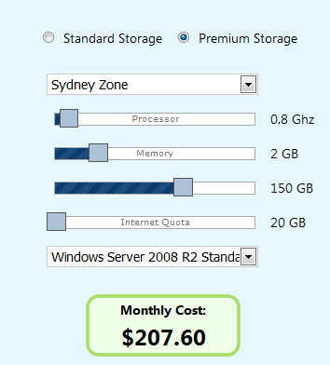

The field use for calculating the Options Package Detail should be :-

- Usage VCPU (column Z)
- Usage Memory (column P)
- Usage Storage (column X)

This data will be provided to PreProcessor via the Telmax21 and populate the Var fields with the VCPU, Memory and Storage. The Telmax will combine the hourly extracts into a single file, which can be called by running a batch for the required billing period.

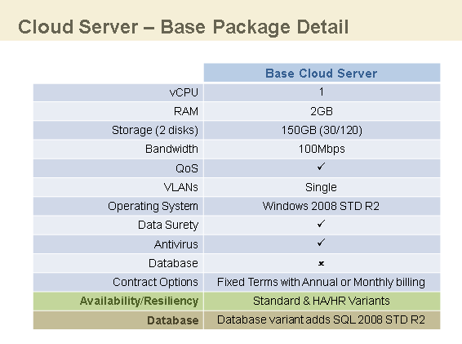
The Base Package looks like it is VCPU is 1G * RAM (Memory) 2G * Storage 150G, which equals $???.??

BatchtypeID: This will be an automatic batch type, which will have the Add transaction button available for once off occasions. I have selected this functionality, as the Annual Charges batch type divides the PA amount by the frequency against the Service Type to invoice monthly, quarterly or annually. The batch will be included under the "Import Data Automatic" data input group and will automatically pick up all active ServiceIDs and include in the invoice.

Revenue Batchtype ID is 648
The batch name is “Cloud Server”, which appears on the Invoice.

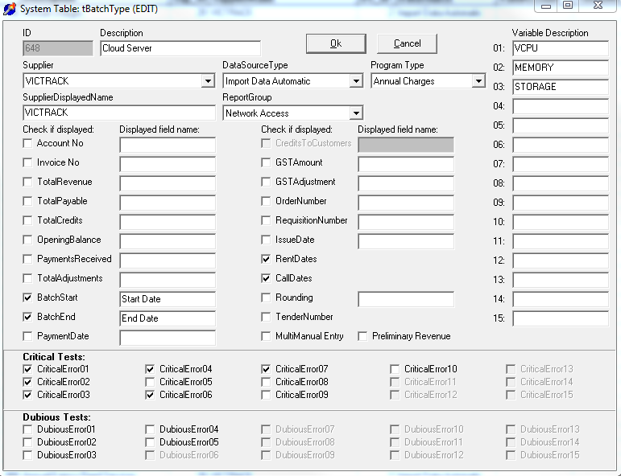
The only fields added to the Var fields so far is the 3 fields to calculate the base package. Should we include additional data e.g. Premium?

SystemID: The systemID will join together the various Service Types belonging to this batchtype, so that there can be a varied price for different customers.

Revenue system ID is 731

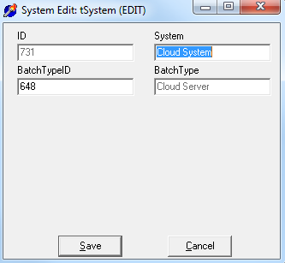

ServiceType: I have created a base package model that will charge an per annual fee and divide it by the Frequency field in the Service type table.

Will an administration fee apply for Cloud services?
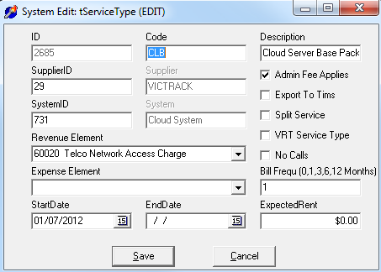

SupplierID: VicTrack is the supplier for Cloud
Application: The application has been added as Cloud Services so that any billing can extract all Cloud ServiceIDs in one extraction.
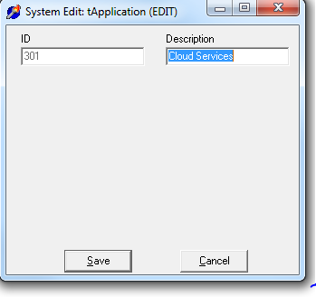
Person: Not populated yet.
ServiceID: The ServiceID naming convention should equate to the device names created in the Cloud VMWare software so that services can be easily audited for correctness. The name should also be consistent with fault reporting and OMW interface and customer familiarity.
Subledger No need to create a subledger for revenue as this new product will have a new revenue natural account (or element)
StatusID Leave empty
CustomerID PP will allow for multiple customers and independent pricing for the Base Package or a variation of the Base Package, by simply creating a separate service type.
BillingPeriod From billing period control eg 2012/10
BatchStatusID Initially set to 1
BatchStartDate Default to first of month for Billing Period eg 1/10/2012. This should look at the ServiceID install date and do a partial month if the installation date falls within the Billing Period selected for the batch.
BatchEndDate Default to last of month for Billing Period eg 31/10/2012. This should look at the ServiceID termination date and do a partial month if the termination date falls within the Billing Period selected for the batch and the critical error should not apply either.

DataCollectionDetail
The data collection will be populated as follows:
SequenceNo Generated by the extract routine
ServiceID Supplied in the Telmax file
TxnDate Supplied in the Telmax file
TxnTime Supplied in the Telmax file
Origin ???
Destination ???
Duration ???
Callcode ???
RateDescription ???
DialledNumber ???
GSTFlag In all imports where VRT is the supplier, the GST flag should be set to N when the customer is also VRT and Y otherwise.
AmountExGST The calculated rate from tRates table for the appropriate ServiceType.
SupplierServiceCode ???
GSTAmount will need to be calculated
AmountIncGST will need to be calculated
FromDate ???
ToDate ???
Transaction Type ???
Var01 VCPU
Var02 Memory
Var03 Storage
Var04 Leave blank
Var05 Leave blank
Var06 Leave blank
Var07 Leave blank
Var08 Leave blank
Var09 Leave blank
Var10 Leave blank
Var11 Leave blank
Var12 Leave blank
Var13 Leave blank
Var14 Leave blank
Var15 Leave blank

Calls or Traffic Data

The calculation of the Traffic should be recorded so that provision can be made for exceeding the value. Do we provide a top and bottom register? How do we record that? Is that maintained in the Telmax or PP? Do we charge it is goes about the ceiling? Do we provide Transactional data?
- Usage Network Received and Transmitted (column R)
- Usage Network Received (column T)
- Usage Network Transmitted (column V)

Trates The rates table will hold the base values so that these values can be varied over time.

The Length field will hold the CPU Base Amount
The Percentage field will hold the RAM or Memory
The Partcost field will hold the Storage
The cost field will hold the PA amount.
The cost100 field will hold the Network Usage dollar figure if the base is exceeded.

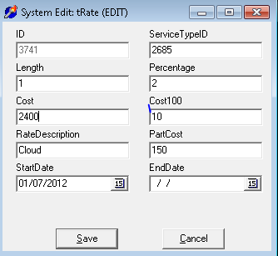

If additional options are applied by the customer and they need to be displayed on the invoice then they will be given a separate serviceid, servicetype and rate e.g. DR, Backup, Database added, so that the Customer and billing staff are able to ascertain what configuration the customer has. Is this correct?

Critical Error 1 If the initiation finds the ServiceID is unknown - included
Critical Error 2 Additional Service - not included
Critical Error 3 Omitted Service - included
Critical Error 4 Unexpected Calls - included
Critical Error 5 Valid Split Service - not included
Critical Error 6 System Reference Correct- not included
Critical Error 7 If the existing ServiceID or Service is terminated - included
Critical Error 8 Incomplete Quetzal data - not included
Critical Error 9 Extra Split Service - not included
Critical Error10 Customer centre unallocated - not included

