1.0. Installation of WTK client software on a user’s Windows PC

WTK 1484 Telmax21 21Windows Menu v1.6d can be installed on XP, Vista, Windows 7 (inc. 64-bit, and Putty support)
- Before starting ensure that the user has been added to the Telmax21 System.
- You will need administrator access to the windows machine to successfully install the WTK client.
- See Section 1.5 for additional User Access Requirements.
- Run the .exe file “.t21wtk1484_winmenV16D.exe” then Choose Next → Install
- You will then be presented with the WTK settings editor, this will enable you to enter user settings for the WTK client.
1.1 WTK Client Settings Editor
- The Settings editor Allows the editing of many of the WTK client settings. (For a break down of what these settings should be for a fresh, first time install see Table 1.1).
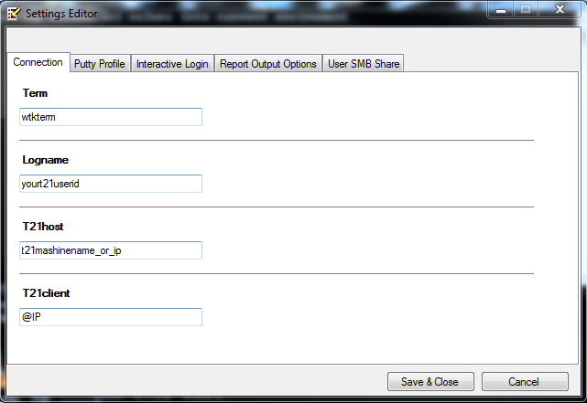

Settings Tab | Default value | User Action Description
Connection
Term | wtkterm | This should be left as “wtkterm”
Logname | yourt21userid | This should be set to the user's Telmax user name
T21host | t21machinename | This should be set to the Hostname or IP address of the Telmax21 System
T21client | yourpcname | This should be replaced with “@IP”
Table 1.1 (Note that Quotation marks should be excluded when entering values)
- Note that configuration information from previous installations may be maintained and these will be in place of the default values.
- To also set the WTK Client to use putty at this stage See Section 1.2
- The User SMB Share tab, allows you to access you report files on the Telmax21 server via windows network protool, To enable it, set Enablesmbshare = 1. Then set Usersmbshare to the UNC path to your Telmax21 user home folder, (eg. \\t21machinename_or_ip\yout21userid). When the Telmax21 D4Gl thin client server is started, and after initialising the D4gl, it will then try to connect to your Telmax21 user home share. You may be prompted for connection credentilas, these will be either your telmax21 userid and password, or your windows login and password if the Telmax21 Samba server has been integrated to the AD. To have the Telmax21 save your reports on your Telmax21 user share, you need to set your Telmax21 report output options to have “Save on Telmax21” ticked, Tto have the reports automatically open, set the View Option to “On Host”
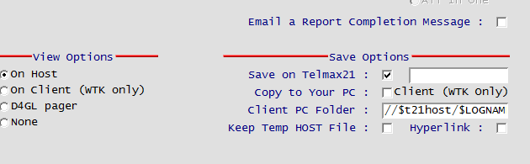
After the above information has been entered, choose “Save & Close” → “Finish” to complete basic installation.

1.2 Configuring the WTK Client to use Putty
- The current version of the WTK Client supports the use of the putty program “plink” to connect to the Telmax21 system on port 22(ssh) with certificates, in addition to the original rlogin protocol.
- It should be noted that the use of rlogin is not enabled by default on the Red Hat Enterprise Linux(RHEL) version of the Telmax21 system and requires additional configuration to enable.
- Enabling the use of putty is possible both at the initial configuration (See Section 1.1) or by opening the WTK Client settings editor (Telmax21 Main Menu →tools →Windows WTK Settings) and selecting the Putty Profile tab
- The “Useputty” field should be left blank to use the user's default profile.
- The “Enableputty” field should be set to 1”

- Setting Fglportfwd to 1, will enable tunnelling the Informix Dynamic 4gL FGL GUI protocol (base port 6400) through a putty tunnel from the Telmax21 thus avoiding any fire wall issue, and allowing the gui to work over VPN.

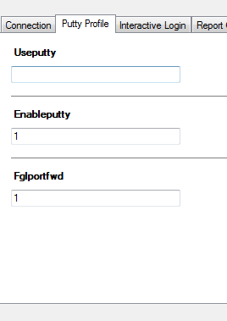

2 Configuring the WTK Client to use Putty (Cont.)

- Select Telmax21 Main Menu →tools → Configure and Install ssh keys on telmax21 server. This will generate the ssh key pair needed for the next step.
  - you will need to enter the user's telmax21 password when prompted.
  - Press any key when prompted to dismiss the window.
- Select Telmax21 Main Menu →tools → Install putty configuration
  - you will need to enter the user's telmax21 password when prompted.
  - You will then be prompted to enter the user's telmax21 password a second time
  - you may be prompted for administration privileges to enter the putty configuration into the registry select yes.
    - You will then be prompted to add the information into the registry itself, select yes
    - you should then be notified that the information has been added successfully, select yes.
- The “PuTTYgen” program will then begin the process to convert the user's ssh private key to a format putty can use.
- Please pay careful attention to the command shell window at this step, as it will provide the information required for the following step.
- After reading the command shell window, select “ok” on the PuTTYgen Notice to dismiss the notification.
- Select the “Save private key” and select “Yes” when prompted with a warning that there is no pass-phrase associated with the key
- Save the putty private key with the name and location displayed in the Command Shell window
- On windows 7 this can be done by typing the full address into the “File name:” bar.
- After the .ppk file has been saved, close the putty key generator program.
- Then select the command shell window and press any key to dismiss the window

1.3 Post Installation Tests
- To test if the WTK client installation was successful start the Telmax21 D4GL Server by running the Telmax21 Main Menu → “...Start Telmax21 D4GL Server”
- If the client is not configured to use putty, enter the user's password in the password field, then click on “ok”. This will attempt to connect to the Telmax21 System.
- If the client is configured to use putty, you may be prompted to allow putty access to the network though the windows firewall, select Allow access.
- If the connection was successful a window will appear stating the client is connected to the system. Selecting “ok” will dismiss the window.
- After a successful connection has been established a test should be run to verify that the client is now operational.
- This could be done by selecting Telmax21 Main Menu → Directory → “Directory Maintenance”
- If the client successfully connects to the system and displays the directory maintenance screen the client should be operational.
1.4 WTK Client Toolbar
- This is an optional step that provides for an alternative method for interacting with the WTK Client for windows 7 & windows 8 machines.
- While optional, it is highly recommended to perform this step in setting up the WTK client for windows 8 machines.
- Right click on the task bar and hover over the toolbar submenu then select new toolbar.
- As the AppData folder is hidden, click into the e address bar, replace the address with the line:
  - C:\Users\[USERNAME]\AppData\Roaming\Microsoft\Windows\Start Menu\Telmax21 Main menu
- Where “[USERNAME]” is the name of the windows use, for example:
  - C:\Users\JaneSmith\AppData\Roaming\Microsoft\Windows\Start Menu\Telmax21 Main menu,
  - where “JaneSmith” is the user's windows username.
1.5 User Access Requirements
- The following TCP sockets are required to be enabled between the users and the Telmax21 server to allow normal mode of operation between the Windows workstations and the Telmax21 server over LAN.

Functionality | TCP Socket number | From | To
Putty | 22 | WIN Cient | TELMAX21
rlogin (if not usring putty) | 513 | WIN Client | TELMAX21
Rshell (if not using smb share) | 514 | TELMAX21 | WIN Client
Smb (for telmax21 home share) | 319 | WIN Clinet | TELMAX21
fglgui (GUI interface) | 6400 | TELMAX21 | WIN Client

